[Deal.DealName]​

Prepared for:
[Client.FirstName] [Client.LastName]
[Company.Name]

Created by:
[Event Organiser.FirstName] [Event Organiser.LastName]​
[Event Organiser.Company]​

[Deal.ProjectStartDateC]
​[Venue.Company]​
Event Risk Management Plan

[Deal.DealName]​
Event details
Event details
Event brief
Resources for reference
RISK MATRIX
Risk Matrix
Consequence & Likelihood tables
CONSEQUENCE TABLE
LIKELIHOOD TABLE
Personal Protective Equipment
PERSONAL PROTECTIVE EQUIPMENT (PPE)
High-Risk Activities or Work
ANY HIGH-RISK ACTIVITIES OR WORK BEING CARRIED OUT
ANY HIGH-RISK MACHINERY OR EQUIPMENT NEARBY
Hazard Identification & Control Measures
Thank you, and we look forward to safely working with you!
PCBU acceptance

Event details

Event details
Event Name: | [Deal.DealName]  [Deal.OpportunityNumberC] | Date of access to venue: | [Deal.ProjectStartDateC]
Event location: | [Venue.Company] | Floor Plan confirmed: | ​
Client or Principal Contractor (PCBU): | ​[Client.Company] | Client contact: | ​[Client.FirstName] [Client.LastName]  ​[Client.Phone]  ​[Client.Email]
Contractors (PCBUs): | [Event Organiser.Company]  [Event Organiser.StreetAddress], [Event Organiser.City], [Event Organiser.State] [Event Organiser.PostalCode]  ABN: [Company.Abn] | Contractors contact: | [Event Organiser.FirstName] [Event Organiser.LastName]  ​[Event Organiser.Email]  ​[Event Organiser.Phone]
Venue (PCBU): | [Venue.Company] | Venue contact: | [Venue.FirstName] [Venue.LastName]  [Venue.Phone]  [Venue.Email]
Contractor sign-in location: | All contractors to phone Security contacts on arrival.  Contractors must sign in / register at Security. | Venue Security / Emergency contacts: | - Medical emergency  - 000  - Security (at Loading dock)  - Loading dock
Date Prepared: | 17 / 10 / 2025 | PCBUs consulted during the assessment process: | [Event Organiser.FirstName] [Event Organiser.LastName] ([Event Organiser.Company]), [Client.FirstName] [Client.LastName] ([Client.Company]), [Venue.FirstName] [Venue.LastName] ([Venue.Company]).

Event brief

Resources for reference
All onsite staff to review and familiarise themselves prior to commencement of work onsite with this Event Risk Management Plan, including specific venue documentation listed below:
Safework NSW - WHS Toolkit​
Safework NSW - Workers obligations
Safework NSW - Incident Report Form
Safework NSW - Incident Reporting Guide​

 | Risk Matrix  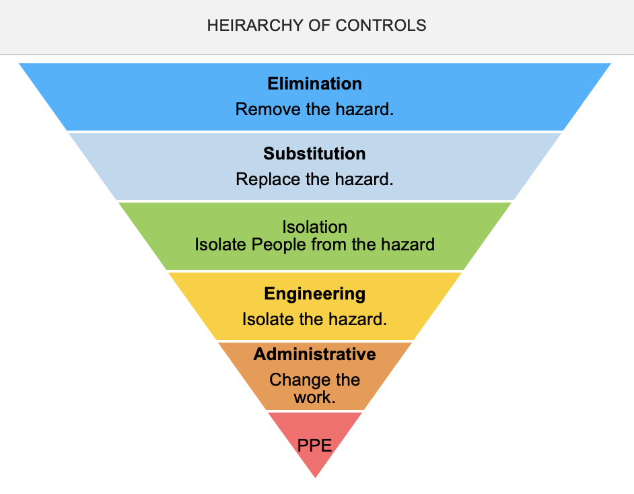
  RISK MATRIX
   | CONSEQUENCE
  LIKELIHOOD | NEGLIGIBLE (1) | MINOR  (2) | MODERATE  (3) | MAJOR  (4) | CATASTROPHIC  (5)
  ALMOST CERTAIN (A) | 1A | 2A | 3A | 4A | 5A
  LIKELY (B) | 1B | 2B | 3B | 4B | 5B
  POSSIBLE (C) | 1C | 2C | 3C | 4C | 5C
  UNLIKELY (D) | 1D | 2D | 3D | 4D | 5D
  RARE (E) | 1E | 2E | 3E | 4E | 5E
  RATING (RESIDUAL RISK) | ACTION
  ​ACUTE | DO NOT PROCEED
  ​HIGH | Review before work starts.
  MODERATE | Ensure control measures in place.  Refer to the 'Hierarchy of Controls'
  ​​LOW | Monitor and keep records.
  Notes on Hierarchy of Controls
  Elimination methods are the most effective and preferred when controlling a hazard.
  Substitution is the second most effective method of controlling a hazard.
  Engineering by isolation is the third most effective,
  while Administrative Controls by changing the work is the fourth most effective method.
  PPE (Personal Protective Equipment) is the least effective method.

Consequence & Likelihood tables

CONSEQUENCE TABLE
Consequence | Category | Business Interruption | Environmental | Financial | Human | Public Image & Reputation
Catastrophic | 5 | Essential service failure, or key revenue generating service removed | Irreversible damage | Above $5,000,000 | Death(s) / many critical injuries | National & International concern / exposure
Major | 4 | Service of provider needs to be replaced | Harm requiring restorative work | Up to $5,000,000 | Single death / multiple long term or critical injuries | State wide concern / exposure
Moderate | 3 | Medium temporary suspension of service required to be cleared byadditional resources | Residual pollution requiring clean up work | Up to $500,000 | Single minor disablement / multiple temporary disablement | Local community concern
Minor | 2 | Short term suspension of service | Remote, temporary pollution | Up to $50,000 | Injury | Customer complaint / faulty settled
Negligible | 1 | Negligible impact, brief reduction/loss of service 2-12 hours | Brief, non hazardous, transient pollution | Up to $10,000 | Minor First Aid | Resolved in day-to-day management

LIKELIHOOD TABLE
Likelihood | Category | Description
Almost Certain | A | Can be expected to occur in most circumstances; more than 75% chance of occurring; complex process with minimal checks & balances; impacting factors outside control of organisation
Likely | B | Will probably occur in most circumstances; 50-75% chance of occurring; complex process with some checks & balances; impacting factors outside control of organisation
Possible | C | Might occur at some time; 25-50% chance of occurring; previous audits / reports indicate non-compliance; complex process with extensive checks and balances; impacting factors outside control of organisation
Unlikely | D | Could occur at some time; less than 25% chance ofoccurring; non-complex process & / or existence of checks and balances
Rare | E | May occur in exceptional circumstances; simple process; no previous incidence of non-compliance

Personal Protective Equipment

PERSONAL PROTECTIVE EQUIPMENT (PPE)
FOOT PROTECTION | HAND PROTECTION | HEAD PROTECTION | HEARING PROTECTION | EYE PROTECTION | RESPIRATORY PROTECTION | FACE  PROTECTION | HIGH-VIS CLOTHING | PROTECTIVE CLOTHING | FALL PROTECTION | SUN PROTECTION | HAIR/JEWELLERY SECURED​
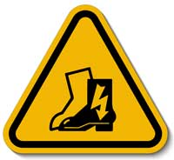 | 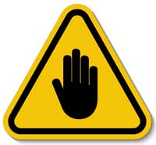 | 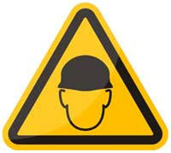 | 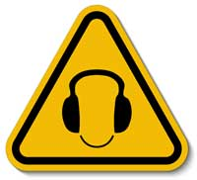 | 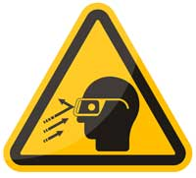 | 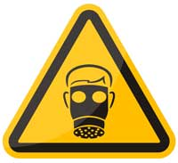 | 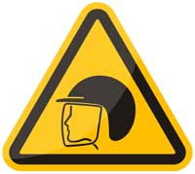 | 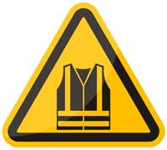 | 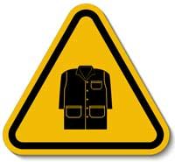 | 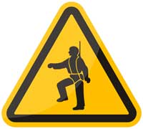 | 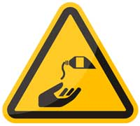 | 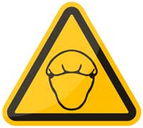

Select the appropriate PPE above suitable for the equipment used or the job task being performed (if applicable).
Note: A SWMS must be reviewed regularly to make sure it remains effective. A SWMS must be reviewed (and revised if necessary) if relevant control measures are revised. The review process should be carried out in consultation with workers (including contractors and subcontractors) who may be affected by the operation of the SWMS and their health and safety representatives who represented that work group at the workplace.

When a SWMS has been revised, the person conducting a business or undertaking must ensure all:

- persons involved in the work are advised that a revision has been made and how they can access the revised SWMS;
- persons who will need to change a work procedure or system as a result of the review are advised of the changes in a way that will enable them to implement their duties consistently with the revised SWMS; and,
- workers that will be involved in the work are provided with the relevant information and instruction that will assist them to understand and implement the revised SWMS.

High-Risk Activities or Work

ANY HIGH-RISK ACTIVITIES OR WORK BEING CARRIED OUT
 | involves a risk of a person falling more than 2 meters. |  |  |  | is carried out on or near pressurised gas mains or piping.
 | is carried out in or near a confined space. |  |  |  | is carried out in an area that may have a contaminated or flammable atmosphere.
 | is carried out on or near energised electrical installations or services. |  |  |  | is carried out on or near chemical, fuel or refrigerant lines.
 | is carried out in an area of a workplace where there is any movement of powered mobile plant. |  |  |  | is carried out on, in or adjacent to a road, railway, shipping lane or other traffic corridor.
 | is carried out in areas with artificial extremes of temperature. |  |  |  | is carried out in or near water or other liquid that involves a risk of drowning.

ANY HIGH-RISK MACHINERY OR EQUIPMENT NEARBY
 | Forklift |  | Genie Lift / other EWP |  | Trucks |  | ​ | Flammable Gas
 | Boom Lift |  | Hoist/s |  | Other vehicles |  |  | Fuel
 | Scissorlift |  | Other (Please specify)

Hazard Identification & Control Measures

# | Type of Hazard | Potential hazard | Details of the specific hazard | IR | Control measures | RR
1 | Infection Control (inc. COVID-19)  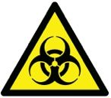 | ✔ Possible infection by or transmission of infectious diseases (inc. COVID-19) | See current Federal and NSW Government information regarding the acquisition of and the transmission of all Infectious Diseases;  See: NSW Health - Infectious Diseases Info​  Infectious (Communicable) Disease means; Coronavirus and any strain of Coronavirus or its sequalae; or Atypical Pneumonia or any strain of such atypical pneumonia. | 3C | - All [Event Organiser.Company] staff confirm they are free of all known symptoms of any communicable diseases.  - All [Event Organiser.Company] staff agree to adhere to the recommended practice of social distancing whenever possible, and will respect the personal space of others, regardless of their own views.  - All [Event Organiser.Company] staff will use hand sanitiser as required and according to venue signage (Venue will provide Hand Sanitiser).  - All [Event Organiser.Company] staff agree to abide by the direction of the venue staff.   | 3D

2 | Vehicles / Road safety  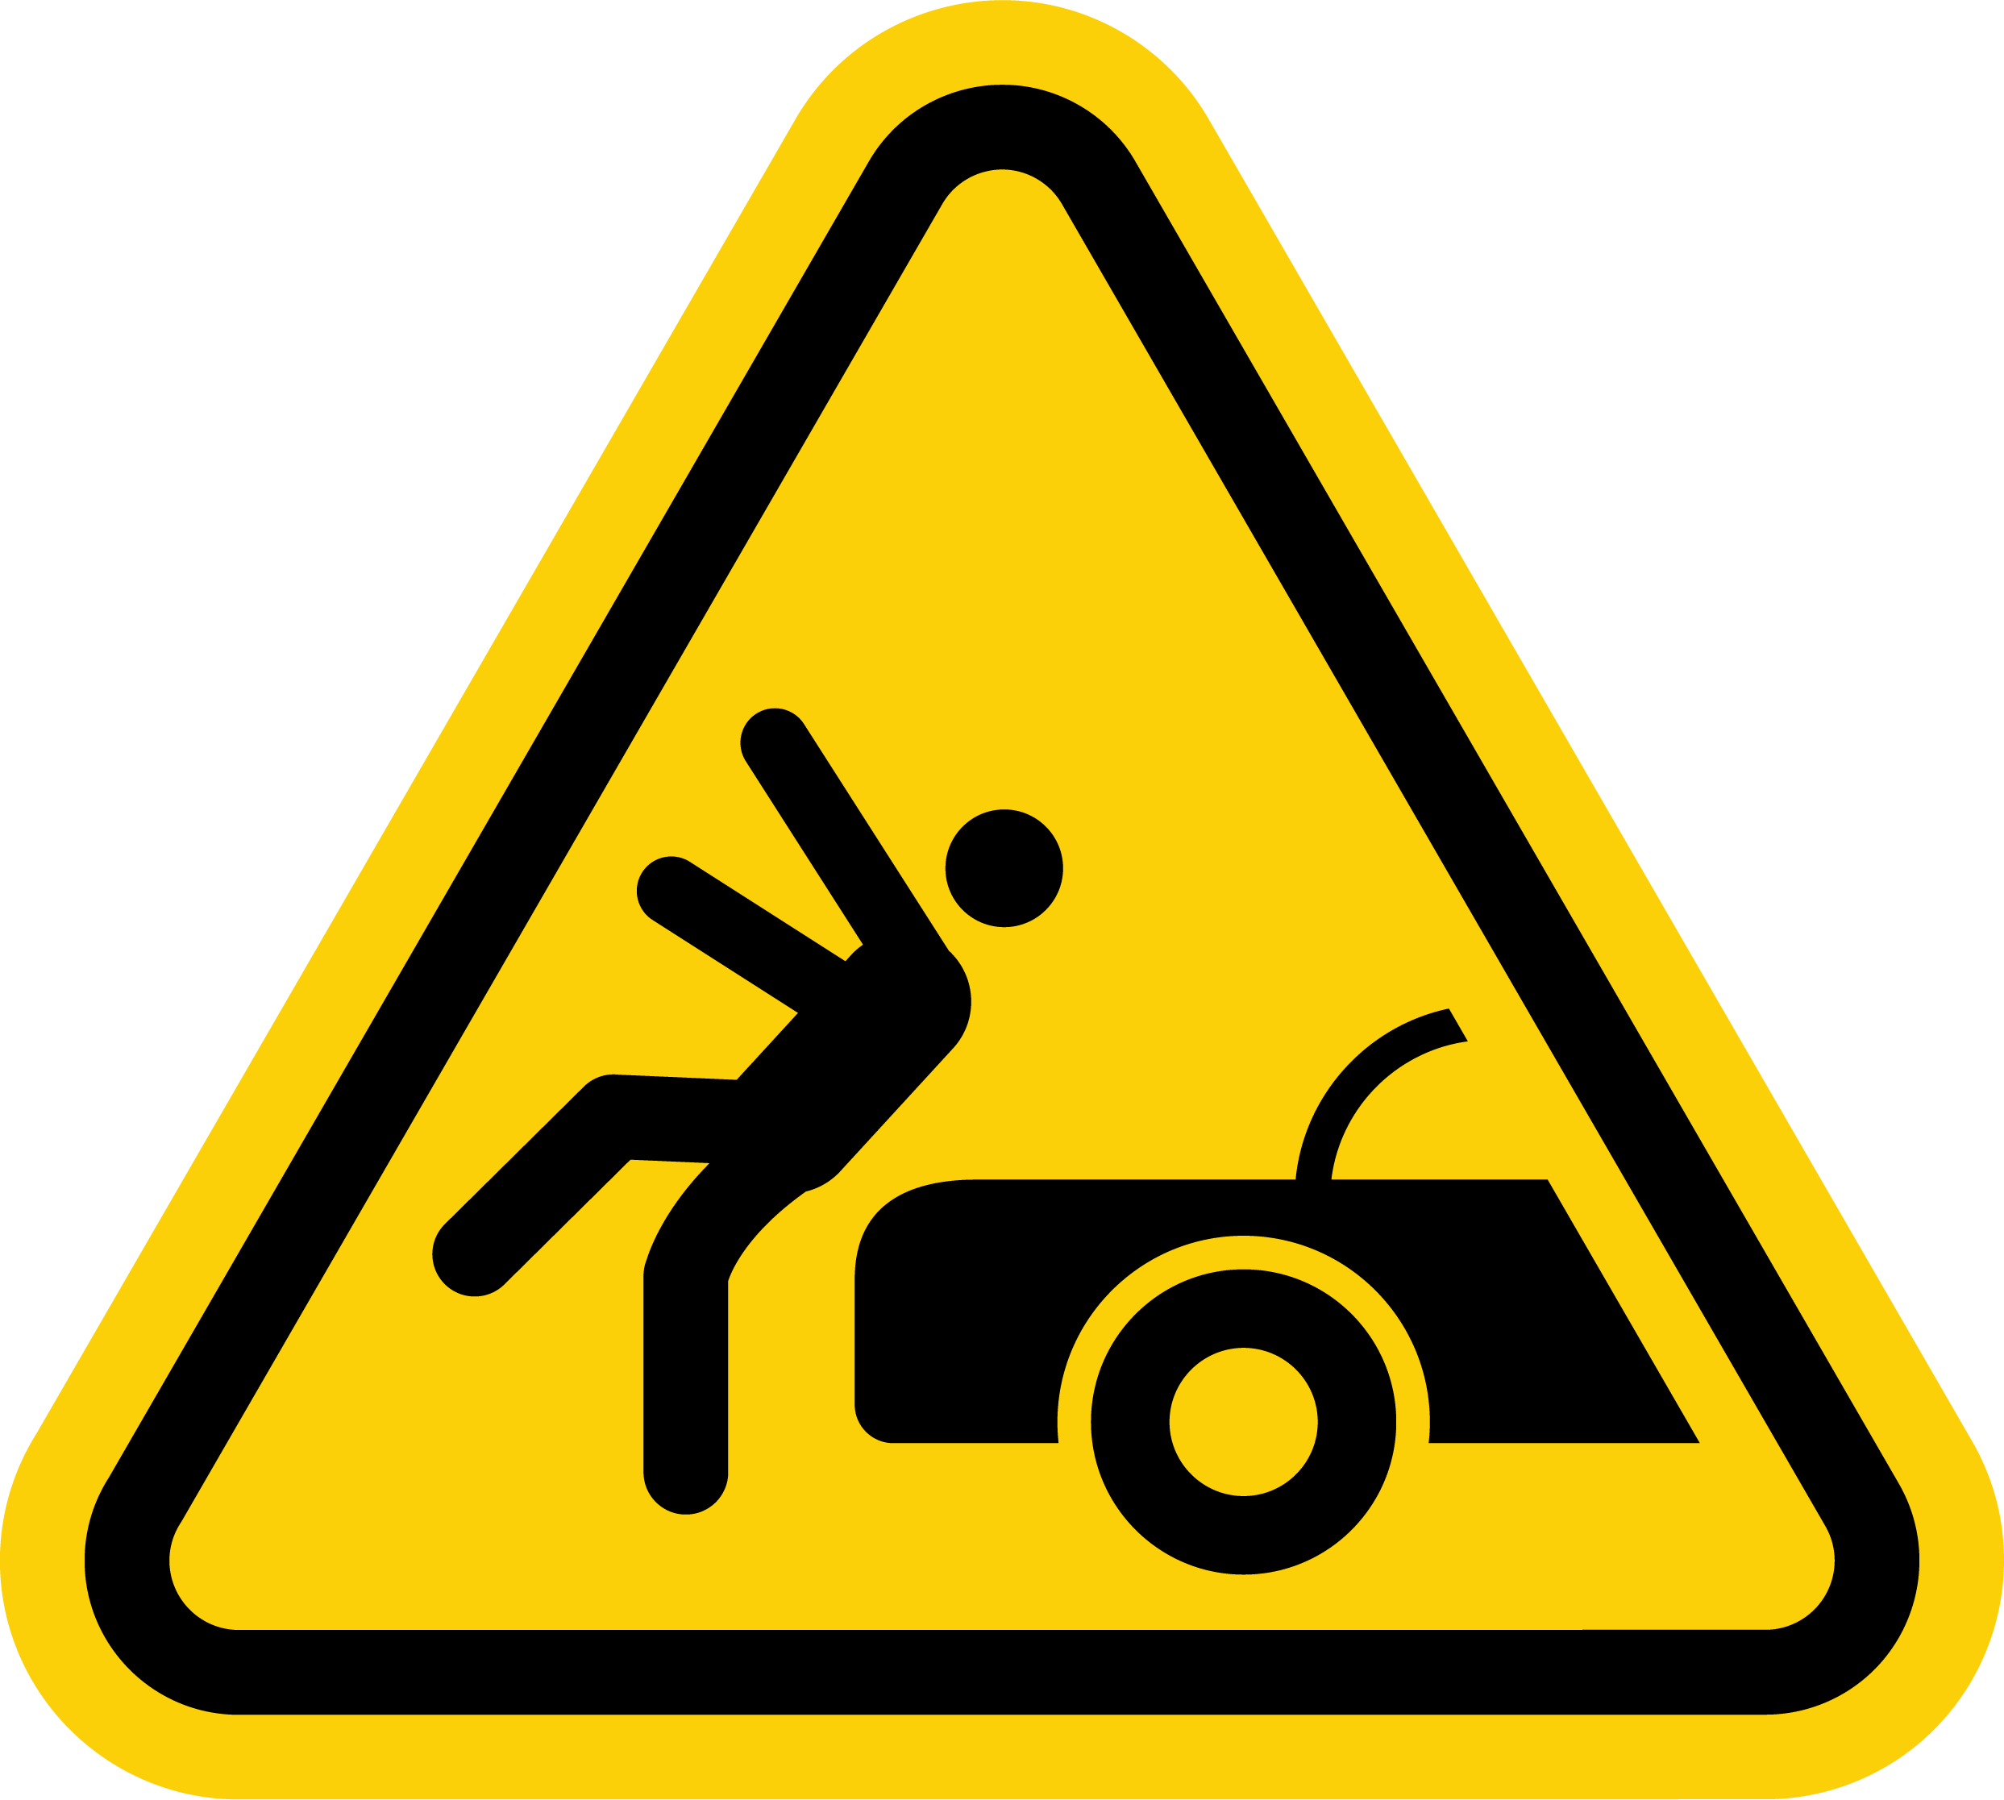  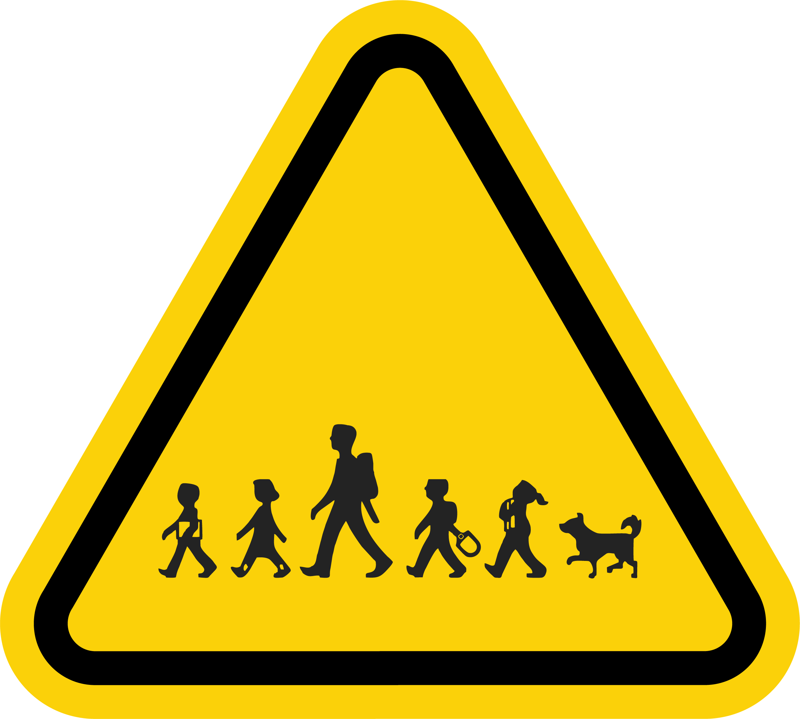 | ✔ Vehicles entering or exiting the site  ✔ Possible use of forklifts or other motorised equipment  ✔ Vehicles stopping in non-designated loading zones  ✔ Vehicles generating toxic fumes from engines idling | Access to Venue is via a dedicated Loading Dock (or Loading Zone at street level)  Commercial vehicles will be delivering / collecting large items contained in protective roadcases on wheels.  General traffic movement in and around the loading / unloading area, where there may be other people, vehicles, and objects.  Vehicles making contact with pedestrians on entry & exit.  Forklifts may be operated by venue staff.  Movement of AV equipment on wheels / trolleys.  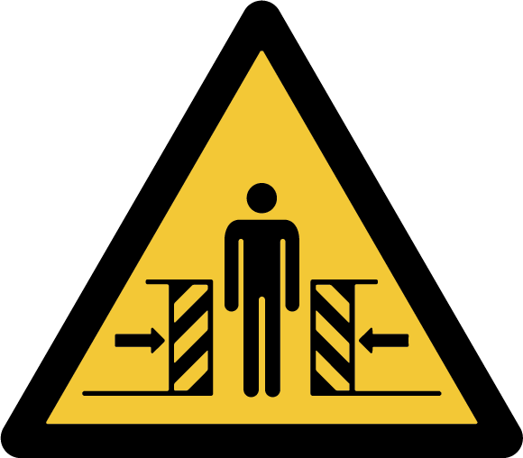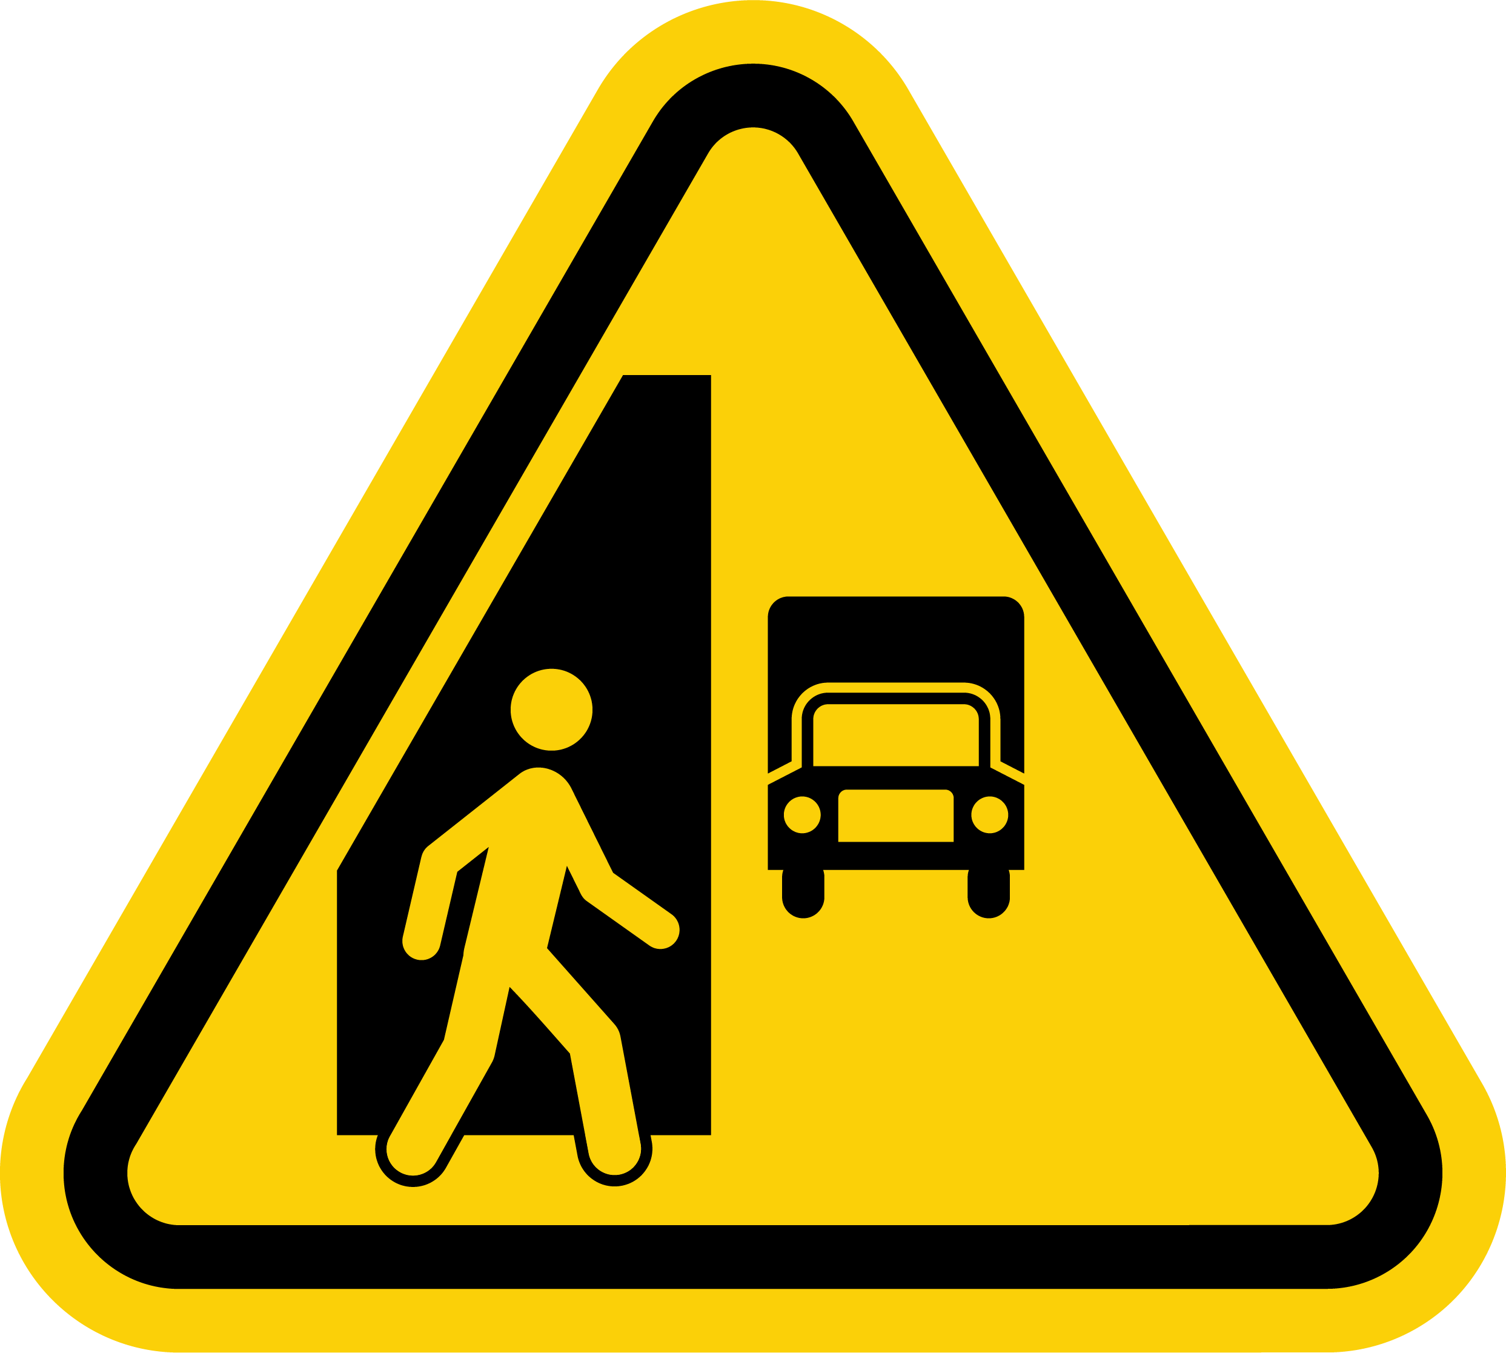 | 4A | - All vehicular driving will be performed by licensed and competent persons to drive on public roads. [Event Organiser.Company] Operations perform regular license & demerit point checks every 6 months.  - Any forklifts (or other EWPs) being used in the 'Loading area' will be operated by licensed and competent persons. [Event Organiser.Company] have a preference for 'Venue staff' to operate forklifts, and will also observe venue rules around this.  - [Event Organiser.Company] Driver of the [Event Organiser.Company] managed vehicle will exercise necessary caution when entering & exiting the 'Loading area';  - End any active phone calls (on hands-free)  - Turn off any music playing  - Open driver & passenger windows to actively listen to any audible warnings  - Activate hazard lights to warn other people (*optional)  - Observe and be prepared for any pedestrian activity  - on the footpath at the driveway crossover  - within the 'Loading area'  - Prioritise vulnerable road users first  - Drive at or under 10km/h to the conditions  - Turn off the engine, and engage all brakes, when not moving  - [Event Organiser.Company] Crew will be utilising dedicated vehicles (Vans, Trucks) for deliveries & collections, which have custom ramps / hoists for unloading / loading.  - [Event Organiser.Company] Crew have been trained how to safely utilise these vehicles and loading devices.  - All [Event Organiser.Company] Crew are provided with Hi-Vis vests, and are available in all vehicles, and within [Event Organiser.Company] portable production packers. These are worn in the 'Loading area';  - In very dark conditions  - During busy activity during unloading or loading  - When required by the venue  - [Event Organiser.Company] Drivers & Crew will take any directions from designated 'Venue staff' or a Dockmaster as required.  - [Event Organiser.Company] Operations will make a loading dock booking (where possible) via the Venue booking system / Security / Dockmaster.  - [Event Organiser.Company] Drivers will use trained spotters (in Hi-Vis vests) to communicate directly with the driver to maintain safe clearance between the vehicle and people during vehicle movement.  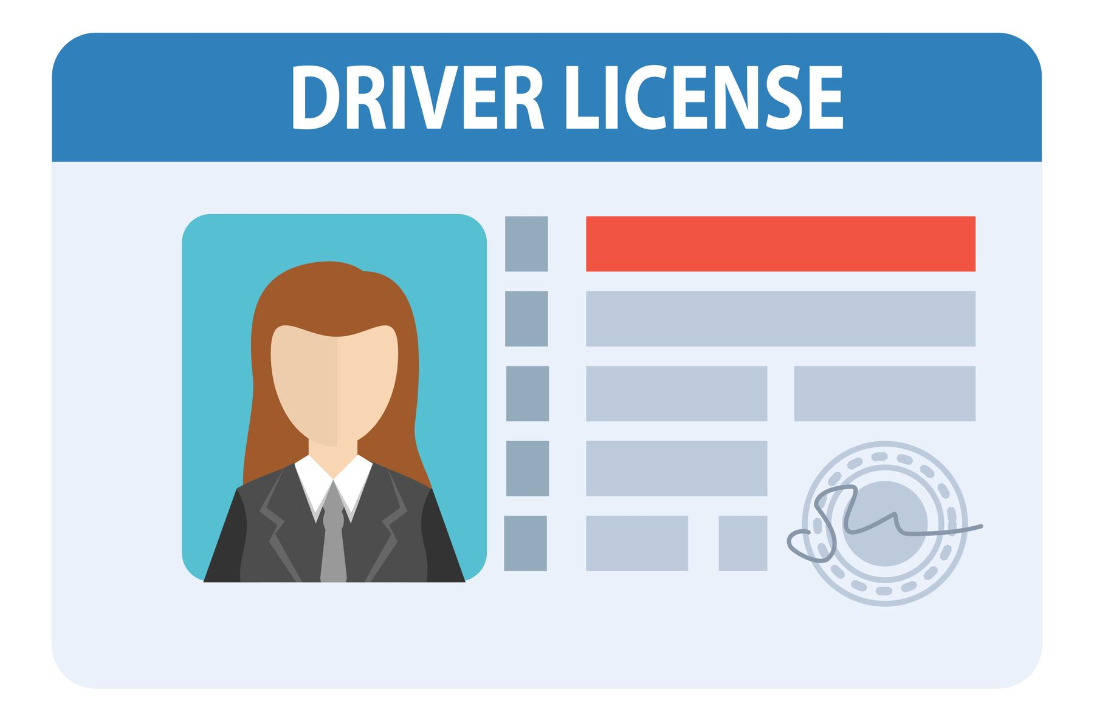 | 4D

2 | Vehicles / Road safety | ✕ Vehicles entering or exiting the site  ✕ Possible use of forklifts or other motorised equipment  ✕ Vehicles stopping in non-designated loading zones  ✕ Vehicles generating toxic fumes from engines idling | Access to Venue is via a dedicated Loading Dock (or Loading Zone at street level)  Commercial vehicles will be delivering / collecting large items contained in protective roadcases on wheels.  General traffic movement in and around the loading / unloading area, where there may be other people, vehicles, and objects.  Vehicles making contact with pedestrians on entry & exit.  Forklifts may be operated by venue staff.  Movement of AV equipment on wheels / trolleys. | 4A | - All vehicular driving will be performed by licensed and competent persons to drive on public roads. [Event Organiser.Company] Operations perform regular license & demerit point checks every 6 months.  - Any forklifts (or other EWPs) being used in the 'Loading area' will be operated by licensed and competent persons. [Event Organiser.Company] have a preference for 'Venue staff' to operate forklifts, and will also observe venue rules around this.  - [Event Organiser.Company] Driver of the [Event Organiser.Company] managed vehicle will exercise necessary caution when entering & exiting the 'Loading area';  - End any active phone calls (on hands-free)  - Turn off any music playing  - Open driver & passenger windows to actively listen to any audible warnings  - Activate hazard lights to warn other people (*optional)  - Observe and be prepared for any pedestrian activity  - on the footpath at the driveway crossover  - within the 'Loading area'  - Prioritise vulnerable road users first  - Drive at or under 10km/h to the conditions  - Turn off the engine, and engage all brakes, when not moving  - [Event Organiser.Company] Crew will be utilising dedicated vehicles (Vans, Trucks) for deliveries & collections, which have custom ramps / hoists for unloading / loading.  - [Event Organiser.Company] Crew have been trained how to safely utilise these vehicles and loading devices.  - All [Event Organiser.Company] Crew are provided with Hi-Vis vests, and are available in all vehicles, and within [Event Organiser.Company] portable production packers. These are worn in the 'Loading area';  - In very dark conditions  - During busy activity during unloading or loading  - When required by the venue  - [Event Organiser.Company] Drivers & Crew will take any directions from designated 'Venue staff' or a Dockmaster as required.  - [Event Organiser.Company] Operations will make a loading dock booking (where possible) via the Venue booking system / Security / Dockmaster.  - [Event Organiser.Company] Drivers will use trained spotters (in Hi-Vis vests) to communicate directly with the driver to maintain safe clearance between the vehicle and people during vehicle movement. | 4E

3 | Manual Handling  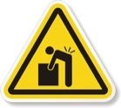 | ✔ Pushing, pulling, carrying, holding restraining or lifting | Transporting audiovisual equipment in professional fit-for-purpose portable road cases on wheels and custom trollies  Lifting & manual positioning of Audiovisual equipment  Carrying and setting general event equipment / operating position furniture | 3B | - Wheels on professional road cases, team lifting, no lifting above shoulder height, [Event Organiser.Company] crew to use correct manual handling techniques, continuous communication, and supervision by supervisor  - 2 or more person lifts to be used whenever a load is Risk Assessed to be beyond the control of an individual  - No overloading or stacking cases beyond manufacturers recommendations  - No obstructing walkways / egress while moving equipment / road cases between locations  - [Event Organiser.Company] crew to wear suitable PPE (steel cap footwear, protective gloves)  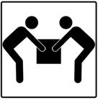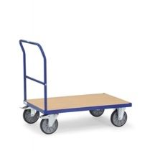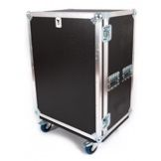  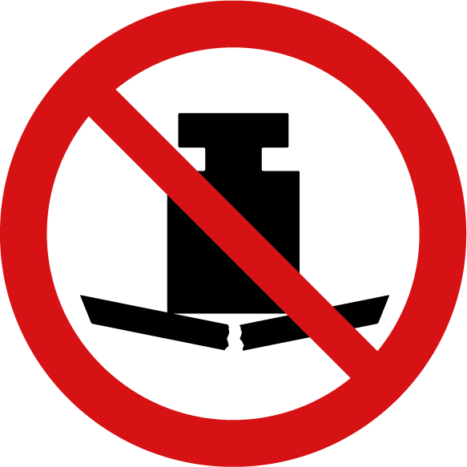 | 3D

3 | Manual Handling | ✕ Pushing, pulling, carrying, holding restraining or lifting | Transporting audiovisual equipment in professional fit-for-purpose portable road cases on wheels and custom trollies  Lifting & manual positioning of Audiovisual equipment  Carrying and setting general event equipment / operating position furniture | 3B | - Wheels on professional road cases, team lifting, no lifting above shoulder height, [Event Organiser.Company] crew to use correct manual handling techniques, continuous communication, and supervision by supervisor  - 2 or more person lifts to be used whenever a load is Risk Assessed to be beyond the control of an individual  - No overloading or stacking cases beyond manufacturers recommendations  - No obstructing walkways / egress while moving equipment / road cases between locations  - [Event Organiser.Company] crew to wear suitable PPE (steel cap footwear, protective gloves) | 3D

4 | Contact with heat  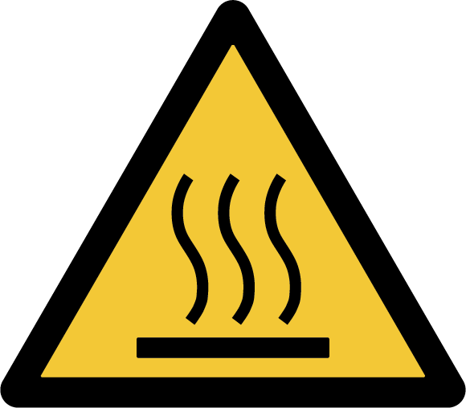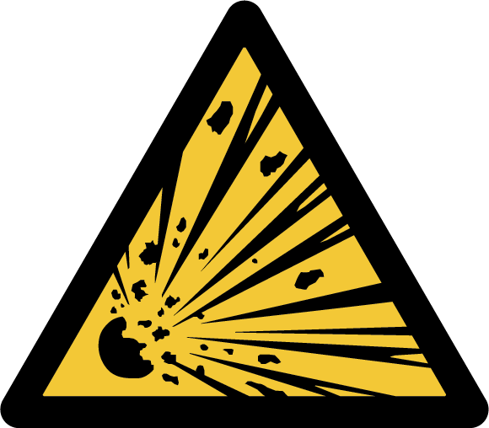 | ✔ Exposure to hot material or objects, surfaces or steam  ✔ Contact with incandescent light sources  ✕ Exposure to sun  ✕ Use of potential sources of ignition such as naked flame candles, lamps, fireworks, pyrotechnics, flutter cannons | Some items may become hot to touch (such as heatsinks on LED fixtures)  Non-specific items producing heat may cause injury.  Incandescent lighting fixtures may generate heat when operating  Lighting for the event will be managed by the Inhouse AV company  Event will be outdoors and so sun exposure is a consideration  Fogger, Smoke or Haze machine required  Fireworks, Pyrotechnics or other special effects units required | 2C | - The Toolbox Talk hazard identification will identify any specific sources of heat, and address suitable clearance to be determined as needed  - [Event Organiser.Company] will avail of standard ambient lighting around all workspace areas  - Protective Gloves / other PPE are supplied in [Event Organiser.Company] mobile production packers, and available at all times  - All possible hot fixtures will be located out of reach by the public and only accessible using EWPs or ladders  - Any requirements for UV Protection will be communicated to all staff prior to arrival to site, to allow for suitable PPE to be worn  - Protective Sunscreen (SPF50) is available in all [Event Organiser.Company] mobile production packers  - Protective hats are made available to staff, or are advised to bring onsite  - as required  - Fogger machine can have some hot areas accessible to touch, and so will be located away from public access, with a safety brief being made to all staff before the event commences  - Trained personnel to handle, manage and operate any specialist items such as Fireworks, Pyrotechnics, handheld canons, or other FX   | 2D

4 | Contact with heat | ✔ Exposure to hot material or objects, surfaces or steam  ✔ Contact with incandescent light sources  ✔ Exposure to sun  ✔ Use of potential sources of ignition such as naked flame candles, lamps, fireworks, pyrotechnics, flutter cannons | Some items may become hot to touch (such as heatsinks on LED fixtures)  Non-specific items producing heat may cause injury.  Incandescent lighting fixtures may generate heat when operating  Lighting for the event will be managed by the Inhouse AV company  Event will be outdoors and so sun exposure is a consideration  Fogger, Smoke or Haze machine required  Fireworks, Pyrotechnics or other special effects units required | 2C | - The Toolbox Talk hazard identification will identify any specific sources of heat, and address suitable clearance to be determined as needed  - [Event Organiser.Company] will avail of standard ambient lighting around all workspace areas  - Protective Gloves / other PPE are supplied in [Event Organiser.Company] mobile production packers, and available at all times  - All possible hot fixtures will be located out of reach by the public and only accessible using EWPs or ladders  - Any requirements for UV Protection will be communicated to all staff prior to arrival to site, to allow for suitable PPE to be worn  - Protective Sunscreen (SPF50) is available in all [Event Organiser.Company] mobile production packers  - Protective hats are made available to staff, or are advised to bring onsite  - as required  - Fogger machine can have some hot areas accessible to touch, and so will be located away from public access, with a safety brief being made to all staff before the event commences  - Trained personnel to handle, manage and operate any specialist items such as Fireworks, Pyrotechnics, handheld canons, or other FX | 2D

4 | Contact with heat | ✕ Exposure to hot material or objects, surfaces or steam  ✕ Contact with incandescent light sources  ✕ Exposure to sun  ✕ Use of potential sources of ignition such as naked flame candles, lamps, fireworks, pyrotechnics, flutter cannons | Some items may become hot to touch (such as heatsinks on LED fixtures)  Non-specific items producing heat may cause injury.  Incandescent lighting fixtures may generate heat when operating  Lighting for the event will be managed by the Inhouse AV company  Event will be outdoors and so sun exposure is a consideration  Fogger, Smoke or Haze machine required  Fireworks, Pyrotechnics or other special effects units required | 2C | - The Toolbox Talk hazard identification will identify any specific sources of heat, and address suitable clearance to be determined as needed  - [Event Organiser.Company] will avail of standard ambient lighting around all workspace areas  - Protective Gloves / other PPE are supplied in [Event Organiser.Company] mobile production packers, and available at all times  - All possible hot fixtures will be located out of reach by the public and only accessible using EWPs or ladders  - Any requirements for UV Protection will be communicated to all staff prior to arrival to site, to allow for suitable PPE to be worn  - Protective Sunscreen (SPF50) is available in all [Event Organiser.Company] mobile production packers  - Protective hats are made available to staff, or are advised to bring onsite  - as required  - Fogger machine can have some hot areas accessible to touch, and so will be located away from public access, with a safety brief being made to all staff before the event commences  - Trained personnel to handle, manage and operate any specialist items such as Fireworks, Pyrotechnics, handheld canons, or other FX | 2D

5 | Contact with electricity   | ✔ Use of electrical tools, equipment, or plant  ✔ Contact with cables, switchboards, or other electrical installations  ✔ Contact with amplifiers, dimmers, audio-visual equipment  ✕ Contact with electrical generators / portable power supplies | Use of power tools that may damage or cut through electrical wires.  Overloading power circuits, either tripping the circuit breaking or causing heat and/or fire.  Earth leakage issues could risk electric shock to people, and event reliability.  Poorly maintained equipment could pose a serious risk of electric shock.  Loose or badly run cabling could pose a trip hazard destabilising connections, potentially causing arcing, short circuits, or electric shock.  Indoor rated equipment could be affected by rain or moisture if used outdoors. | 4A | - Electrical power is supplied via Venue power supply.  - Electrical power is supplied via Portable generators.  - Electrical power is supplied via 10amp GPO sockets.  - Electrical power is supplied via 32amp 3-phase distribution sockets.  - All final subcircuits supplied must have 30mA RCD with a rating of less than 32a. This RCD must be available for inspection.  - Any outdoor electrical connections (temporary or permanent) must be housed within waterproof enclosures (IP65 or above).  - Electrical safety test tags in use as per AS/NZS 3760, and [Event Organiser.Company] policy & procedures.  - [Event Organiser.Company] Crew to carry out visual inspections on all electrical equipment & infrastructure managed by [Event Organiser.Company] prior to energising any electrical cables and equipment. Any failed inspections to be tagged & removed from service.  - [Event Organiser.Company] Crew to carry out visual inspections on all electrical equipment & infrastructure managed by the venue prior to energising any electrical cables and equipment. Any failed inspections to be reported to the venue immediately, and tagged where possible.  - [Event Organiser.Company] Crew to run all cabling safely and neatly. Regular inspections for any loose connections to be done pre-event and during the event if any activity warrants this need.  - [Event Organiser.Company] Toolbox talk should identify any unusual or unexpected electrical hazards.  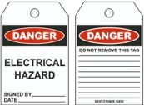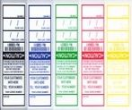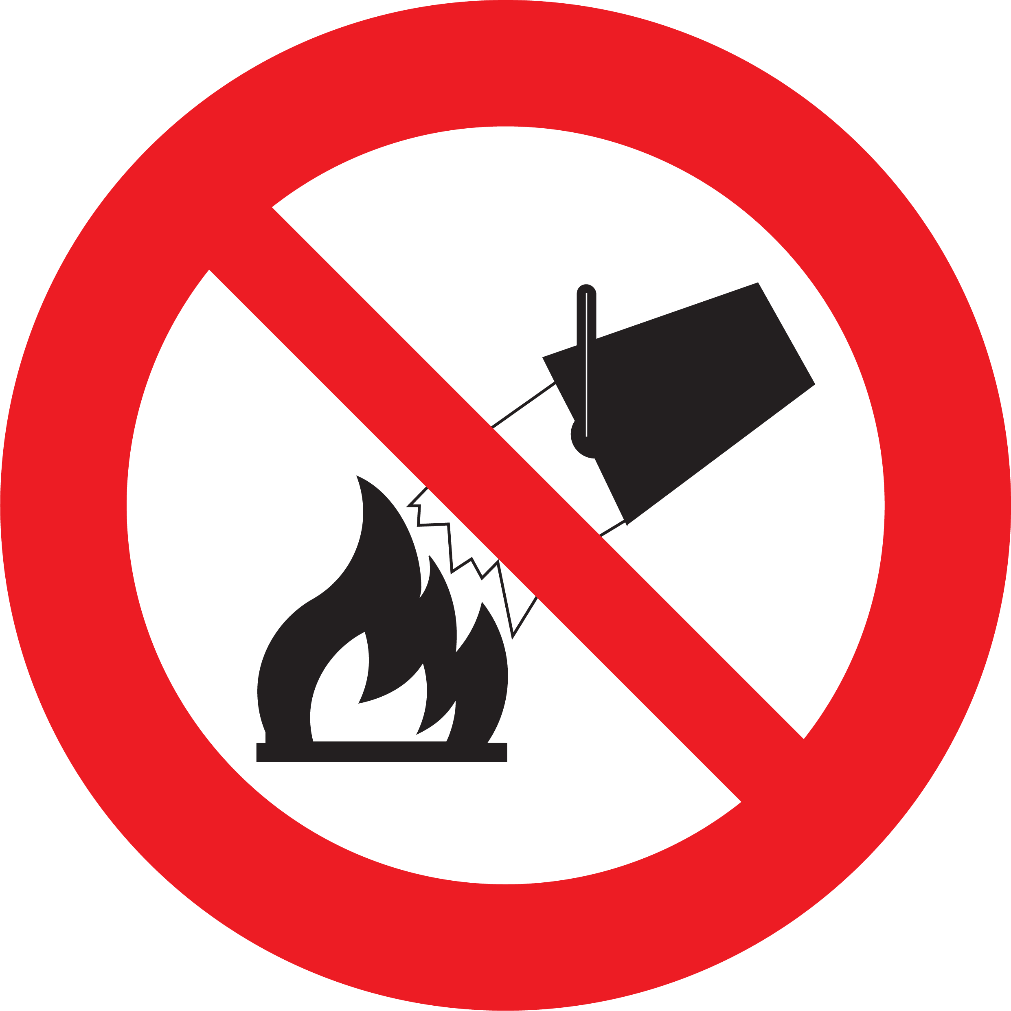 | 4D

5 | Contact with electricity | ✔ Use of electrical tools, equipment, or plant  ✔ Contact with cables, switchboards, or other electrical installations  ✔ Contact with amplifiers, dimmers, audio-visual equipment  ✔ Contact with electrical generators / portable power supplies | Use of power tools that may damage or cut through electrical wires.  Overloading power circuits, either tripping the circuit breaking or causing heat and/or fire.  Earth leakage issues could risk electric shock to people, and event reliability.  Poorly maintained equipment could pose a serious risk of electric shock.  Loose or badly run cabling could pose a trip hazard destabilising connections, potentially causing arcing, short circuits, or electric shock.  Indoor rated equipment could be affected by rain or moisture if used outdoors. | 4A | - Electrical power is supplied via Venue power supply.  - Electrical power is supplied via Portable generators.  - Electrical power is supplied via 10amp GPO sockets.  - Electrical power is supplied via 32amp 3-phase distribution sockets.  - All final subcircuits supplied must have 30mA RCD with a rating of less than 32a. This RCD must be available for inspection.  - Any outdoor electrical connections (temporary or permanent) must be housed within waterproof enclosures (IP65 or above).  - Electrical safety test tags in use as per AS/NZS 3760, and [Event Organiser.Company] policy & procedures.  - [Event Organiser.Company] Crew to carry out visual inspections on all electrical equipment & infrastructure managed by [Event Organiser.Company] prior to energising any electrical cables and equipment. Any failed inspections to be tagged & removed from service.  - [Event Organiser.Company] Crew to carry out visual inspections on all electrical equipment & infrastructure managed by the venue prior to energising any electrical cables and equipment. Any failed inspections to be reported to the venue immediately, and tagged where possible.  - [Event Organiser.Company] Crew to run all cabling safely and neatly. Regular inspections for any loose connections to be done pre-event and during the event if any activity warrants this need.  - [Event Organiser.Company] Toolbox talk should identify any unusual or unexpected electrical hazards. | 4D

5 | Contact with electricity | ✕ Use of electrical tools, equipment, or plant  ✕ Contact with cables, switchboards, or other electrical installations  ✕ Contact with amplifiers, dimmers, audio-visual equipment  ✕ Contact with electrical generators / portable power supplies | Use of power tools that may damage or cut through electrical wires.  Overloading power circuits, either tripping the circuit breaking or causing heat and/or fire.  Earth leakage issues could risk electric shock to people, and event reliability.  Poorly maintained equipment could pose a serious risk of electric shock.  Loose or badly run cabling could pose a trip hazard destabilising connections, potentially causing arcing, short circuits, or electric shock.  Indoor rated equipment could be affected by rain or moisture if used outdoors. | 4A | - Electrical power is supplied via Venue power supply.  - Electrical power is supplied via Portable generators.  - Electrical power is supplied via 10amp GPO sockets.  - Electrical power is supplied via 32amp 3-phase distribution sockets.  - All final subcircuits supplied must have 30mA RCD with a rating of less than 32a. This RCD must be available for inspection.  - Any outdoor electrical connections (temporary or permanent) must be housed within waterproof enclosures (IP65 or above).  - Electrical safety test tags in use as per AS/NZS 3760, and [Event Organiser.Company] policy & procedures.  - [Event Organiser.Company] Crew to carry out visual inspections on all electrical equipment & infrastructure managed by [Event Organiser.Company] prior to energising any electrical cables and equipment. Any failed inspections to be tagged & removed from service.  - [Event Organiser.Company] Crew to carry out visual inspections on all electrical equipment & infrastructure managed by the venue prior to energising any electrical cables and equipment. Any failed inspections to be reported to the venue immediately, and tagged where possible.  - [Event Organiser.Company] Crew to run all cabling safely and neatly. Regular inspections for any loose connections to be done pre-event and during the event if any activity warrants this need.  - [Event Organiser.Company] Toolbox talk should identify any unusual or unexpected electrical hazards. | 4E

6 | Exposure to Noise  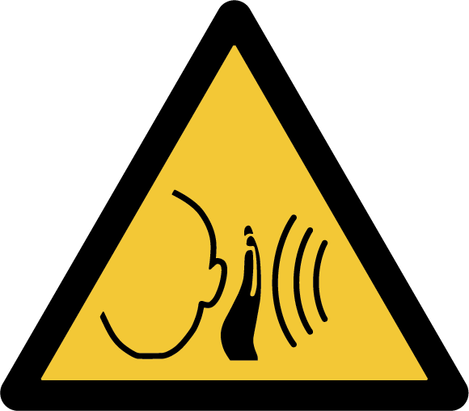 | ✔ Exposure to a noisy environment  ✔ Exposure to noisy plant or equipment  ✕ Exposure to Live entertainment  ✕ Exposure to noisy pyrotechnics, fireworks, firearms, or other explosives  ✕ Exposure to unmonitored unwanted noise | Excessive sudden loud noise or continuous noise over time.  Loud noises from adjacent plant / EWPs / vehicles.  Live entertainment may be challenging to control stage volume and overall room volume.  Conversation may be strained between attendees during the event.  Communication to attendees may be hindered in the event of an emergency.  Audio is direct to a broadcast stream, and may be unmonitored for unwanted loud noise. | 3B | - Verbal warnings given in the area prior to system PA tuning and test.  - Peak noise levels no greater than 140 decibels at any time during the day.  - An average exposure level of 85 decibels over an eight-hour period.  - Noise attenuating earplugs to be supplied and used by affected crew if necessary. Noise reducing Earmuffs may be supplied if noise is identified to be excessive.  - [Event Organiser.Company] Crew will leave the affected area during any extended periods of noisy work from plant and/or equipment  - [Event Organiser.Company] Operator will be monitoring the audio levels, as well as visually observing the attendees for any signs of discomfort, to ensure sound levels are suitable, balanced, and no unwanted noise exists.  - [Event Organiser.Company] Operator will be on standby at all times to provide a VOG (Voice of God) microphone for any urgent announcements, while turning down all other sound under their control.  - [Event Organiser.Company] Operator will be monitoring any broadcast stream, to ensure sound levels are suitable, balanced, and no unwanted noise exists.  - www.safework.nsw.gov.au/health-and-safety/safety-topics-a-z/noise-at-work  - clauses 56 – 59 of the NSW Work Health and Safety Regulation 2011  - Safework NSW Dec 2011 Code of Practice Managing Noise and Preventing Hearing Loss at Work  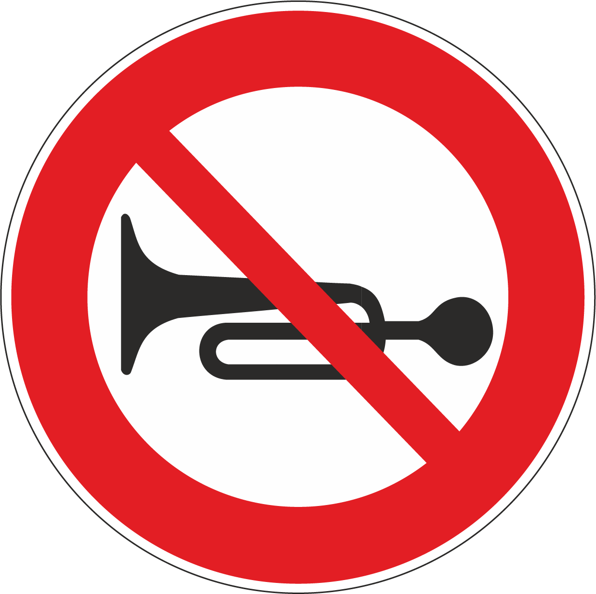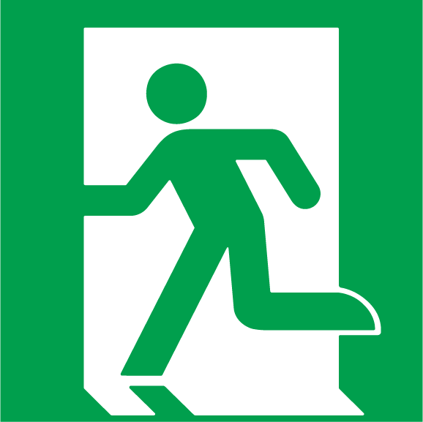 | 3D

6 | Exposure to Noise | ✔ Exposure to a noisy environment  ✔ Exposure to noisy plant or equipment  ✔ Exposure to Live entertainment  ✔ Exposure to noisy pyrotechnics, fireworks, firearms, or other explosives  ✔ Exposure to unmonitored unwanted noise | Excessive sudden loud noise or continuous noise over time.  Loud noises from adjacent plant / EWPs / vehicles.  Live entertainment may be challenging to control stage volume and overall room volume.  Conversation may be strained between attendees during the event.  Communication to attendees may be hindered in the event of an emergency.  Audio is direct to a broadcast stream, and may be unmonitored for unwanted loud noise. | 3B | - Verbal warnings given in the area prior to system PA tuning and test.  - Peak noise levels no greater than 140 decibels at any time during the day.  - An average exposure level of 85 decibels over an eight-hour period.  - Noise attenuating earplugs to be supplied and used by affected crew if necessary. Noise reducing Earmuffs may be supplied if noise is identified to be excessive.  - [Event Organiser.Company] Crew will leave the affected area during any extended periods of noisy work from plant and/or equipment  - [Event Organiser.Company] Operator will be monitoring the audio levels, as well as visually observing the attendees for any signs of discomfort, to ensure sound levels are suitable, balanced, and no unwanted noise exists.  - [Event Organiser.Company] Operator will be on standby at all times to provide a VOG (Voice of God) microphone for any urgent announcements, while turning down all other sound under their control.  - [Event Organiser.Company] Operator will be monitoring any broadcast stream, to ensure sound levels are suitable, balanced, and no unwanted noise exists.  - www.safework.nsw.gov.au/health-and-safety/safety-topics-a-z/noise-at-work  - clauses 56 – 59 of the NSW Work Health and Safety Regulation 2011  - Safework NSW Dec 2011 Code of Practice Managing Noise and Preventing Hearing Loss at Work | 3C

6 | Exposure to Noise | ✕ Exposure to a noisy environment  ✕ Exposure to noisy plant or equipment  ✕ Exposure to Live entertainment  ✕ Exposure to noisy pyrotechnics, fireworks, firearms, or other explosives  ✕ Exposure to unmonitored unwanted noise | Excessive sudden loud noise or continuous noise over time.  Loud noises from adjacent plant / EWPs / vehicles.  Live entertainment may be challenging to control stage volume and overall room volume.  Conversation may be strained between attendees during the event.  Communication to attendees may be hindered in the event of an emergency.  Audio is direct to a broadcast stream, and may be unmonitored for unwanted loud noise. | 3B | - Verbal warnings given in the area prior to system PA tuning and test.  - Peak noise levels no greater than 140 decibels at any time during the day.  - An average exposure level of 85 decibels over an eight-hour period.  - Noise attenuating earplugs to be supplied and used by affected crew if necessary. Noise reducing Earmuffs may be supplied if noise is identified to be excessive.  - [Event Organiser.Company] Crew will leave the affected area during any extended periods of noisy work from plant and/or equipment  - [Event Organiser.Company] Operator will be monitoring the audio levels, as well as visually observing the attendees for any signs of discomfort, to ensure sound levels are suitable, balanced, and no unwanted noise exists.  - [Event Organiser.Company] Operator will be on standby at all times to provide a VOG (Voice of God) microphone for any urgent announcements, while turning down all other sound under their control.  - [Event Organiser.Company] Operator will be monitoring any broadcast stream, to ensure sound levels are suitable, balanced, and no unwanted noise exists.  - www.safework.nsw.gov.au/health-and-safety/safety-topics-a-z/noise-at-work  - clauses 56 – 59 of the NSW Work Health and Safety Regulation 2011  - Safework NSW Dec 2011 Code of Practice Managing Noise and Preventing Hearing Loss at Work | 3E

7 | Contact with High Pressure  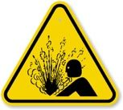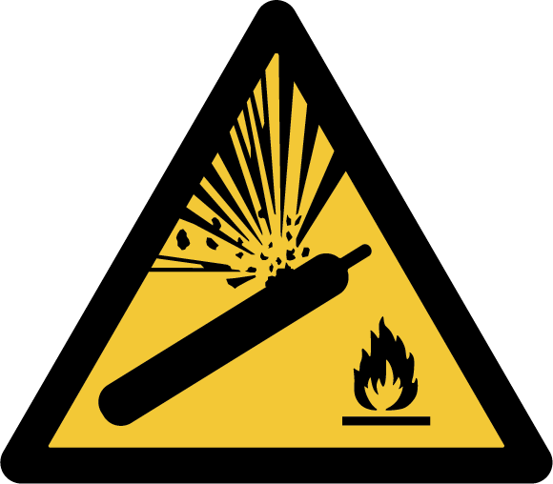 | ✔ Inflation of Balloons or other inflatables  ✔ Confetti or flutter canon (or other special effects) using compressed air via portable cylinders | Incorrect use of compressed air cylinders, causing bodily harm  Incorrect triggering of Confetti or flutter canon (or other special effects) | 3B | - Specialist trained suppliers are contracted to provide these services, with independent WHS documentation.  - All activity involving pressurised storage to be in accordance with specialist suppliers’ procedures & prior Venue approval & supervision  - Wearing of Safety Glasses and other PPE  - Any triggering of special effects to be tested and rehearsed beforehand   | 3D

7 | Contact with High Pressure | ✕ Inflation of Balloons or other inflatables  ✕ Confetti or flutter canon (or other special effects) using compressed air via portable cylinders | Incorrect use of compressed air cylinders, causing bodily harm  Incorrect triggering of Confetti or flutter canon (or other special effects) | 3C | - Specialist trained suppliers are contracted to provide these services, with independent WHS documentation.  - All activity involving pressurised storage to be in accordance with specialist suppliers’ procedures & prior Venue approval & supervision  - Wearing of Safety Glasses and other PPE  - Any triggering of special effects to be tested and rehearsed beforehand | 3E

8 | Contact with Chemicals    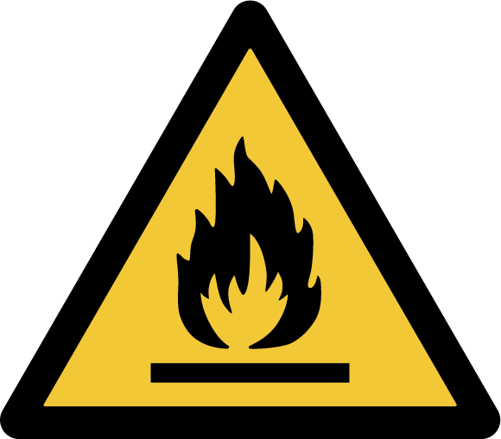 | ✔ Use, handling, storage, or disposal of chemicals  ✔ Risk of chemical reactions  ✔ Exposure to inhaled fumes or skin contact  ✕ Exposure to hazardous building materials | Spilled chemicals causing damage or harm to others  Accidental skin contact with chemicals  Potential asphyxiating reaction from people in proximity to the theatrical hazer  Potential presence of Asbestos at the site  Potential presence of Lead Paint at the site | 3C | - Glues, paints, thinners, cleaners, and lubricants are carried in all [Event Organiser.Company] Production Packers  - All chemicals carried in [Event Organiser.Company] Production Packers have matching MSDS (Material Safety Data Sheets) from the product manufacturer, which have been checked before deployment  - Haze fluid is non-toxic and approved for general stage use. Stored under manufacturer’s instructions and industry standards  - [Event Organiser.Company] Crew should avoid unnecessary contact with unknown surfaces, materials, including walls, doors, etc.  - [Event Organiser.Company] will adhere to all signage indicating Danger of hazardous materials or other hazards | 3E

8 | Contact with Chemicals | ✔ Use, handling, storage, or disposal of chemicals  ✔ Risk of chemical reactions  ✔ Exposure to inhaled fumes or skin contact  ✔ Exposure to hazardous building materials | Spilled chemicals causing damage or harm to others  Accidental skin contact with chemicals  Potential asphyxiating reaction from people in proximity to the theatrical hazer  Potential presence of Asbestos at the site  Potential presence of Lead Paint at the site | 3B | - Glues, paints, thinners, cleaners, and lubricants are carried in all [Event Organiser.Company] Production Packers  - All chemicals carried in [Event Organiser.Company] Production Packers have matching SDS (Safety Data Sheets) from the product manufacturer, which have been checked before deployment  - Haze fluid is non-toxic and approved for general stage use. Stored under manufacturer’s instructions and industry standards  - [Event Organiser.Company] Crew should avoid unnecessary contact with unknown surfaces, materials, including walls, doors, etc.  - [Event Organiser.Company] will adhere to all signage indicating Danger of hazardous materials or other hazards | 3D

8 | Contact with Chemicals | ✕ Use, handling, storage, or disposal of chemicals  ✕ Risk of chemical reactions  ✕ Exposure to inhaled fumes or skin contact  ✕ Exposure to hazardous building materials | Spilled chemicals causing damage or harm to others  Accidental skin contact with chemicals  Potential asphyxiating reaction from people in proximity to the theatrical hazer  Potential presence of Asbestos at the site  Potential presence of Lead Paint at the site | 3C | - Glues, paints, thinners, cleaners, and lubricants are carried in all [Event Organiser.Company] Production Packers  - All chemicals carried in [Event Organiser.Company] Production Packers have matching SDS (Safety Data Sheets) from the product manufacturer, which have been checked before deployment  - Haze fluid is non-toxic and approved for general stage use. Stored under manufacturer’s instructions and industry standards  - [Event Organiser.Company] Crew should avoid unnecessary contact with unknown surfaces, materials, including walls, doors, etc.  - [Event Organiser.Company] will adhere to all signage indicating Danger of hazardous materials or other hazards | 3E

9 | Contact with Radiation  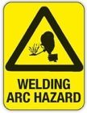 | ✔ Sun exposure  ✔ Exposure to lasers  ✔ Exposure to hot works | Staff may be exposed to UV radiation.  Barcode Scanners (non-laser) in use with the public  Any high-risk lasers used could cause damage to people or property  Any hot-work (such as 'Arc welding') could be hazardous to users and bystanders | 3C | - All [Event Organiser.Company] staff to be provided with suitably rated and approved sunscreen & are advised to bring hats as a precaution  - All work while outdoors is to be carried out with suitable skin / eye protection (PPE)  - Use of long-sleeved shirts during work outdoors if required  - The [Event Organiser.Company] staff toolbox talk is to highlight and reinforce the requirement for all PPE and preventative measures  - No direct laser exposure from scanning technology  - All commercial lasers (i.e. Special FX) are only to be operated by trained and certified personnel, and must be conducted according to a dedicated SWMS  - Any hot-works must be conducted according to a dedicated SWMS, in a space suitable for this purpose, and to be made inaccessible to non-authorised personnel during these works. The use of suitable and approved PPE (such as gloves, protective clothing, and safety glasses)   | 3E

9 | Contact with Radiation | ✕ Sun exposure  ✕ Exposure to lasers  ✕ Exposure to hot works | Staff may be exposed to UV radiation.  Barcode Scanners (non-laser) in use with the public  Any high-risk lasers used could cause damage to people or property  Any hot-work (such as 'Arc welding') could be hazardous to users and bystanders | 3C | - All [Event Organiser.Company] staff to be provided with suitably rated and approved sunscreen & are advised to bring hats as a precaution  - All work while outdoors is to be carried out with suitable skin / eye protection (PPE)  - Use of long-sleeved shirts during work outdoors if required  - The [Event Organiser.Company] staff toolbox talk is to highlight and reinforce the requirement for all PPE and preventative measures  - No direct laser exposure from scanning technology  - All commercial lasers (i.e. Special FX) are only to be operated by trained and certified personnel, and must be conducted according to a dedicated SWMS  - Any hot-works must be conducted according to a dedicated SWMS, in a space suitable for this purpose, and to be made inaccessible to non-authorised personnel during these works. The use of suitable and approved PPE (such as gloves, protective clothing, and safety glasses) | 3E

10 | Being struck against  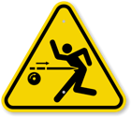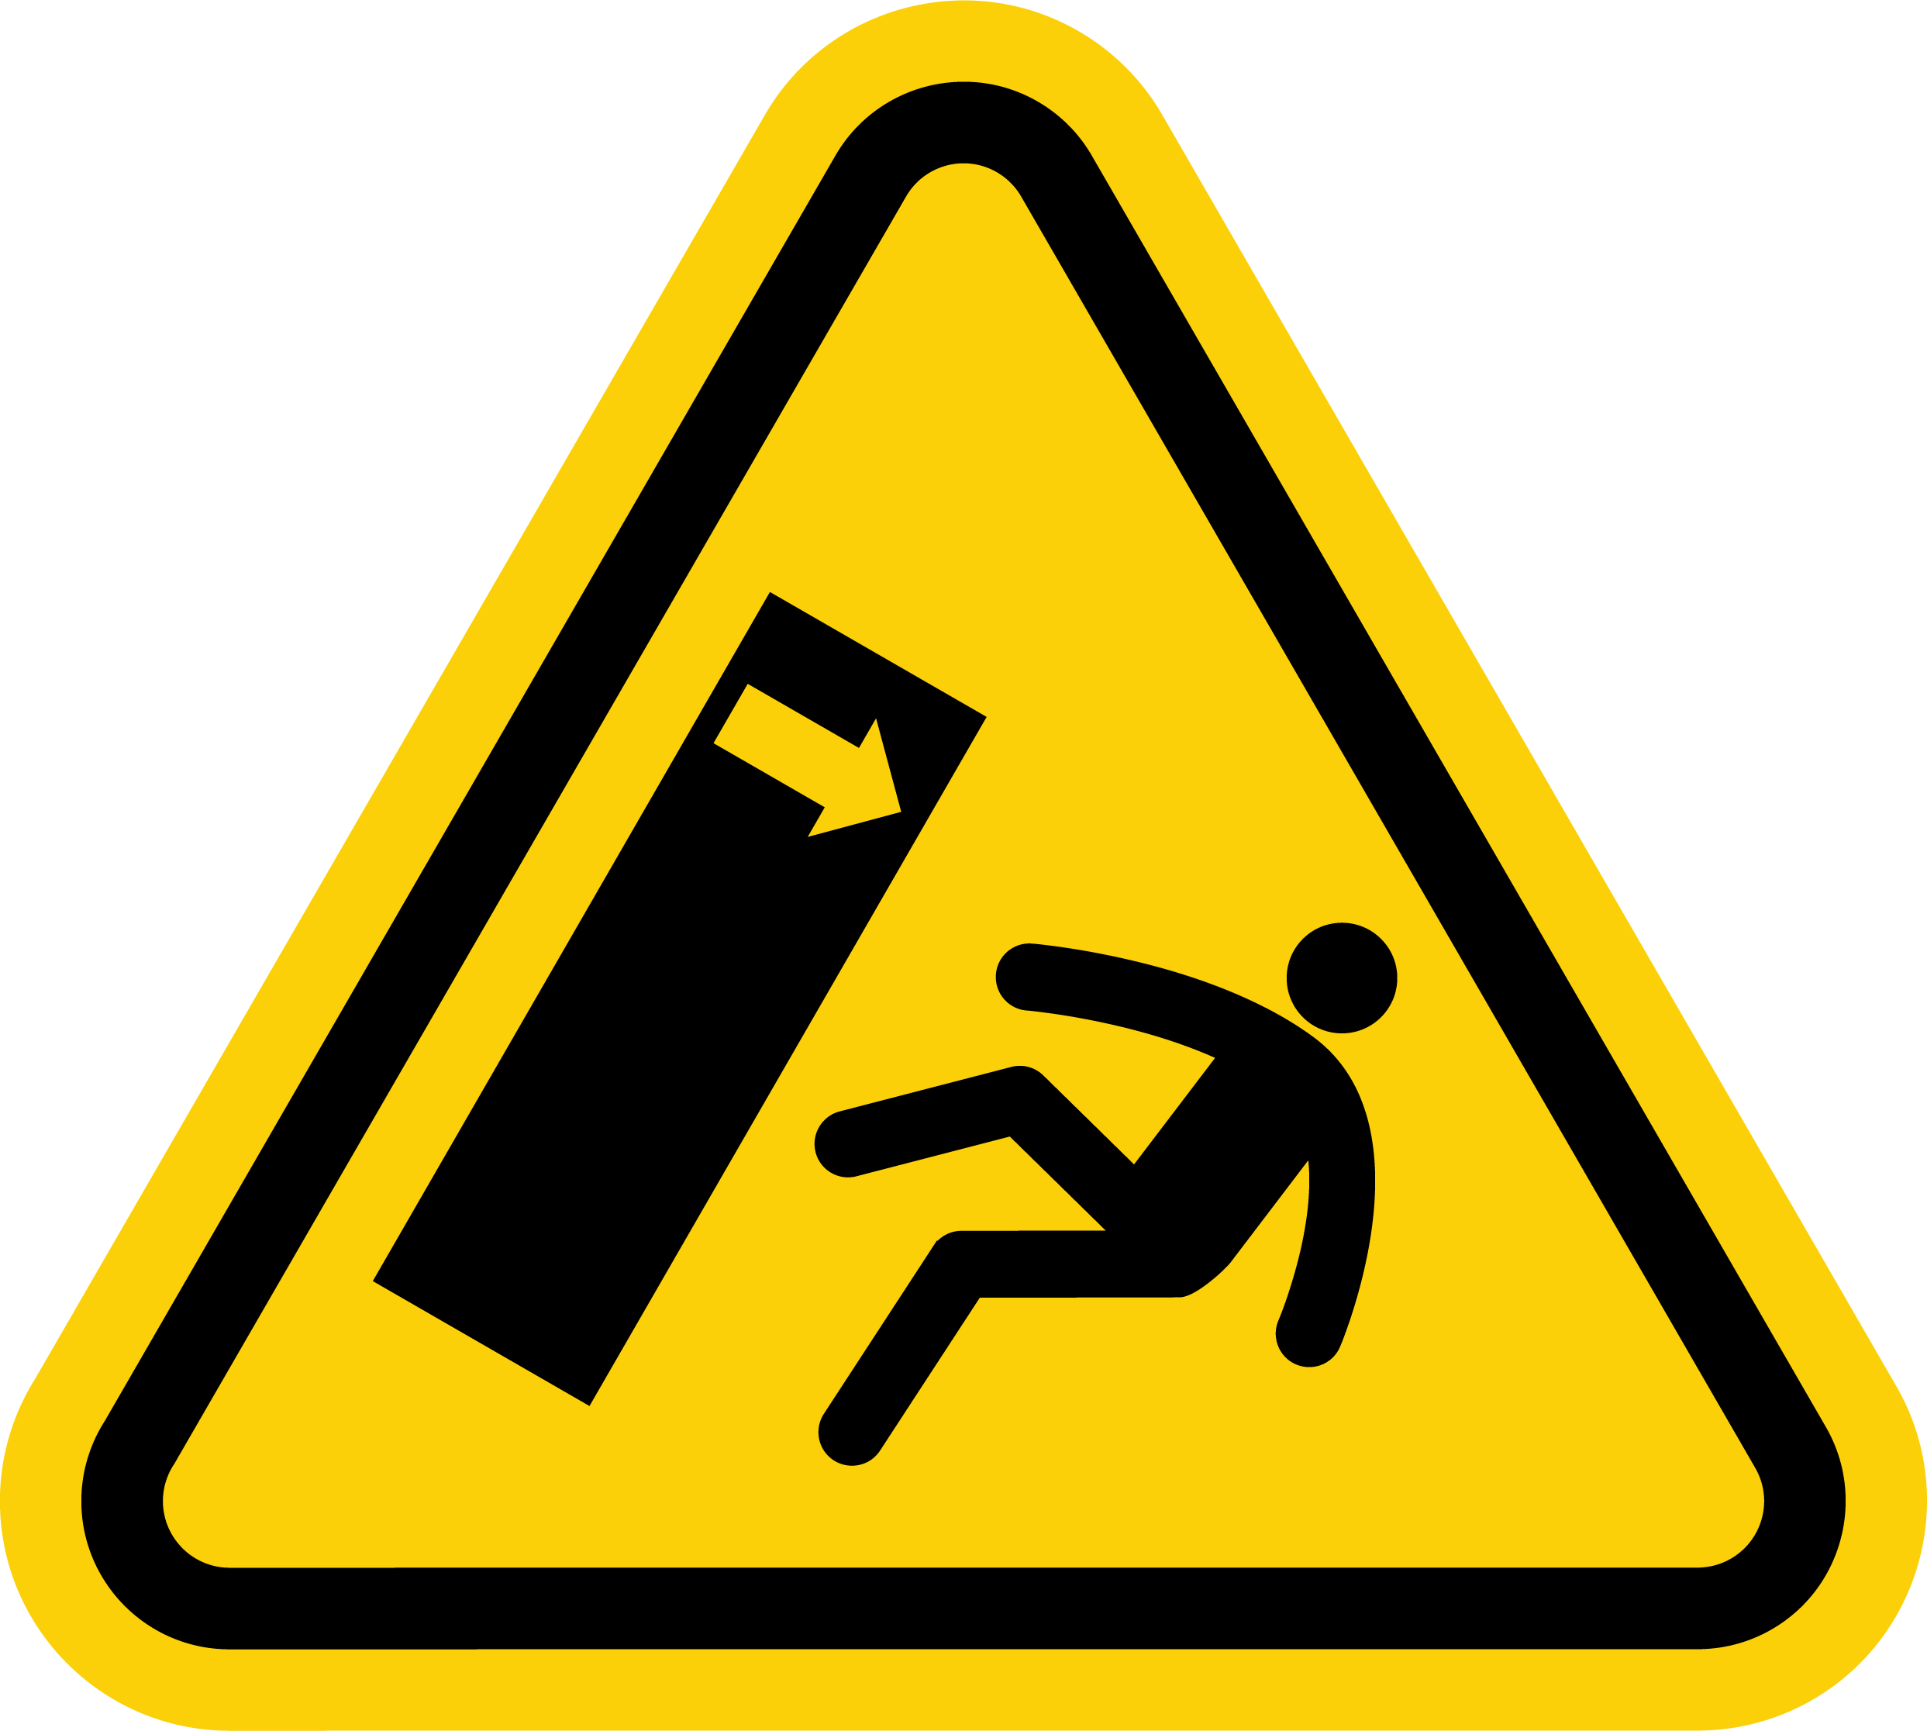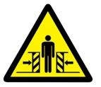 | ✔ Exposure to protruding objects  ✔ Heavy or unstable objects that may fall over  ✔ Cramped or confined workspaces | People inadvertently walk into free-standing technical elements that are temporary and not usually in those locations.  Temporary setup of free-standing technical elements that could fall if unstable.  Temporary setup of free-standing themed backdrop and/or other elements provided by other suppliers.  Floor space will be adequate as per prior Venue assessment and floorplan. | 3A | - Any floor equipment protruding into the audience area will indicated on CAD floor plans, be clearly visible and trip hazards visible with high-contrast tape or controlled via mats.  - Any floor equipment that poses a trip hazard to passers-by, is either highlighted with bright white or flourescent gaffa tape, or has a solid object installed between the hazard and any pedestrian traffic to create a natural barrier (i.e. a large potted plant / table), or other elements are removed to create bigger egress areas (i.e. removing chairs to create a wider passageway).  - All free-standing equipment will be of commercial quality and secured against movement. Free-standing items to be secured with weighted shot-bags to counter any tip hazard.  - All identified hazards will be reported to the [Event Organiser.Company] Crew leader and/or the [Event Organiser.Company] WHS Officer and/or the Security onsite, so those hazards can be addressed and control measures applied against them.  - AV Operator Desk / Registration Desk / Expo Booth positions are as per [Event Organiser.Company] standard and not confined in any way.  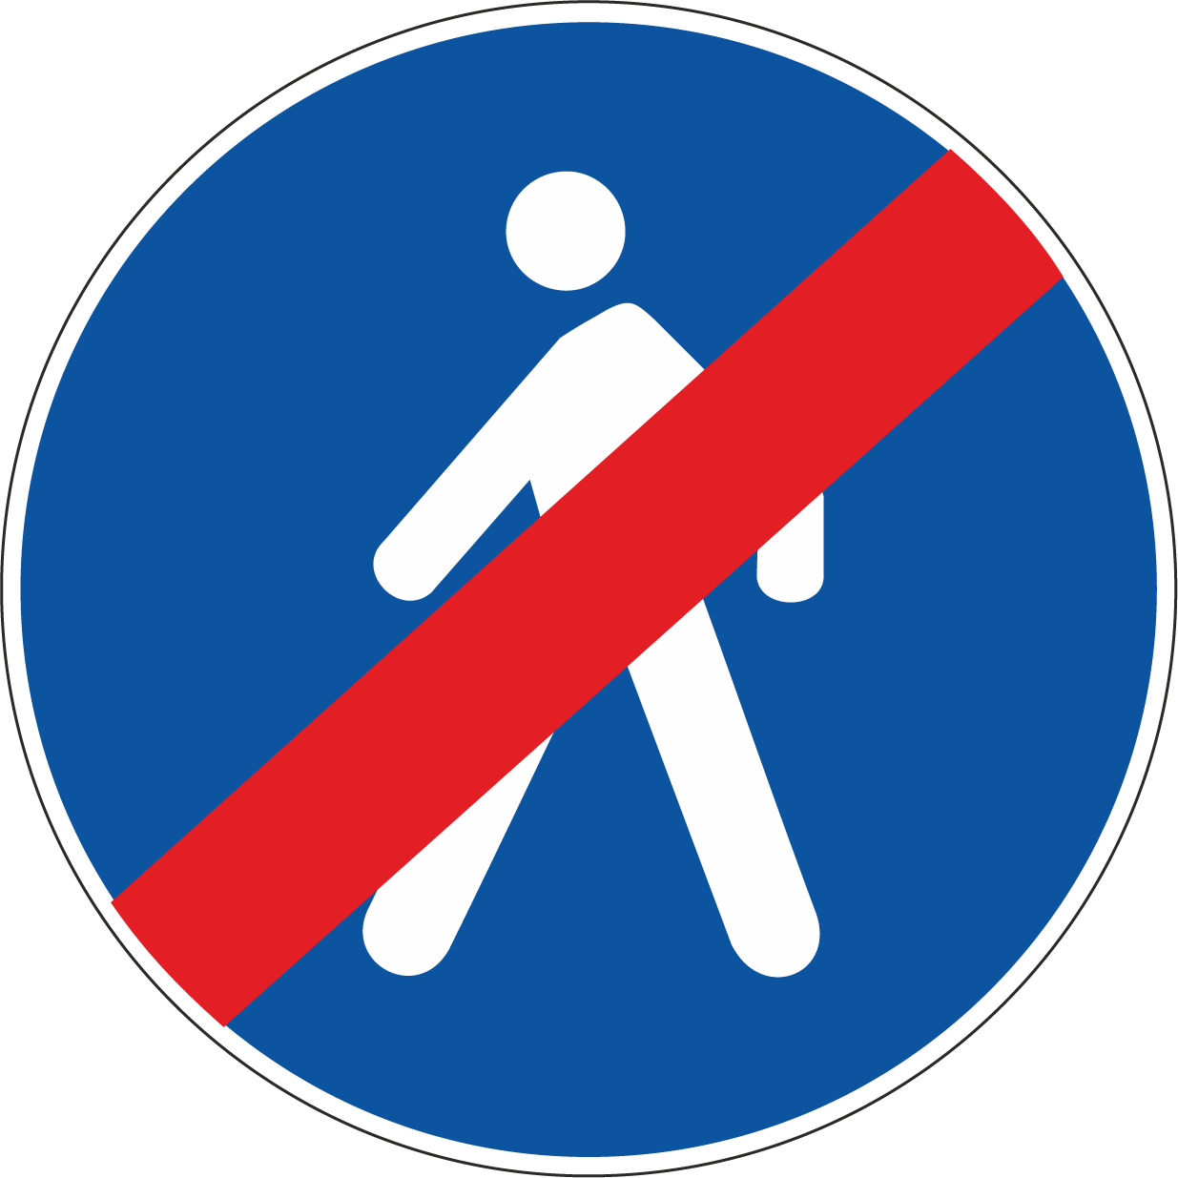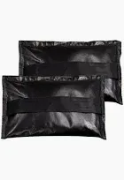 | 3C

10 | Being struck against | ✕ Exposure to protruding objects  ✕ Heavy or unstable objects that may fall over  ✕ Cramped or confined workspaces | People inadvertently walk into free-standing technical elements that are temporary and not usually in those locations.  Temporary setup of free-standing technical elements that could fall if unstable.  Temporary setup of free-standing themed backdrop and/or other elements provided by other suppliers.  Floor space will be adequate as per prior Venue assessment and floorplan. | 3A | - Any floor equipment protruding into the audience area will indicated on CAD floor plans, be clearly visible and trip hazards visible with high-contrast tape or controlled via mats.  - Any floor equipment that poses a trip hazard to passers-by, is either highlighted with bright white or flourescent gaffa tape, or has a solid object installed between the hazard and any pedestrian traffic to create a natural barrier (i.e. a large potted plant / table), or other elements are removed to create bigger egress areas (i.e. removing chairs to create a wider passageway).  - All free-standing equipment will be of commercial quality and secured against movement. Free-standing items to be secured with weighted shot-bags to counter any tip hazard.  - All identified hazards will be reported to the [Event Organiser.Company] Crew leader and/or the [Event Organiser.Company] WHS Officer and/or the Security onsite, so those hazards can be addressed and control measures applied against them.  - AV Operator Desk / Registration Desk / Expo Booth positions are as per [Event Organiser.Company] standard and not confined in any way. | 3E

11 | Being struck by an Object  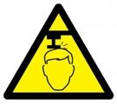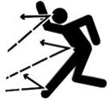 | ✔ Exposure to work or objects overhead  ✔ Exposure to flying objects  ✔ Exposure to moving fly/rigging bars | Untrained personnel working at height  Personnel are not aware of the correct safe steps when working at heights  Loose items, including hand tools, may be dropped from working at height, onto people or property below  Ladders could become unstable or fall over while in use  Elements rigged or suspended at height could fall  Incorrect operation of motorised truss or fly-bars | 4A | - Any working at heights is only to be conducted by trained and certified personnel, and must be conducted according to a dedicated SWMS & SafeWork NSW ladder guide (if applicable)  - [Event Organiser.Company] may require some access using either scissor lift or platform ladders.  - Exclusion zone enforced around overhead work as equipment is being installed and use of spotters to enforce  - Any hazardous overhead work performed on scissor lifts is covered by Venue & [Event Organiser.Company] specific Safe Work Method Statements (attached)  - Secondary means of support is in place (i.e. steel cable attached in case a bolt fails on a clamp.)  - Any necessary tools are secured before ascending any ladders / lifters  - Verbal 'call out', listen for responses AND visual check before the operation of any moving truss descending or ascending. Spotter in place if visual obstructions prevent operator from clear line of sight to the exclusion zone    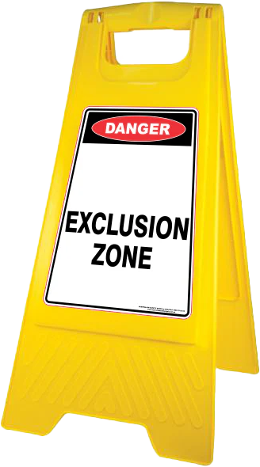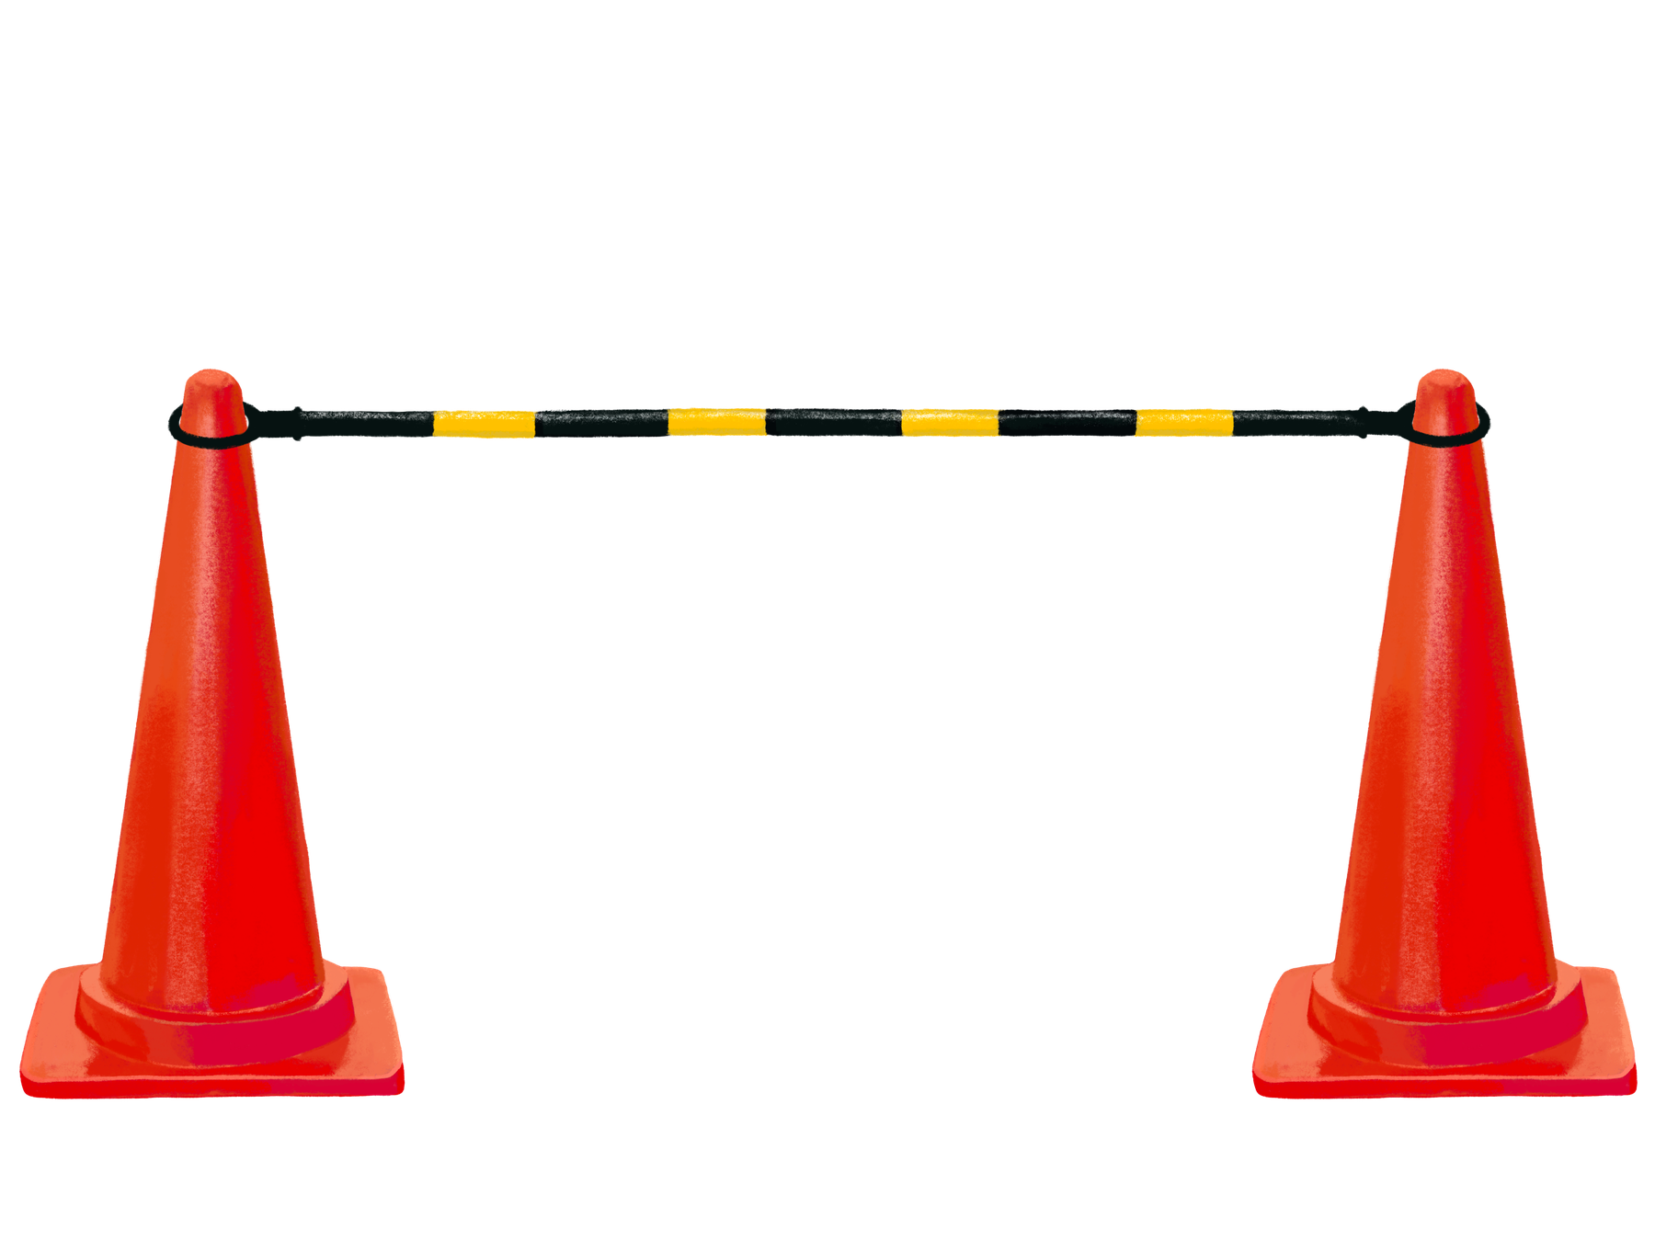 | 4C

11 | Being struck by an Object | ✕ Exposure to work or objects overhead  ✕ Exposure to flying objects  ✕ Exposure to moving fly/rigging bars | Untrained personnel working at height  Personnel are not aware of the correct safe steps when working at heights  Loose items, including hand tools, may be dropped from working at height, onto people or property below  Ladders could become unstable or fall over while in use  Elements rigged or suspended at height could fall  Incorrect operation of motorised truss or fly-bars | 4A | - Any working at heights is only to be conducted by trained and certified personnel, and must be conducted according to a dedicated SWMS & SafeWork NSW ladder guide (if applicable)  - [Event Organiser.Company] may require some access using either scissor lift or platform ladders.  - Exclusion zone enforced around overhead work as equipment is being installed and use of spotters to enforce  - Any hazardous overhead work performed on scissor lifts is covered by Venue & [Event Organiser.Company] specific Safe Work Method Statements (attached)  - Secondary means of support is in place (i.e. steel cable attached in case a bolt fails on a clamp.)  - Any necessary tools are secured before ascending any ladders / lifters  - Verbal 'call out', listen for responses AND visual check before the operation of any moving truss descending or ascending. Spotter in place if visual obstructions prevent operator from clear line of sight to the exclusion zone | 4E

12 | Fall from height / depth  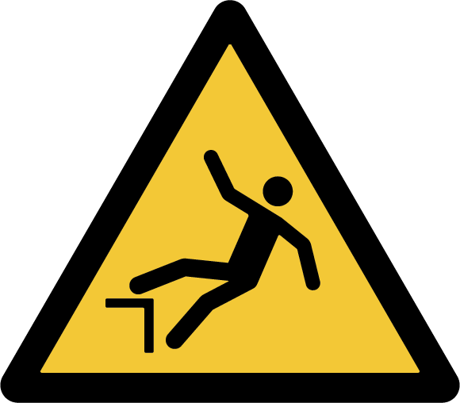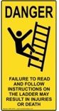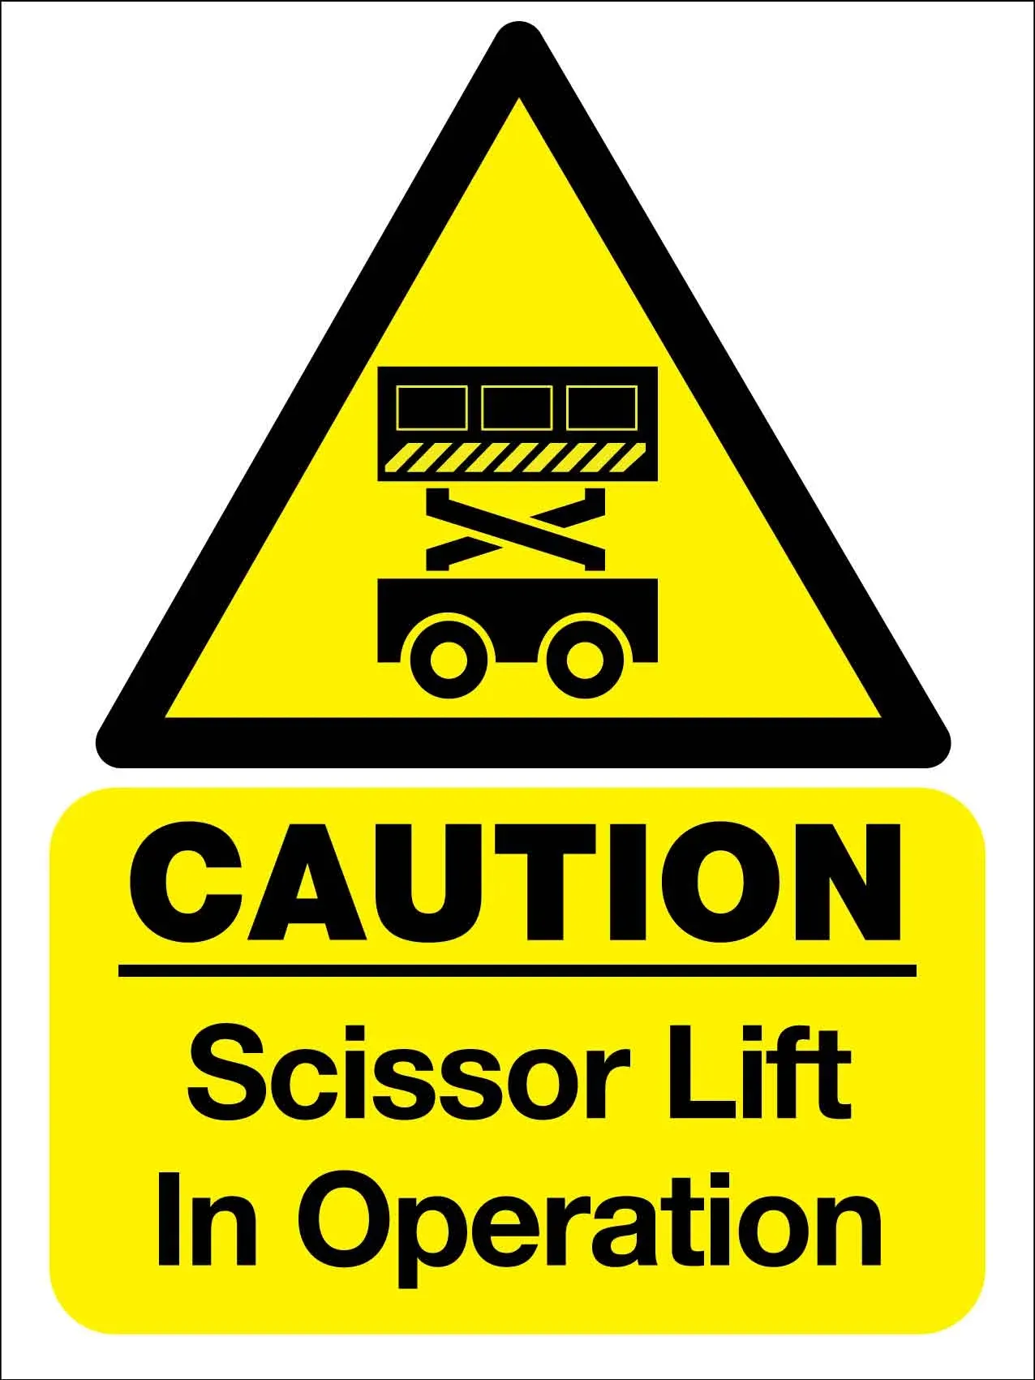 | ✔ Work performed at height or near an unprotected edge  ✔ Work performed at height or on raised platforms, without handrails, barriers, or other forms of protection  ✕ Work performed using a ladder  ✕ Work performed using an EWP  ✕ Work performed using a specialised hoist or lift | Falling from height, Unauthorised access to work area  Incorrect equipment setup, Tripping hazards  Ineffective safety system, Untrained personnel  Loose footing, Edge protection failure  Falling objects, Loss of balance  Falls, Uneven surfaces  Incorrect load rating, Overloading  Miscommunication, Equipment malfunction  Loose hardware, Inadequate fall protection  Tripping hazards, Equipment damage  Slips on wet surfaces, Tripping over debris  Information not shared, Inadequate documentation | 4A | - Any raised platforms / stages are to be set at a height under 1000mm, and are assessed as safe for this event  - Any equipment to be secured to permanent venue infrastructure is to be installed by trained staff.  - If using venue truss, descending this to ground level working height when possible  - Working at height is to be highlighted in the [Event Organiser.Company] Toolbox talk  - All Ladder operations will be conducted according to the SWMS, manufacturer's recommendations, SafeWork NSW best practise, plus any venue specific requirements. This includes conducting all safety checks.  - All EWP operations will be conducted according to the SWMS, manufacturer's recommendations, EWPA best practise, plus any venue specific requirements. This includes conducting all safety checks and completing logbooks.  - All EWP operations will be conducted by a trained operator inside the EWP, and will include a trained spotter outside the EWP on ground level. Both personnel will wear hi-vis PPE clothing, and must be able to have clear verbal communication.  - Any EWPs onsite that are not directly managed by [Event Organiser.Company] must be managed by an identified responsible party, and must comply with all requirements and regulations.  - Any accessible lift / hoist is fit for purpose, and supplied by a specialist supplier.  - If being used for access to a raised stage, then a dedicated stage manager, will conduct safety checks on the device before any person engages with or uses the device. A full rehearsal will be conducted with the users present. The device will be operated according to the manufacturer's recommendations.  - If being used for access to unload / load vehicles, then all staff operating the hoist must be properly trained in it's safe use, and are responsible for the safety of others in the vicinity of the hoist, both as passengers and/or bystanders.  - If any safety checks or tests do not pass, or are unable to be conducted for any reason, or if any person of authority is unsure about the safety or reliability of plant or device then that item should not be used and a replacement unit may be sourced.  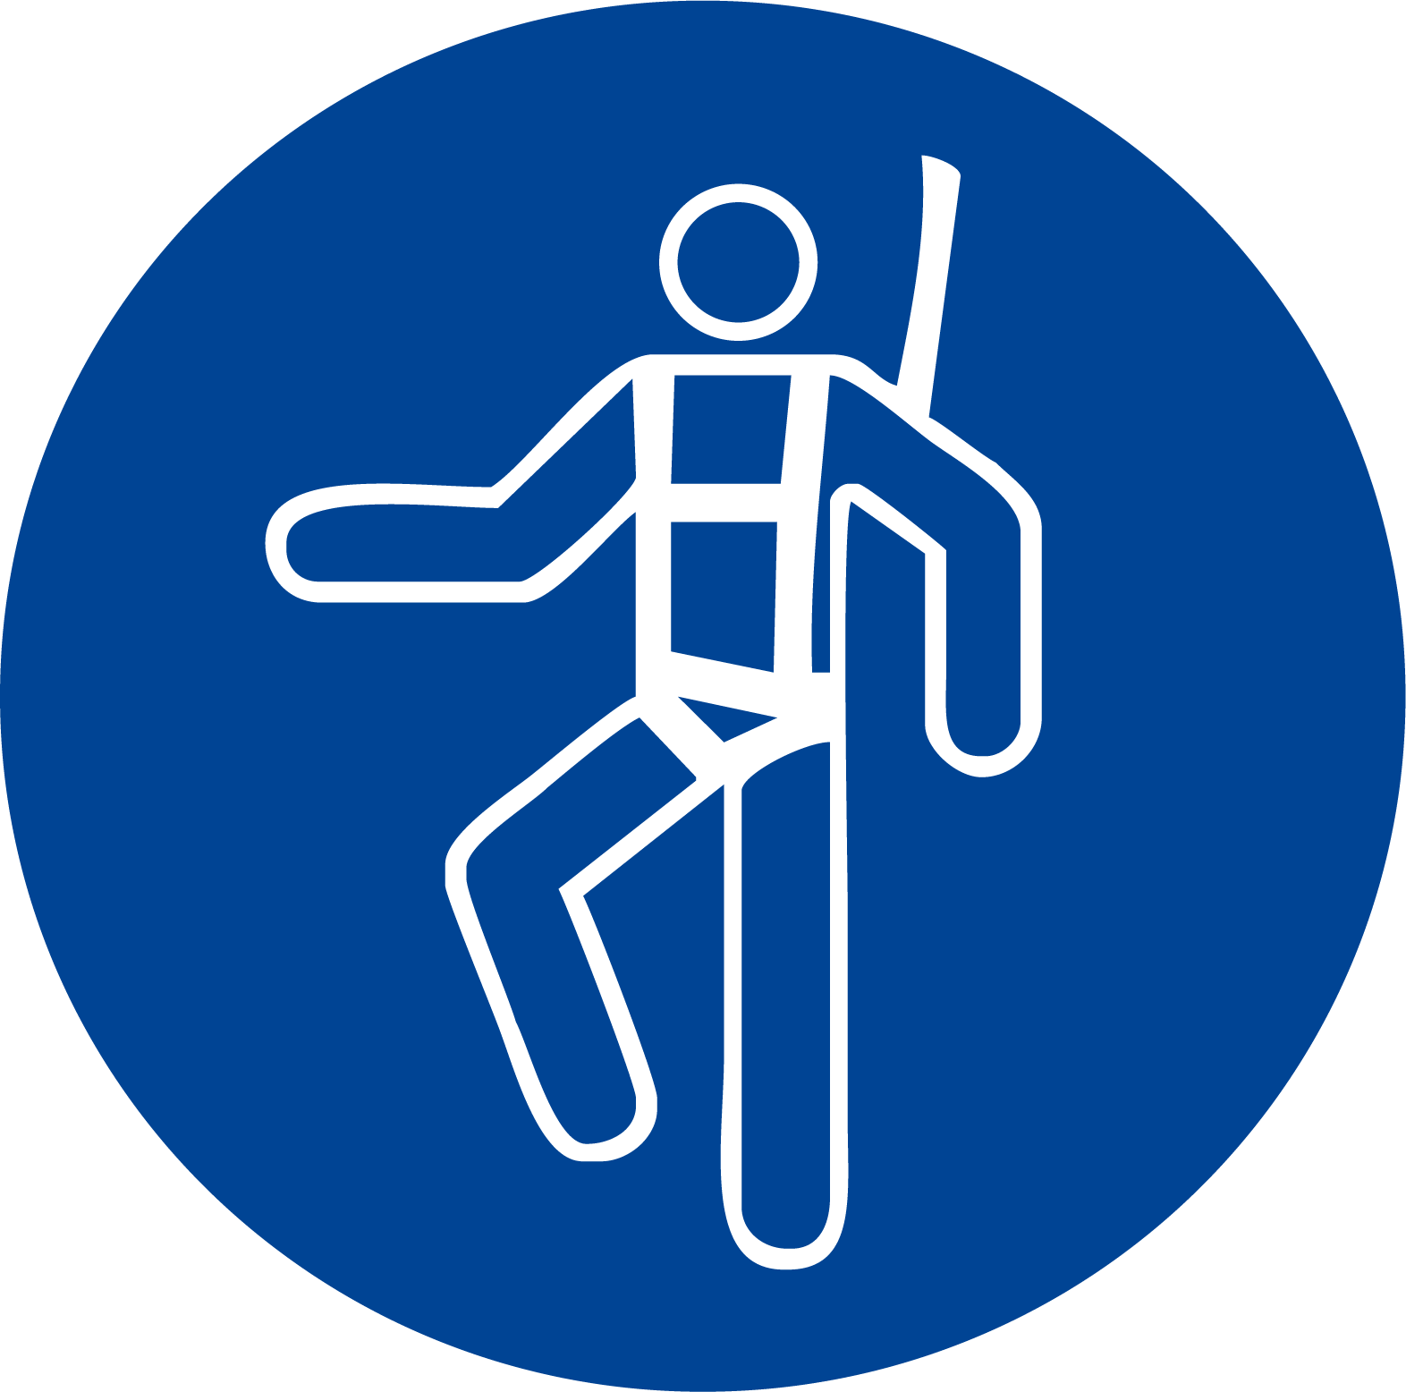 | 4C

12 | Fall from height / depth | ✔ Work performed at height or near an unprotected edge  ✔ Work performed at height or on raised platforms, without handrails, barriers, or other forms of protection  ✔ Work performed using a ladder  ✔ Work performed using an EWP  ✔ Work performed using a specialised hoist or lift | Falling from height, Unauthorised access to work area  Incorrect equipment setup, Tripping hazards  Ineffective safety system, Untrained personnel  Loose footing, Edge protection failure  Falling objects, Loss of balance  Falls, Uneven surfaces  Incorrect load rating, Overloading  Miscommunication, Equipment malfunction  Loose hardware, Inadequate fall protection  Tripping hazards, Equipment damage  Slips on wet surfaces, Tripping over debris  Information not shared, Inadequate documentation | 4A | - Any raised platforms / stages are to be set at a height under 1000mm, and are assessed as safe for this event  - Any equipment to be secured to permanent venue infrastructure is to be installed by trained staff.  - If using venue truss, descending this to ground level working height when possible  - Working at height is to be highlighted in the [Event Organiser.Company] Toolbox talk  - All Ladder operations will be conducted according to the SWMS, manufacturer's recommendations, SafeWork NSW best practise, plus any venue specific requirements. This includes conducting all safety checks.  - All EWP operations will be conducted according to the SWMS, manufacturer's recommendations, EWPA best practise, plus any venue specific requirements. This includes conducting all safety checks and completing logbooks.  - All EWP operations will be conducted by a trained operator inside the EWP, and will include a trained spotter outside the EWP on ground level. Both personnel will wear hi-vis PPE clothing, and must be able to have clear verbal communication.  - Any EWPs onsite that are not directly managed by [Event Organiser.Company] must be managed by an identified responsible party, and must comply with all requirements and regulations.  - Any accessible lift / hoist is fit for purpose, and supplied by a specialist supplier.  - If being used for access to a raised stage, then a dedicated stage manager, will conduct safety checks on the device before any person engages with or uses the device. A full rehearsal will be conducted with the users present. The device will be operated according to the manufacturer's recommendations.  - If being used for access to unload / load vehicles, then all staff operating the hoist must be properly trained in it's safe use, and are responsible for the safety of others in the vicinity of the hoist, both as passengers and/or bystanders.  - If any safety checks or tests do not pass, or are unable to be conducted for any reason, or if any person of authority is unsure about the safety or reliability of plant or device then that item should not be used and a replacement unit may be sourced. | 4C

12 | Fall from height / depth | ✕ Work performed at height or near an unprotected edge  ✕ Work performed at height or on raised platforms, without handrails, barriers, or other forms of protection  ✕ Work performed using a ladder  ✕ Work performed using an EWP  ✕ Work performed using a specialised hoist or lift | Falling from height, Unauthorised access to work area  Incorrect equipment setup, Tripping hazards  Ineffective safety system, Untrained personnel  Loose footing, Edge protection failure  Falling objects, Loss of balance  Falls, Uneven surfaces  Incorrect load rating, Overloading  Miscommunication, Equipment malfunction  Loose hardware, Inadequate fall protection  Tripping hazards, Equipment damage  Slips on wet surfaces, Tripping over debris  Information not shared, Inadequate documentation | 4A | - Any raised platforms / stages are to be set at a height under 1000mm, and are assessed as safe for this event  - Any equipment to be secured to permanent venue infrastructure is to be installed by trained staff.  - If using venue truss, descending this to ground level working height when possible  - Working at height is to be highlighted in the [Event Organiser.Company] Toolbox talk  - All Ladder operations will be conducted according to the SWMS, manufacturer's recommendations, SafeWork NSW best practise, plus any venue specific requirements. This includes conducting all safety checks.  - All EWP operations will be conducted according to the SWMS, manufacturer's recommendations, EWPA best practise, plus any venue specific requirements. This includes conducting all safety checks and completing logbooks.  - All EWP operations will be conducted by a trained operator inside the EWP, and will include a trained spotter outside the EWP on ground level. Both personnel will wear hi-vis PPE clothing, and must be able to have clear verbal communication.  - Any EWPs onsite that are not directly managed by [Event Organiser.Company] must be managed by an identified responsible party, and must comply with all requirements and regulations.  - Any accessible lift / hoist is fit for purpose, and supplied by a specialist supplier.  - If being used for access to a raised stage, then a dedicated stage manager, will conduct safety checks on the device before any person engages with or uses the device. A full rehearsal will be conducted with the users present. The device will be operated according to the manufacturer's recommendations.  - If being used for access to unload / load vehicles, then all staff operating the hoist must be properly trained in it's safe use, and are responsible for the safety of others in the vicinity of the hoist, both as passengers and/or bystanders.  - If any safety checks or tests do not pass, or are unable to be conducted for any reason, or if any person of authority is unsure about the safety or reliability of plant or device then that item should not be used and a replacement unit may be sourced. | 4E

13 | Slips and falls  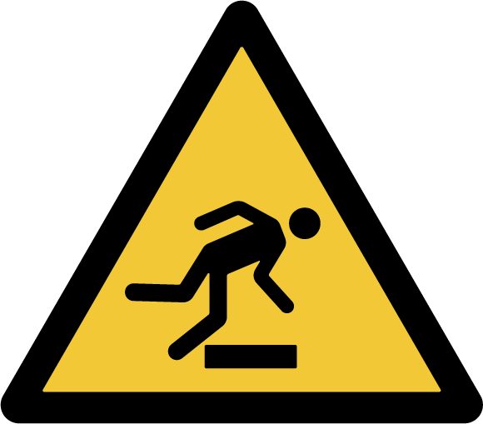 | ✔ Wet or slippery surfaces  ✔ Unstable or uneven surfaces | Hazardous slippery surface caused by liquid or oily spillage.  Hazardous slippery surface caused by residual water from wet shoes entering the venue. | 3C | - Indoor venue with no inherently hazardous floor surfaces.  - [Event Organiser.Company] Crew to avoid walking over any identified hazardous floor surfaces.  - Any unexpected spills or splashes to be controlled by venue maintenance team, with adequate signage.  - Appropriate work footwear to be worn by all [Event Organiser.Company] Crew  - Slip / Trip hazards to be promptly removed or reported to venue staff / security.  - Any food & drink consumed by [Event Organiser.Company] Crew is to be managed effectively, including cleaning up and disposing of all rubbish and liquids immediately. This avoids any accidental spillages from drinks, etc.  - Exclusion zones enacted where a slip hazard is identified, until that hazard no longer poses a threat.  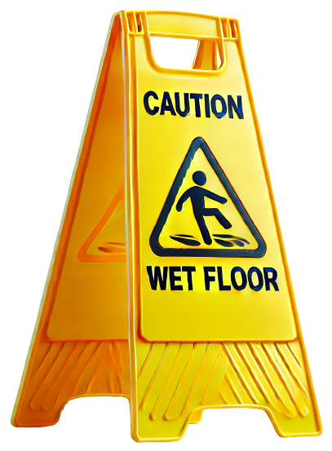 | 3D

13 | Slips and falls | ✕ Wet or slippery surfaces  ✕ Unstable or uneven surfaces | Hazardous slippery surface caused by liquid or oily spillage.  Hazardous slippery surface caused by residual water from wet shoes entering the venue. | 3C | - Indoor venue with no inherently hazardous floor surfaces.  - [Event Organiser.Company] Crew to avoid walking over any identified hazardous floor surfaces.  - Any unexpected spills or splashes to be controlled by venue maintenance team, with adequate signage.  - Appropriate work footwear to be worn by all [Event Organiser.Company] Crew  - Slip / Trip hazards to be promptly removed or reported to venue staff / security.  - Any food & drink consumed by [Event Organiser.Company] Crew is to be managed effectively, including cleaning up and disposing of all rubbish and liquids immediately. This avoids any accidental spillages from drinks, etc.  - Exclusion zones enacted where a slip hazard is identified, until that hazard no longer poses a threat. | 3E

14 | Caught between   | ✔ Exposure to moving vehicles, or moving parts on stationary vehicles  ✔ Exposure to moving plant (Forklift, Scissorlift, other EWP)  ✔ Moving materials, loads or equipment | Possible heavy vehicle traffic in loading dock due to other deliveries or other supplier movements.  Possible heavy vehicle traffic at street level loading access point due to public vehicular movement.  Use of scissor lifts (or other plant) may be required by venue staff or other third party suppliers onsite.  Potential to be struck by heavy items (in professional roadcases or on wheels) being moved around by AV1 or other suppliers onsite, during delivery, bump-in, bump-out, and collection. | 4A | - All vehicles to use a dedicated loading dock that is under security control.  - All [Event Organiser.Company] Crew to complete venue inductions, to be aware of any possible hazards on entry.  - Hi-Vis vests to be worn by all [Event Organiser.Company] Crew in loading dock and while scissor lifts are in operation.  - All [Event Organiser.Company] Crew to follow Scissor lift SWMS document (attached).  - All EWP operators must have valid EWPA Yellow-cards, and must complete the supplied EWPA logbook for every use.  - All EWP movements must have a dedicated spotter (in Hi-Vis and Steelcap footwear) to supervise and assist with any identified hazards.  - Any items on wheels should have have locks engaged when possible to avoid any accidental movement or rolling away.  - All [Event Organiser.Company] Crew to have appropriate training & certification before operating equipment.  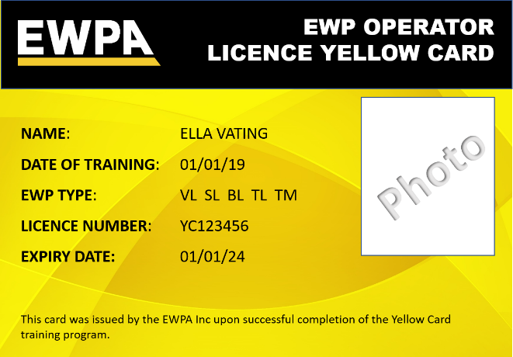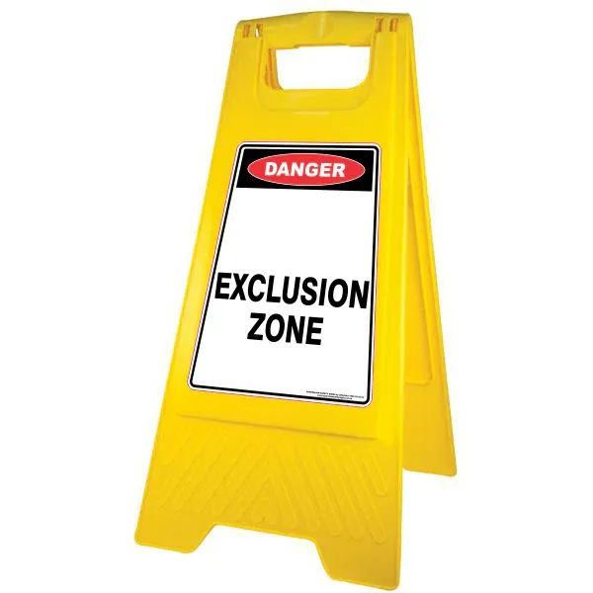 | 4C

14 | Caught between | ✕ Exposure to moving vehicles, or moving parts on stationary vehicles  ✕ Exposure to moving plant (Forklift, Scissorlift, other EWP)  ✕ Moving materials, loads or equipment | Possible heavy vehicle traffic in loading dock due to other deliveries or other supplier movements.  Possible heavy vehicle traffic at street level loading access point due to public vehicular movement.  Use of scissor lifts (or other plant) may be required by venue staff or other third party suppliers onsite.  Potential to be struck by heavy items (in professional roadcases or on wheels) being moved around by AV1 or other suppliers onsite, during delivery, bump-in, bump-out, and collection. | 4A | - All vehicles to use a dedicated loading dock that is under security control.  - All [Event Organiser.Company] Crew to complete venue inductions, to be aware of any possible hazards on entry.  - Hi-Vis vests to be worn by all [Event Organiser.Company] Crew in loading dock and while scissor lifts are in operation.  - All [Event Organiser.Company] Crew to follow Scissor lift SWMS document (attached).  - All EWP operators must have valid EWPA Yellow-cards, and must complete the supplied EWPA logbook for every use.  - All EWP movements must have a dedicated spotter (in Hi-Vis and Steelcap footwear) to supervise and assist with any identified hazards.  - Any items on wheels should have have locks engaged when possible to avoid any accidental movement or rolling away.  - All [Event Organiser.Company] Crew to have appropriate training & certification before operating equipment. | 4E

15 | Ergonomic hazards  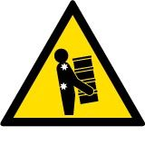 | ✔ Restricted or awkward work postures  ✔ Overreaching while holding heavy or awkward objects  ✔ Repetition of tasks or movements | Crew may be expected to adapt their body posture into unnatural or awkward positions in order to complete the setup or packdown.  Crew may be expected to adapt their body posture into unnatural or awkward positions in order to conduct their role (i.e. Operating AV equipment diuring the event).  AV Operators conducting repetitive tasks across a physically wide desk area while sitting in a static / fixed chair. | 2C | - [Event Organiser.Company] Crew to avoid any ergonomic hazards by requesting assistance from others to share the load, distribute any weight, or make manual tasks easier and safer.  - [Event Organiser.Company] Crew to utilise any ladders, platforms, or EWPs to provide easier and safer access instead of overreaching.  - Office-style 'Swivel' Chairs are to be provided by the venue for all technical operators to negate any potential postural hazards. In the absence of these being available onsite, then [Event Organiser.Company] will provide these.  - All AV operating positions are as per an agreed floorplan and do not require any unusual stretching or regular neck craning for the operators to view the subjects on stage / on displays.  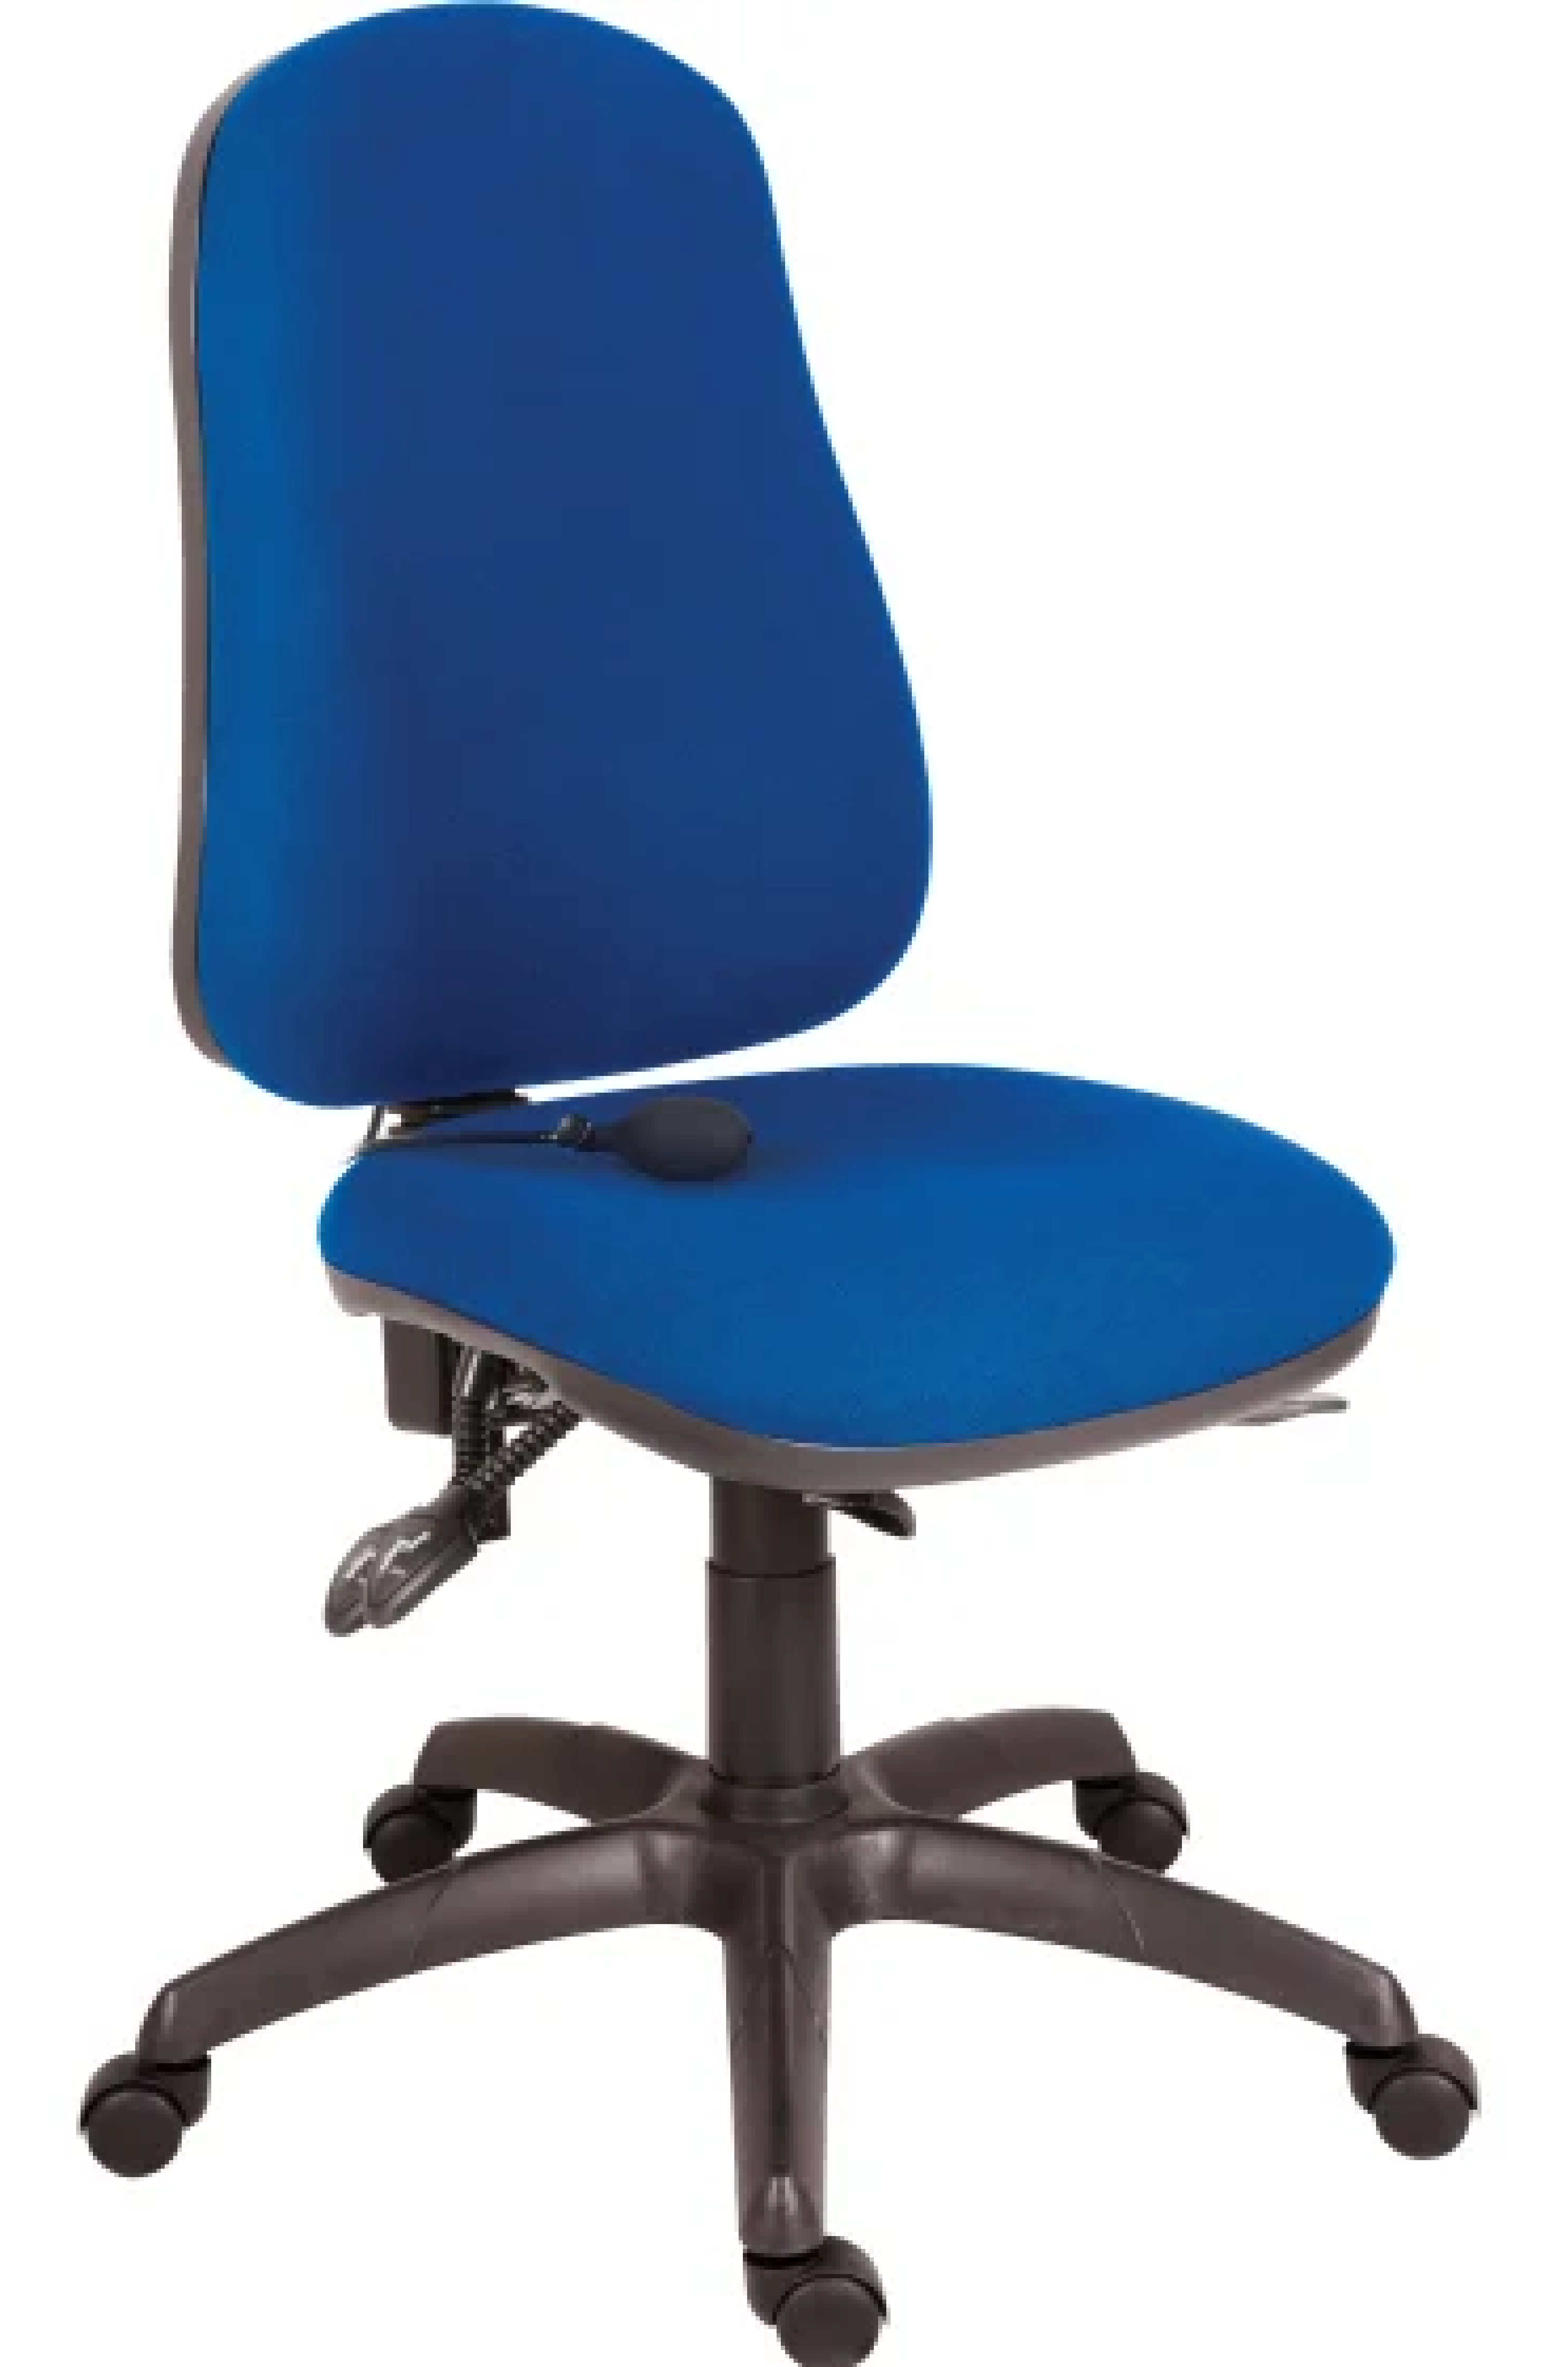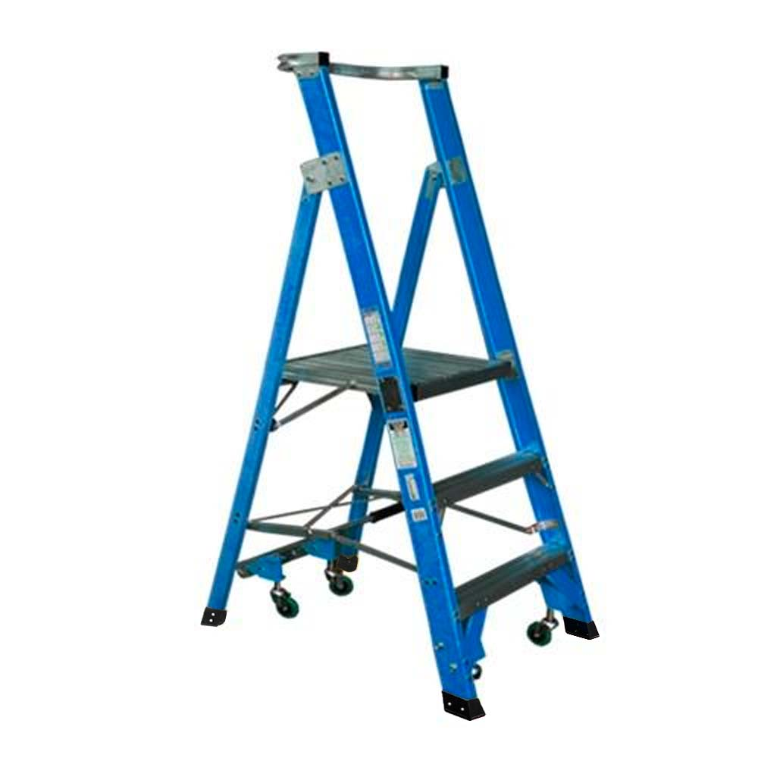 | 2D

15 | Ergonomic hazards | ✔ Restricted or awkward work postures  ✔ Overreaching while holding heavy or awkward objects  ✔ Repetition of tasks or movements | Crew may be expected to adapt their body posture into unnatural or awkward positions in order to complete the setup or packdown.  Crew may be expected to adapt their body posture into unnatural or awkward positions in order to conduct their role (i.e. Operating AV equipment diuring the event).  AV Operators conducting repetitive tasks across a physically wide desk area while sitting in a static / fixed chair. | 2C | - [Event Organiser.Company] Crew to avoid any ergonomic hazards by requesting assistance from others to share the load, distribute any weight, or make manual tasks easier and safer.  - [Event Organiser.Company] Crew to utilise any ladders, platforms, or EWPs to provide easier and safer access instead of overreaching.  - Office-style 'Swivel' Chairs are to be provided by the venue for all technical operators to negate any potential postural hazards. In the absence of these being available onsite, then [Event Organiser.Company] will provide these.  - All AV operating positions are as per an agreed floorplan and do not require any unusual stretching or regular neck craning for the operators to view the subjects on stage / on displays | 2E

16 | Biological hazards  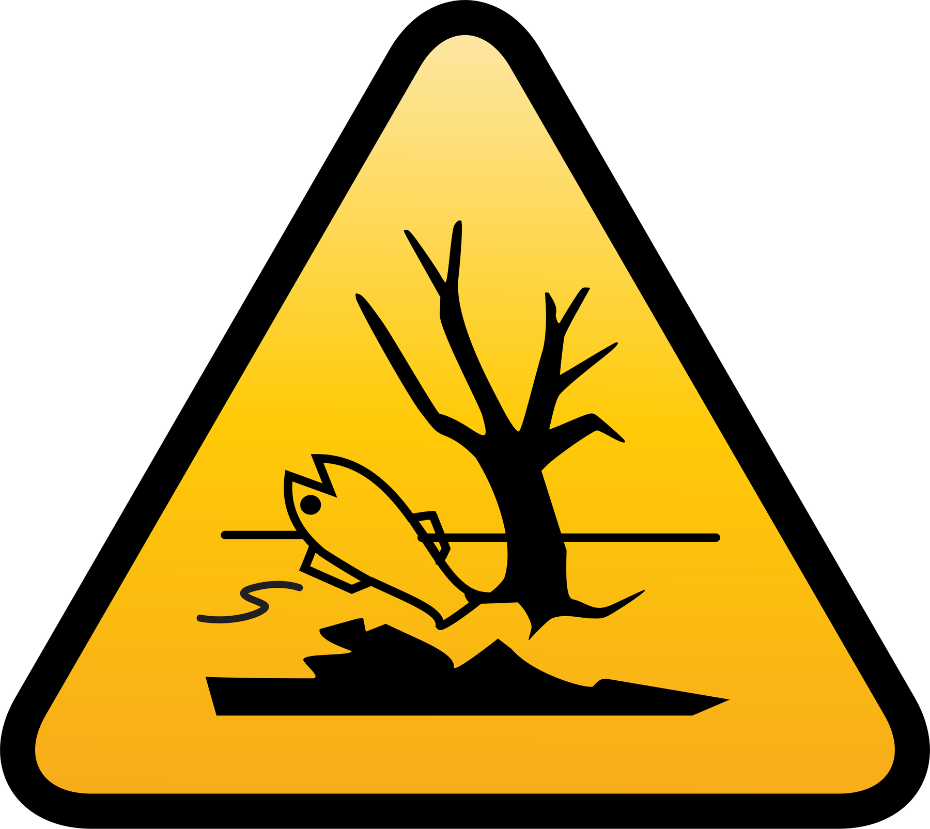 | ✔ Potential exposure to sharps, environmental or waste containments | Potential hazard of 'sharps' (used or clean) being encountered in either public or communal toilet facilities. | 3C | - All [Event Organiser.Company] staff have a minimum expectation to have access to regularly inspected and cleaned washroom / bathroom facilities onsite.  - Venue staff to pre-clean & regularly inspect all washroom and toilet facilities for any possible access to sharps & associated hazards.  - [Event Organiser.Company] Crew to alert Venue Security on discovery of any medical waste materials found. | 3E

16 | Biological hazards | ✕ Potential exposure to sharps, environmental or waste containments | Potential hazard of 'sharps' (used or clean) being encountered in either public or communal toilet facilities. | 3C | - All [Event Organiser.Company] staff have a minimum expectation to have access to regularly inspected and cleaned washroom / bathroom facilities onsite.  - Venue staff to pre-clean & regularly inspect all washroom and toilet facilities for any possible access to sharps & associated hazards.  - [Event Organiser.Company] Crew to alert Venue Security on discovery of any medical waste materials found. | 3E

17 | Confined space  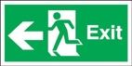 | ✔ Restricted means of entry or exit  ✔ Toxic atmosphere  ✔ Low levels of oxygen  ✔ Fire / Explosion hazards | People cannot locate a suitable exit to safety.  Working in an area that has a harmful level of containment.  Working in an area that does not have a safe level of oxygen or adequate ventilation.  Working in an area where a stored substance could cause engulfment. | 4A | - Adequate space and clearance for all work, including the required quantity of emergency exits to be kept clear based on the quantity of attendees, has been assessed on this site, and approved by the venue / site managers.  - Any physical exits that are restricted or covered or made inaccessible during this entire event (bump-in, operation, bump-out), will be made known to security & all fire wardens onsite, and alternative emergency procedures must be communicated and agreed with all parties onsite.  - Any permanent exit signage that is obstructed from general view will have temporary illuminated Exit signage installed for the entire duration of this event (bump-in, operation, bump-out).  - Alternative methods of egress to these exits may be created by openings in temporary drapes, walls, or flats.  - Additional manual ventilation (fans) will be installed if required to compensate for confined space or poor air quality.  - All [Event Organiser.Company] staff must wear suitable PPE respiratory masks in the event of any harmful levels of containment.  - Any stored substances that have any potential to ignite or fuel a fire must be removed from any identified confined space.  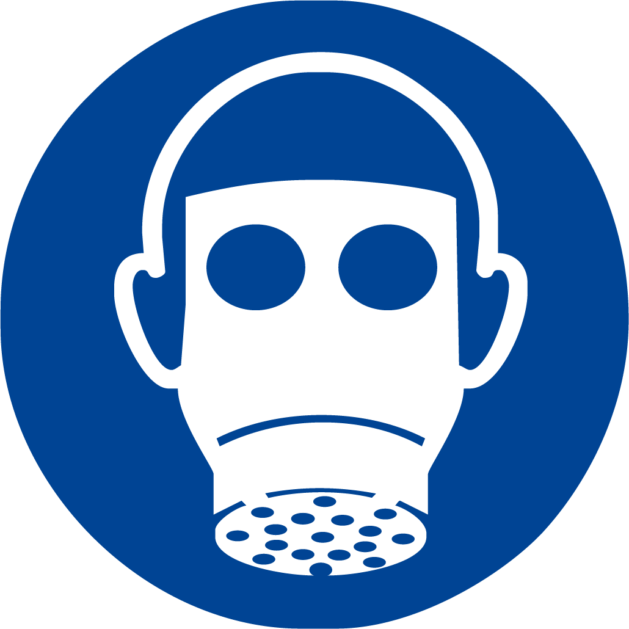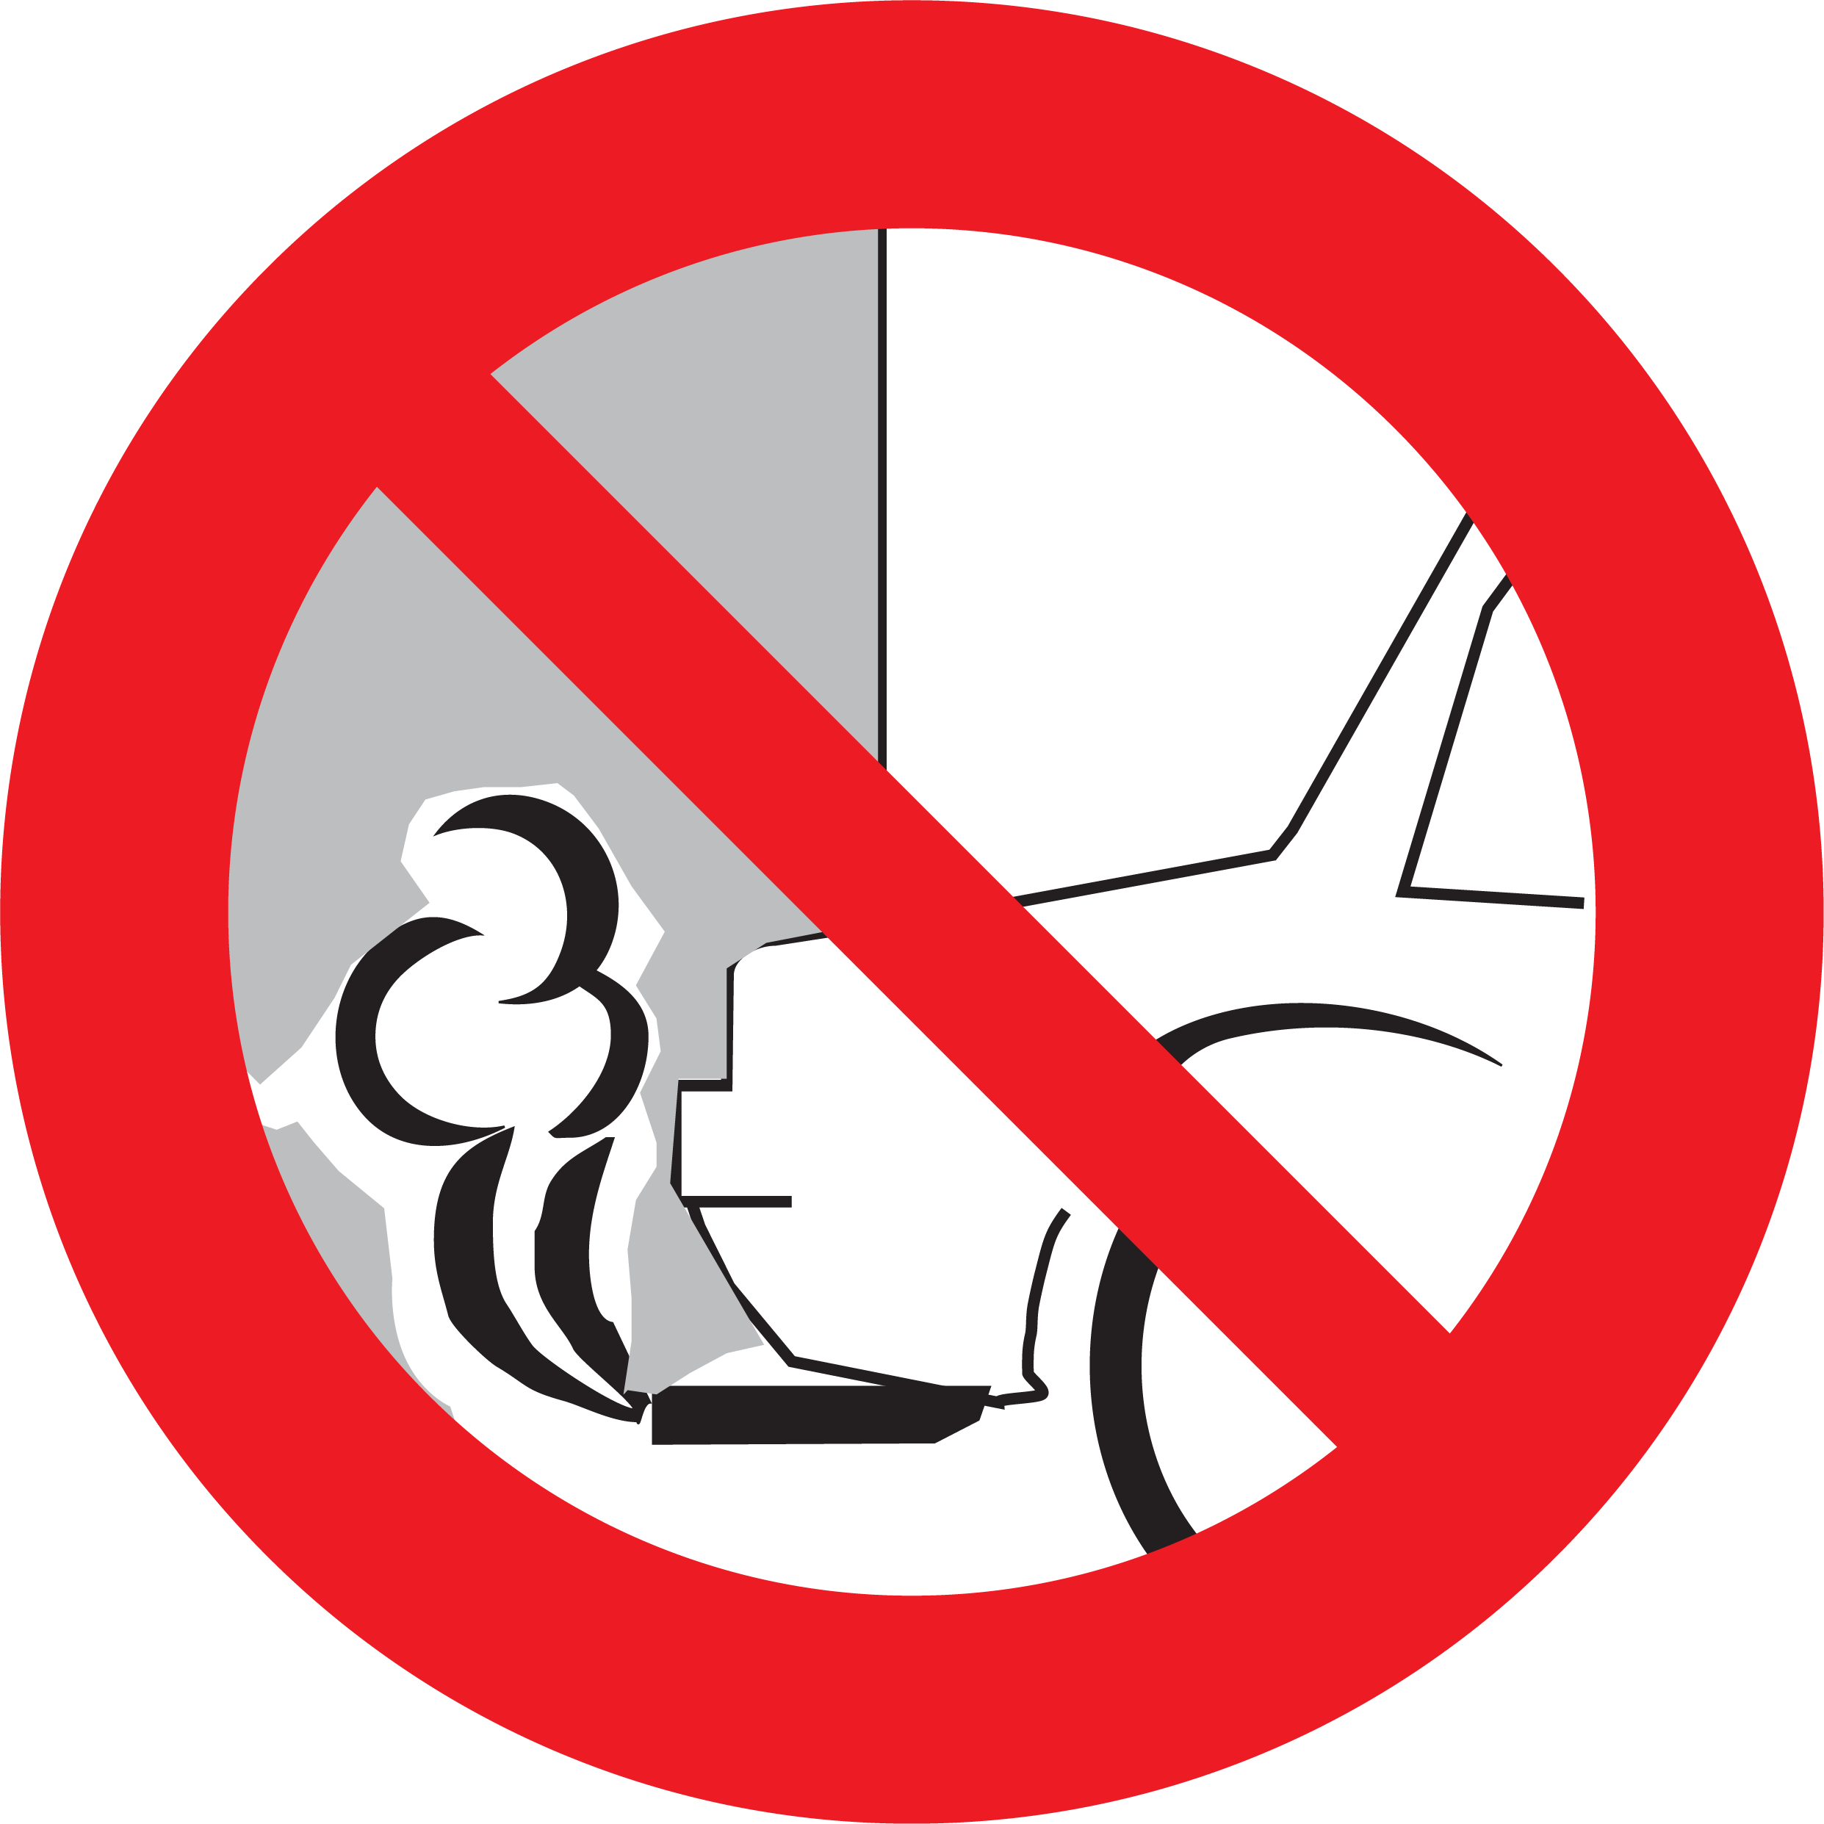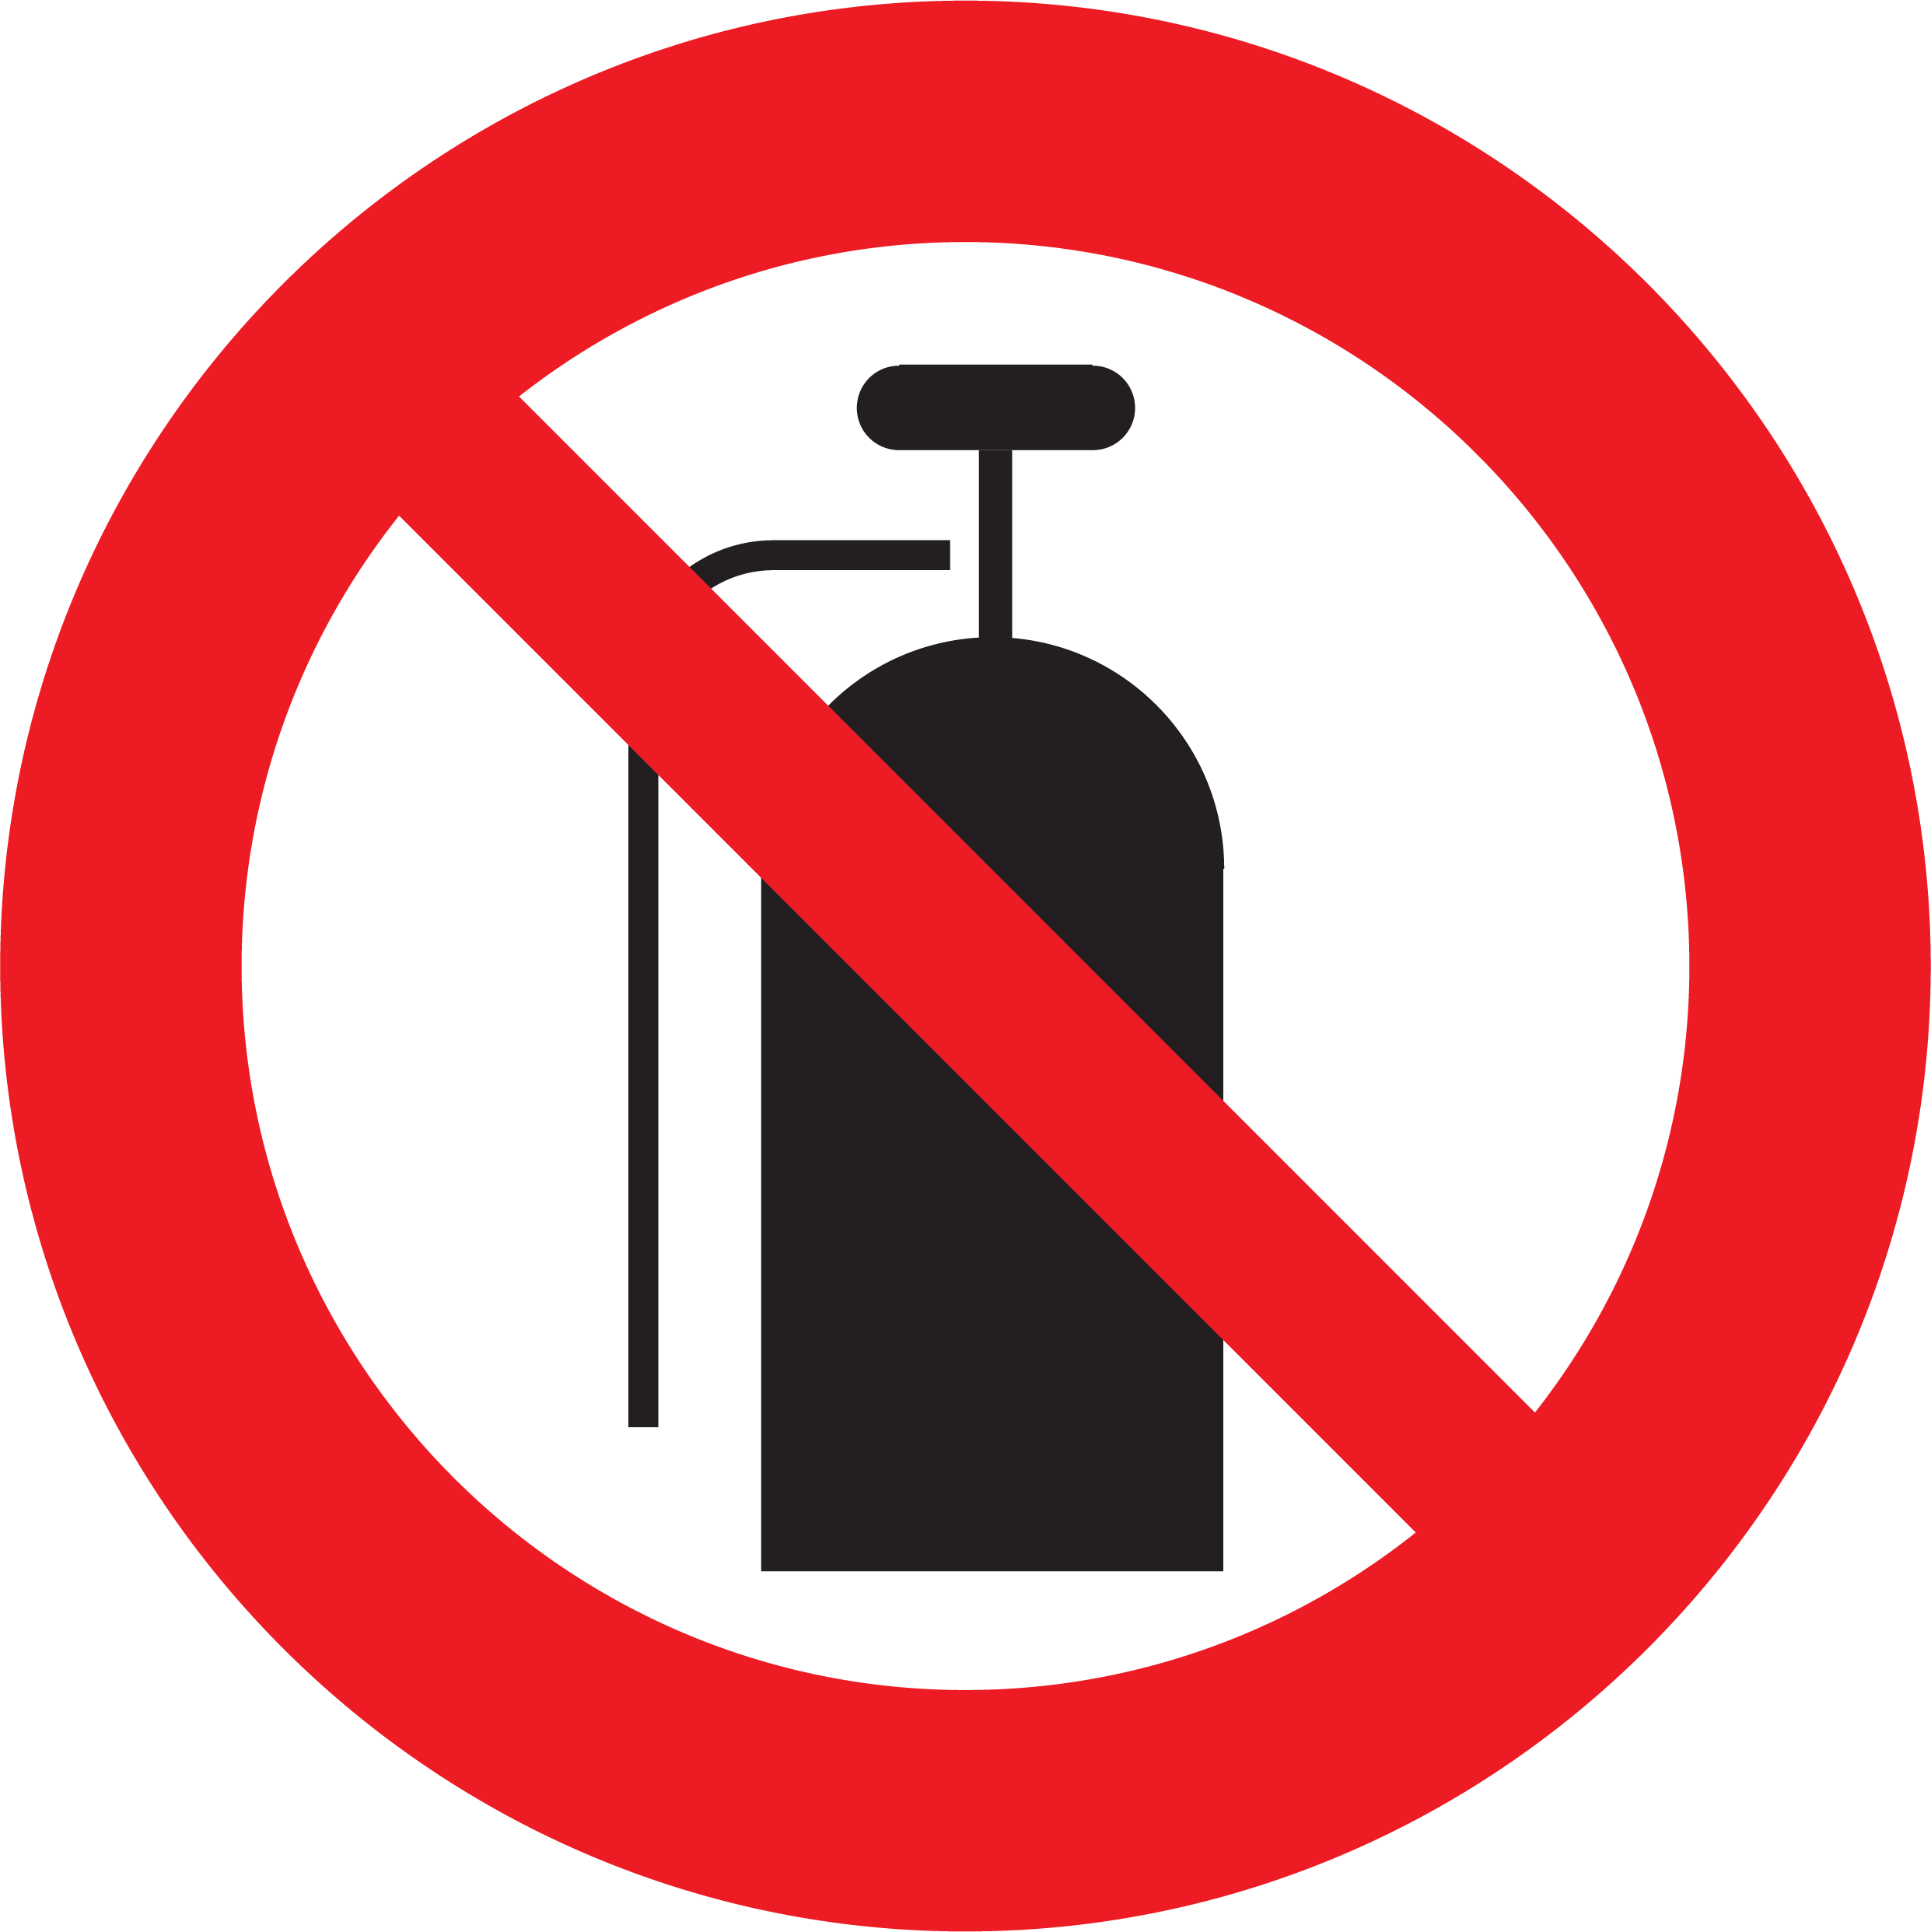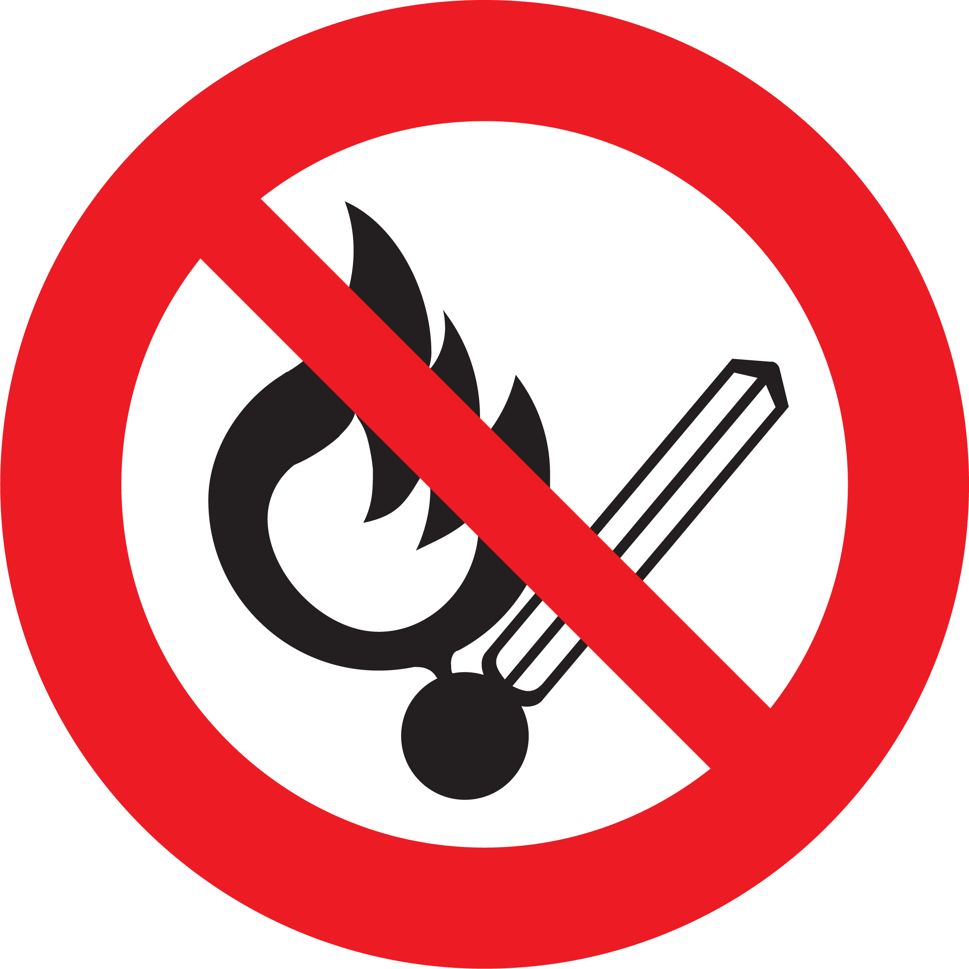 | 4D

17 | Confined space | ✕ Restricted means of entry or exit  ✕ Toxic atmosphere  ✕ Low levels of oxygen  ✕ Fire / Explosion hazards | People cannot locate a suitable exit to safety.  Working in an area that has a harmful level of containment.  Working in an area that does not have a safe level of oxygen or adequate ventilation.  Working in an area where a stored substance could cause engulfment. | 4A | - Adequate space and clearance for all work, including the required quantity of emergency exits to be kept clear based on the quantity of attendees, has been assessed on this site, and approved by the venue / site managers.  - Any physical exits that are restricted or covered or made inaccessible during this entire event (bump-in, operation, bump-out), will be made known to security & all fire wardens onsite, and alternative emergency procedures must be communicated and agreed with all parties onsite.  - Any permanent exit signage that is obstructed from general view will have temporary illuminated Exit signage installed for the entire duration of this event (bump-in, operation, bump-out).  - Alternative methods of egress to these exits may be created by openings in temporary drapes, walls, or flats.  - Additional manual ventilation (fans) will be installed if required to compensate for confined space or poor air quality.  - All [Event Organiser.Company] staff must wear suitable PPE respiratory masks in the event of any harmful levels of containment.  - Any stored substances that have any potential to ignite or fuel a fire must be removed from any identified confined space. | 4E

18 | People  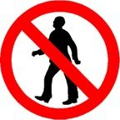 | ✔ Working in an area accessible by Venue employees and other workers  ✔ Working in an area accessible by members of the public / non-inducted persons | Subcontractors, Venue staff and Venue guests may be onsite during the bump-in / bump-out process.  Event setup areas may involve Venue employees and contractors.  Members of the public may be allowed access to adjoining Venue areas and other points of egress around the setup.  People distracted or not aware of their surroundings (i.e. mobile phone) | 4B | - [Event Organiser.Company] to provide a production delivery schedule in advance to Venue / security / Event Organisers  - All [Event Organiser.Company] Crew to follow Venue Bump-In / Bump-Out procedures as outlined in venue documentation.  - All [Event Organiser.Company] Crew to always follow the direction or instructions of the nominated Venue Manager / Security.  - All [Event Organiser.Company] Crew are made aware of their surroundings and situational hazards through Venue induction, [Event Organiser.Company] Toolbox Talk, and ongoing communication onsite.  - Work will be performed within the Venue WH&S procedures and full cooperation given to all Venue representatives & supervisors.  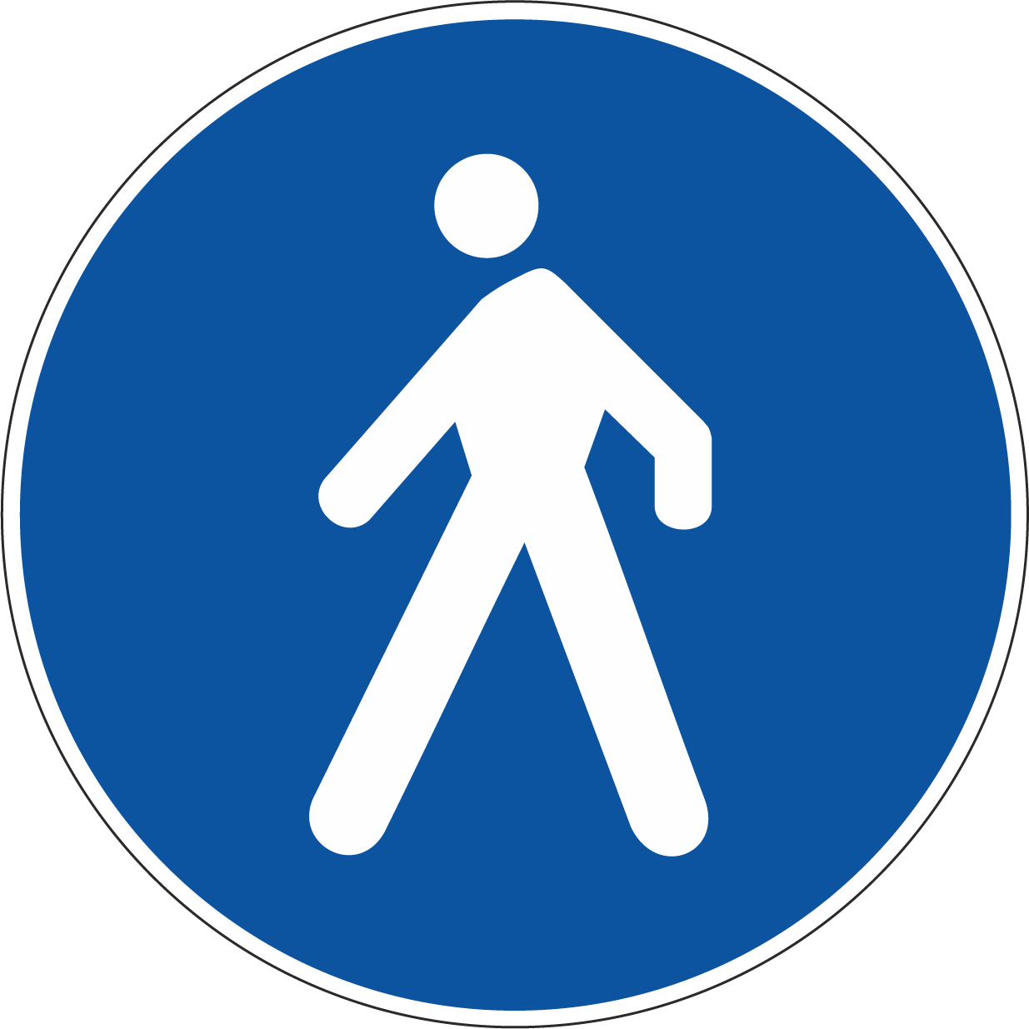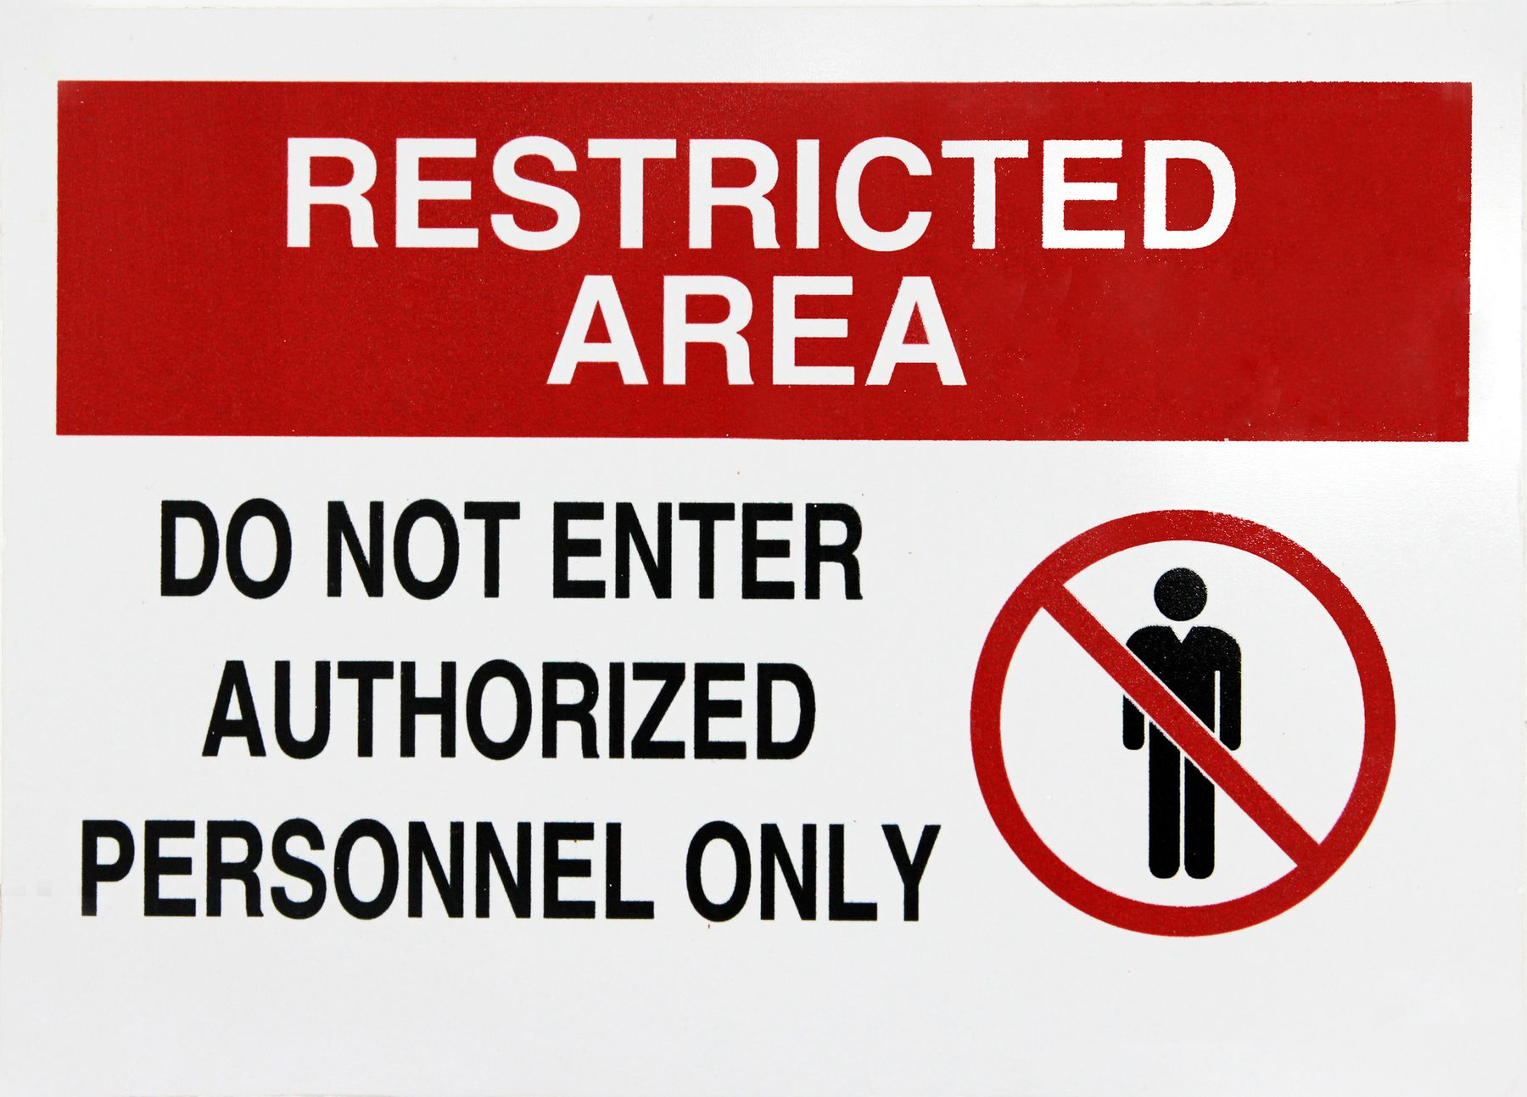 | 4D

18 | People | ✕ Working in an area accessible by Venue employees and other workers  ✕ Working in an area accessible by members of the public / non-inducted persons | Subcontractors, Venue staff and Venue guests may be onsite during the bump-in / bump-out process.  Event setup areas may involve Venue employees and contractors.  Members of the public may be allowed access to adjoining Venue areas and other points of egress around the setup.  People distracted or not aware of their surroundings (i.e. mobile phone) | 4B | - [Event Organiser.Company] to provide a production delivery schedule in advance to Venue / security / Event Organisers  - All [Event Organiser.Company] Crew to follow Venue Bump-In / Bump-Out procedures as outlined in venue documentation.  - All [Event Organiser.Company] Crew to always follow the direction or instructions of the nominated Venue Manager / Security.  - All [Event Organiser.Company] Crew are made aware of their surroundings and situational hazards through Venue induction, [Event Organiser.Company] Toolbox Talk, and ongoing communication onsite.  - Work will be performed within the Venue WH&S procedures and full cooperation given to all Venue representatives & supervisors. | 4E

19 | Air Quality / Air Pollution | ✔ Exposure to toxic airborne chemicals  ✔ Exposure to dust / fine particle matter  ✔ Exposure to smoke & fumes | Smoke machines, haze, or dry ice  Smoke / Haze Machines will be in use for this event.  Possible allergic reactions to those sensitive to chemicals when exposed to high concentrations.  Generation of dust / fine particle matter (i.e. PM2.5, PM10) e.g. cutting MDF in timber partition work.  Exposure to toxic smoke from outdoor activities (i.e. bushfires, fires nearby).  Exposure to toxic fumes from vehicle exhausts. | 4B | - Use of stage Smoke / Fogger / Haze machine to be operated only be suitably qualified crew, competent with their safe use. Only to be used in well ventilated areas. Follow manufacturer’s instructions for the safe use of these units  - Use of industry-standard Smoke / Fog / Haze liquid which is approved for general stage use and used as per manufacturer’s instructions  - Any cutting of items will be done in a well ventilated approved area (possibly outside), and the required PPE will be worn by any persons susceptible to exposure.  - Any exposure to toxic fumes will be identified, and attempts to be made to isolate the airflow. Required PPE will be worn by any persons susceptible to exposure, as a secondary measure.  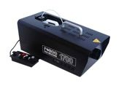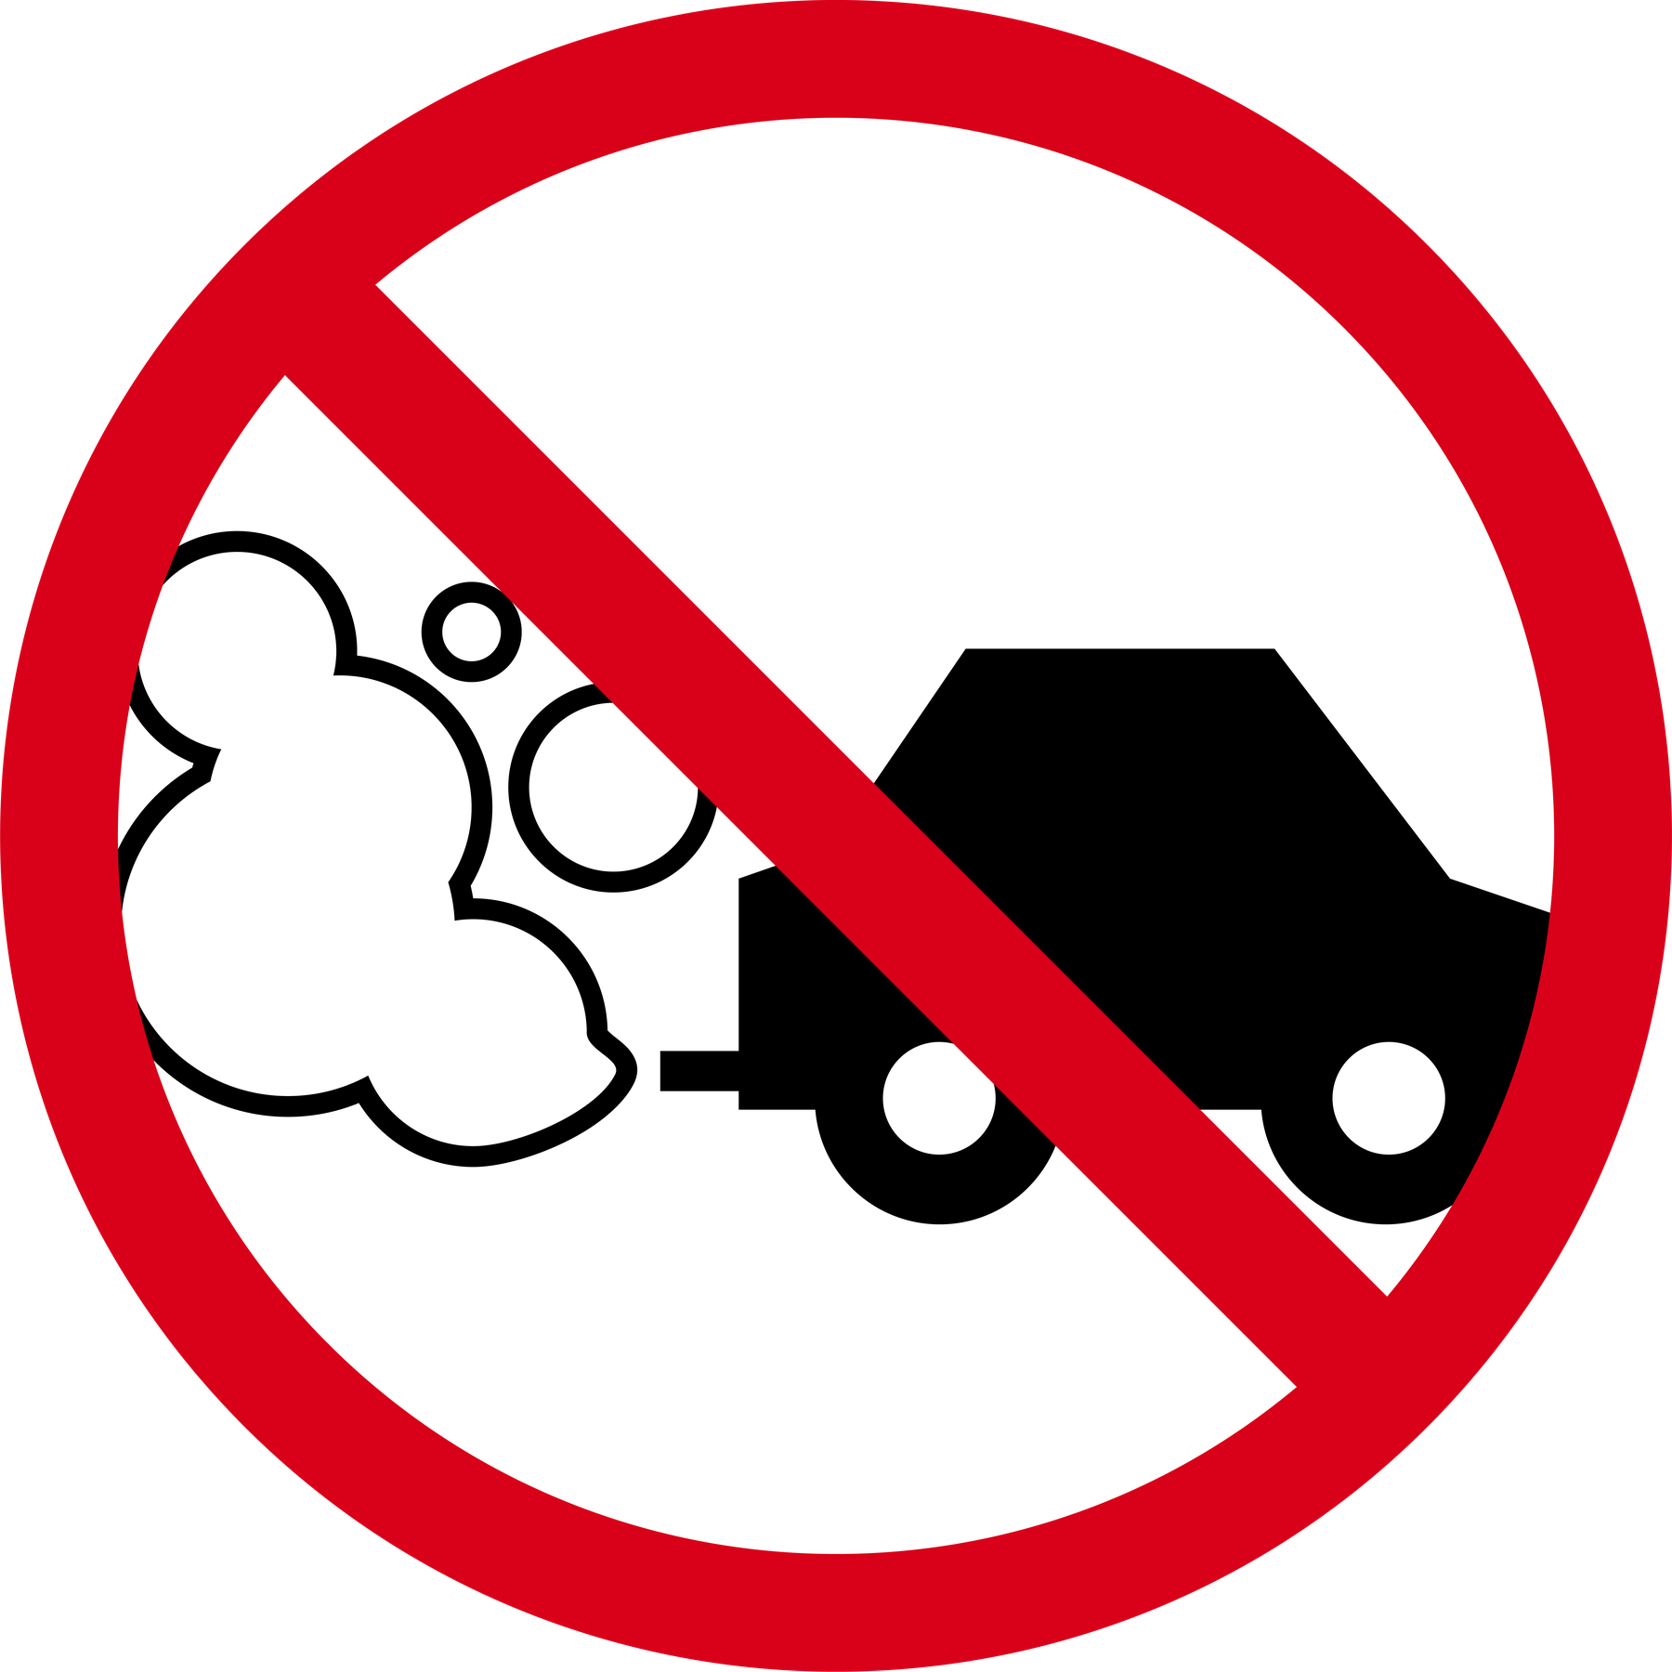 | 4E

19 | Air Quality / Air Pollution | ✕ Exposure to toxic airborne chemicals  ✕ Exposure to dust / fine particle matter  ✕ Exposure to smoke & fumes | Smoke machines, haze, or dry ice  Smoke / Haze Machines will be in use for this event.  Possible allergic reactions to those sensitive to chemicals when exposed to high concentrations.  Generation of dust / fine particle matter (i.e. PM2.5, PM10) e.g. cutting MDF in timber partition work.  Exposure to toxic smoke from outdoor activities (i.e. bushfires, fires nearby).  Exposure to toxic fumes from vehicle exhausts. | 4B | - Use of stage Smoke / Fogger / Haze machine to be operated only be suitably qualified crew, competent with their safe use. Only to be used in well ventilated areas. Follow manufacturer’s instructions for the safe use of these units  - Use of industry-standard Smoke / Fog / Haze liquid which is approved for general stage use and used as per manufacturer’s instructions  - Any cutting of items will be done in a well ventilated approved area (possibly outside), and the required PPE will be worn by any persons susceptible to exposure.  - Any exposure to toxic fumes will be identified, and attempts to be made to isolate the airflow. Required PPE will be worn by any persons susceptible to exposure, as a secondary measure. | 4E

20 | Performers / Acts  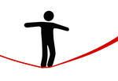    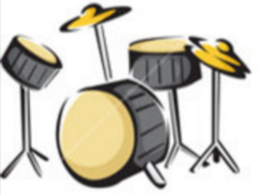  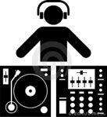 | ✔ Acrobatics, aerialists, stilt walkers, or other high-risk activities  ✔ Performers with “act specific” equipment or props requiring special installation or operation  ✔ Standard Live Band / Acoustic Duo performance during the event.  ✔ Standard DJ performance during the event.  ✔ Dance (individual / troupe) performance during the event.  ✔ Theatrical performance / Aerial performance during the event.  ✔ Custom performance (insert details). | Band could fall off stage during their performance, if not given a famil of the stage boundaries, steps on and off, and check the lighting is not creating blind spots.  Band equipment could fall off the stage or onto stage, if not suitably secured.  There may be some performers using wheelchairs, and could fall off the stage if not suitably secured.  Any guest performers may not be physically fit or sober to perform on the stage.  Sound levels could exceed suitable and comfortable decibel levels throughout the performance. | 4C | - All stage musical and other performers are coordinated onsite during the event by [Event Organiser.Company]  - Overall performance to be under the control & supervision of a [Event Organiser.Company] Stage Manager at all times  - Performers are of a professional standard and have performed at similar events previously and should be assessed as safe by the venue  - Any guest performers are to be reviewed for suitability and sobriety by event organiser before ascending onto the stage.  - Any high-risk activity will be covered by a site & event specific risk assessment process  - Relevant documents are requested by [Event Organiser.Company] from the Performers (or their agents), including but not limited to:  - Risk Assessment  - Public liability insurance certificate  - Any other relevant information or certification  - Any required rigging attachments are to be secured & checked by qualified riggers.  - Band members / Performers are to be given a toolbox talk by [Event Organiser.Company] crew during rehearsals; including the topics of stage boundaries, securing all backline and other equipment, entry & exit to/from stage, checking the lighting doesn't create blind spots, volume levels are controllable, careful consideration to any non-scheduled guest performers, instructing all empty cases & bags are neatly stored away and do not create any trip hazards around the stage.  - The [Event Organiser.Company] stage manager will rehearse with any wheelchair users to ascend on and descend off the stage, as well as confirm the position onstage to ensure it's safe.  - [Event Organiser.Company] will set realistic expectations with the Band regarding volume levels, and inform them that the volume will be turned down if required or if instructed by the venue.   | 4D

20 | Performers / Acts | ✕ Acrobatics, aerialists, stilt walkers, or other high-risk activities  ✕ Performers with “act specific” equipment or props requiring special installation or operation  ✕ Standard Live Band / Acoustic Duo performance during the event.  ✕ Standard DJ performance during the event.  ✕ Dance (individual / troupe) performance during the event.  ✕ Theatrical performance / Aerial performance during the event.  ✕ Custom performance (insert details). | Band could fall off stage during their performance, if not given a famil of the stage boundaries, steps on and off, and check the lighting is not creating blind spots.  Band equipment could fall off the stage or onto stage, if not suitably secured.  There may be some performers using wheelchairs, and could fall off the stage if not suitably secured.  Any guest performers may not be physically fit or sober to perform on the stage.  Sound levels could exceed suitable and comfortable decibel levels throughout the performance. | 4C | - All stage musical and other performers are coordinated onsite during the event by [Event Organiser.Company]  - Overall performance to be under the control & supervision of a [Event Organiser.Company] Stage Manager at all times  - Performers are of a professional standard and have performed at similar events previously and should be assessed as safe by the venue  - Any guest performers are to be reviewed for suitability and sobriety by event organiser before ascending onto the stage.  - Any high-risk activity will be covered by a site & event specific risk assessment process  - Relevant documents are requested by [Event Organiser.Company] from the Performers (or their agents), including but not limited to:  - Risk Assessment  - Public liability insurance certificate  - Any other relevant information or certification  - Any required rigging attachments are to be secured & checked by qualified riggers.  - Band members / Performers are to be given a toolbox talk by [Event Organiser.Company] crew during rehearsals; including the topics of stage boundaries, securing all backline and other equipment, entry & exit to/from stage, checking the lighting doesn't create blind spots, volume levels are controllable, careful consideration to any non-scheduled guest performers, instructing all empty cases & bags are neatly stored away and do not create any trip hazards around the stage.  - The [Event Organiser.Company] stage manager will rehearse with any wheelchair users to ascend on and descend off the stage, as well as confirm the position onstage to ensure it's safe.  - [Event Organiser.Company] will set realistic expectations with the Band regarding volume levels, and inform them that the volume will be turned down if required or if instructed by the venue. | 4E

21 | Animals  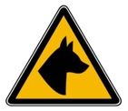 | ✔ Animals onsite | Any animals that are not managed by a responsible person could cause harm or damage to people or property.  Animals onsite could be traumatised by unusual surroundings, loud noises and/or bright lights. | 2C | - Any animals onsite are under the control of a trained person, who has provided relevant and required documentation to [Event Organiser.Company].  - Exhibited-Animals-Standards-for-Exhibiting-Animals-at-Mobile-Establishments-in-New-South-Wales-February-2019.pdf  - https://www.rspcansw.org.au/ | 2E

21 | Animals | ✕ Animals onsite | Any animals that are not managed by a responsible person could cause harm or damage to people or property.  Animals onsite could be traumatised by unusual surroundings, loud noises and/or bright lights. | 2C | - Any animals onsite are under the control of a trained person, who has provided relevant and required documentation to [Event Organiser.Company].  - Exhibited-Animals-Standards-for-Exhibiting-Animals-at-Mobile-Establishments-in-New-South-Wales-February-2019.pdf  - https://www.rspcansw.org.au/ | 2E

22 | Children  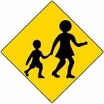 | ✔ Working with Children | Compromising the safety, welfare and well-being of children.  Enabling unsupervised access to children by unauthorised or prohibited persons.  Enabling photos or other recordings of children by unauthorised or prohibited persons. | 4A | - All [Event Organiser.Company] Staff are subject to Working with Children check, for those who will have “face to face” or “physical contact” with persons under 18 years of age  - All nominated [Event Organiser.Company] Crew have a current Working with children check - NSW  - Any Interstate based [Event Organiser.Company] Crew have a current Interstate WWCC, yet are exempt from the NSW WWCC  - All children must have authorised supervisors in attendance at all times when they need to have direct contact with an [Event Organiser.Company] Crew member (i.e. when they are being fitted with a wireless microphone, or being briefed on the stage layout, changing PowerPoint slides, etc.)   | 4D

22 | Children | ✕ Working with Children | Compromising the safety, welfare and well-being of children.  Enabling unsupervised access to children by unauthorised or prohibited persons.  Enabling photos or other recordings of children by unauthorised or prohibited persons. | 4A | - All [Event Organiser.Company] Staff are subject to Working with Children check, for those who will have “face to face” or “physical contact” with persons under 18 years of age  - All nominated [Event Organiser.Company] Crew have a current Working with children check - NSW  - Any Interstate based [Event Organiser.Company] Crew have a current Interstate WWCC, yet are exempt from the NSW WWCC  - All children must have authorised supervisors in attendance at all times when they need to have direct contact with an [Event Organiser.Company] Crew member (i.e. when they are being fitted with a wireless microphone, or being briefed on the stage layout, changing PowerPoint slides, etc.) | 4E

23 | Plant & Equipment | ✔ Heavy equipment or materials such as forklifts, reach trucks, or hoists used onsite (excluding scissoflifts & other EWPs) | Forklifts required to raise / lower technical equipment to a higher floor (or stage) level of the venue.  Forklifts required to be used to transport loads via the dock or established pathways.  Forklifts may be used by other suppliers (including subcontractors) to unload and load from vehicles, as well as bring items to the event floor. | 4C | - All [Event Organiser.Company] drivers of a forklift truck equipped with a mast and an elevating load carriage with a pair of fork arms or other attachment must have a Safework NSW Hi-Risk License (class LF)  - All Forklift movements must have a dedicated spotter (in Hi-Vis and Steelcap footwear) to supervise and assist with hazards.  - Hi-Vis Vests must be worn by the Forklift operator and the dedicated spotter when Forklifts are in operation  - A dedicated SWMS is provided to [Event Organiser.Company] from all subcontractors that are using and/or managing Forklifts  ​ | 4D

23 | Plant & Equipment | ✕ Heavy equipment or materials such as forklifts, reach trucks, or hoists used onsite (excluding scissoflifts & other EWPs) | Forklifts required to raise / lower technical equipment to a higher floor (or stage) level of the venue.  Forklifts required to be used to transport loads via the dock or established pathways.  Forklifts may be used by other suppliers (including subcontractors) to unload and load from vehicles, as well as bring items to the event floor. | 4C | - All [Event Organiser.Company] drivers of a forklift truck equipped with a mast and an elevating load carriage with a pair of fork arms or other attachment must have a Safework NSW Hi-Risk License (class LF)  - All Forklift movements must have a dedicated spotter (in Hi-Vis and Steelcap footwear) to supervise and assist with hazards.  - Hi-Vis Vests must be worn by the Forklift operator and the dedicated spotter when Forklifts are in operation  - A dedicated SWMS is provided to [Event Organiser.Company] from all subcontractors that are using and/or managing Forklifts  ​​ | 4E

24 | Construction  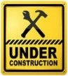 | ✔ Set / event construction on site  ✔ Set pieces or scenic items installed  ✔ Free-standing technical equipment installed | Poorly constructed elements could fall over or unintentionally dismantle.  Temporary floor-mounted Themed (Fabric/Aluminium) backdrop behind stage.  Freestanding AV equipment could become unstable and fall over. | 3C | - All equipment supplied is professional floor-mounted fit for purpose equipment, with positions indicated on attached floorplan  - All free-standing equipment will be of commercial quality and secured against movement. Free-standing items to be secured with weighted shot-bags to counter any tip hazard.  - Any scenic construction to be indicated on Event CAD floor plans and specific SWMS for safe construction is provided.  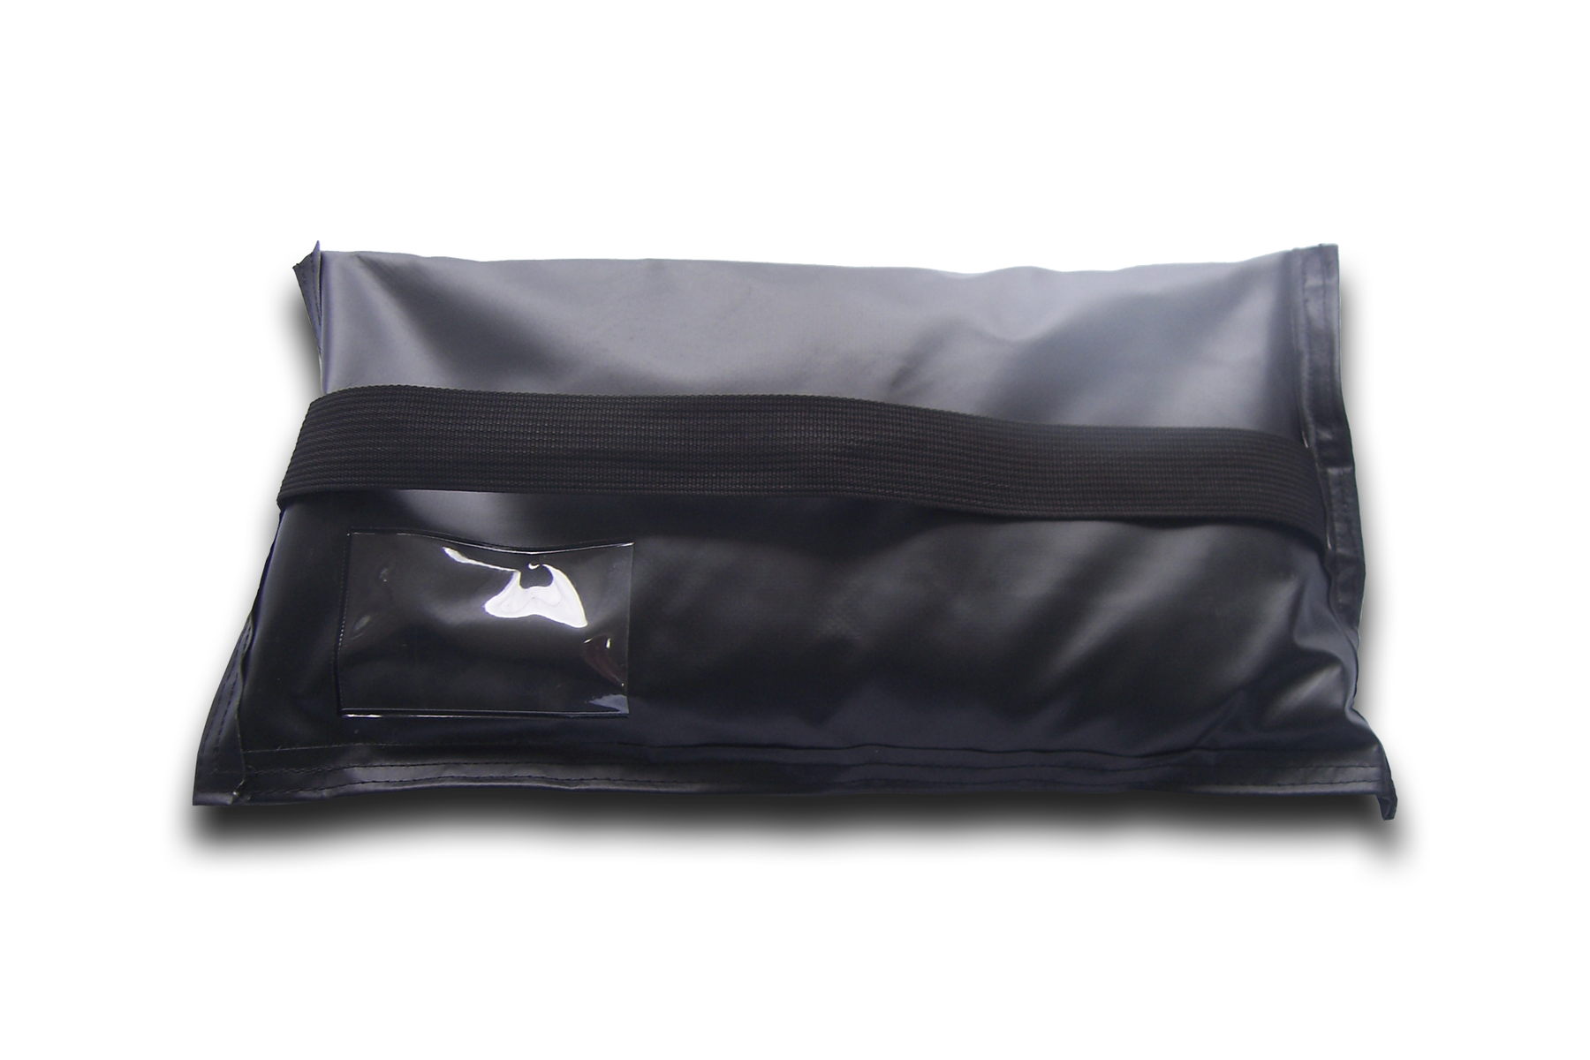 | 3E

24 | Construction | ✕ Set / event construction on site  ✕ Set pieces or scenic items installed  ✕ Free-standing technical equipment installed | Poorly constructed elements could fall over or unintentionally dismantle.  Temporary floor-mounted Themed (Fabric/Aluminium) backdrop behind stage.  Freestanding AV equipment could become unstable and fall over. | 3C | - All equipment supplied is professional floor-mounted fit for purpose equipment, with positions indicated on attached floorplan  - All free-standing equipment will be of commercial quality and secured against movement. Free-standing items to be secured with weighted shot-bags to counter any tip hazard.  - Any scenic construction to be indicated on Event CAD floor plans and specific SWMS for safe construction is provided. | 3E

25 | Rigging  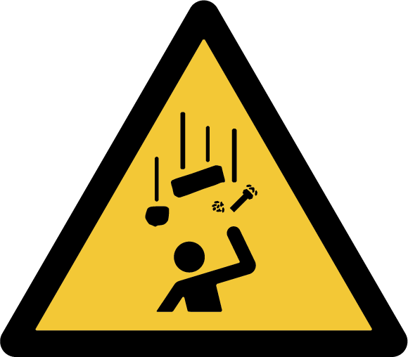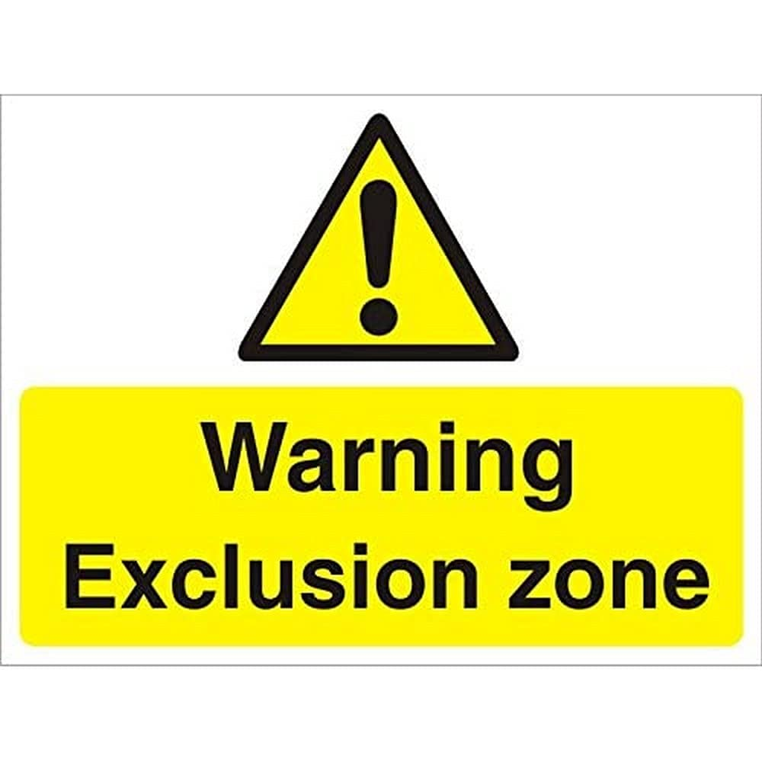 | ✔ Rigging work | Loads suspended above people becomes unsecured.  Permanent rigging infrastructure is unsuitable.  Rigging plans are not approved. | 4B | - All rigging of overhead Rigging elements will be pre-approved as per conditions conveyed by the venue in advance  - Licensed Riggers only to be used in this setup & will have prior experience of this site  - Rigging carried out by authorised and qualified personnel at all times to minimise risk  - Position of rigging points and loads to be indicated on CAD plans for approval  - Risk Assessment & SWMS for any Rigging activities are to be provided to all PCBUs / stakeholders. | 4D

25 | Rigging | ✕ Rigging work | Loads suspended above people becomes unsecured.  Permanent rigging infrastructure is unsuitable.  Rigging plans are not approved. | 4B | - All rigging of overhead Rigging elements will be pre-approved as per conditions conveyed by the venue in advance  - Licensed Riggers only to be used in this setup & will have prior experience of this site  - Rigging carried out by authorised and qualified personnel at all times to minimise risk  - Position of rigging points and loads to be indicated on CAD plans for approval  - Risk Assessment & SWMS for any Rigging activities have been requested and will be provided by the venue. | 4E

26 | Emergency Situations  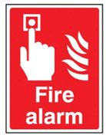 | ✔ Fire  ✔ Security  ✔ Building | Emergency procedures and evacuation meeting points  Emergency response to Fire & Building Safety & Security  Management of public safety and Security during the event | 4C | - [Event Organiser.Company] supervisory staff must have reviewed emergency assembly points on attached map prior to site arrival  - Emergency evacuation procedures conveyed by Venue staff (if possible) during initial venue induction / [Event Organiser.Company] Toolbox Talk.  - Evacuation meeting points, external to the building, outlined in venue access information (attached)  - [Event Organiser.Company] reviews site specific emergency procedures during Toolbox Talk prior to work commencing  - Emergency Response Procedures and Response under control & supervision of Venue security staff   | 4C

26 | Emergency Situations | ✕ Fire  ✕ Security  ✕ Building | Emergency procedures and evacuation meeting points  Emergency response to Fire & Building Safety & Security  Management of public safety and Security during the event | 4C | - [Event Organiser.Company] supervisory staff must have reviewed emergency assembly points on attached map prior to site arrival  - Emergency evacuation procedures conveyed by Venue staff (if possible) during initial venue induction / [Event Organiser.Company] Toolbox Talk.  - Evacuation meeting points, external to the building, outlined in venue access information (attached)  - [Event Organiser.Company] reviews site specific emergency procedures during Toolbox Talk prior to work commencing  - Emergency Response Procedures and Response under control & supervision of Venue security staff | 4C

27 | First Aid   | ✔ Injury or Illness while in the workplace | Non-specific incidents affecting the health and safety, and well-being of people. | 4B | - Venue (and [Event Organiser.Company]) to provide access to AED (Automated External Defibrillator) equipment and trained First Aid Staff.  - There is a First Aid Room located within the venue under the control of the onsite security team.  - All First Aid procedures & position of equipment outlined via venue documents.  - Further reinforced by Toolbox talk by [Event Organiser.Company] supervisors.  - Any incidents requiring First Aid are to be reported to Security / Venue staff immediately, and further reported via [Event Organiser.Company]'s incident report form.  - Any incidents beyond the capability of First Aid onsite should be escalated to calling Emergency Services, via the onsite security team.   | 4C

27 | First Aid | ✕ Injury or Illness while in the workplace | Non-specific incidents affecting the health and safety, and well-being of people. | 4B | - Venue (and [Event Organiser.Company]) to provide access to AED (Automated External Defibrillator) equipment and trained First Aid Staff.  - There is a First Aid Room located within the venue under the control of the onsite security team.  - All First Aid procedures & position of equipment outlined via venue documents.  - Further reinforced by Toolbox talk by [Event Organiser.Company] supervisors.  - Any incidents requiring First Aid are to be reported to Security / Venue staff immediately, and further reported via [Event Organiser.Company]'s incident report form.  - Any incidents beyond the capability of First Aid onsite should be escalated to calling Emergency Services, via the onsite security team. | 4C

28 | Trip Hazards | ✔ Cables across walkways  ✔ Uneven flooring  ✔ Temporary Equipment on floors / stages  ✔ Wet or slippery surfaces | Temporary power and signal cables run to equipment between power & signal source may be needed.  Outdoor public space with any inherent slip or trip hazards.  Crew or talent may need to egress across temporary cable runs around performance / presentation areas.  Audio-visual equipment may pose a trip hazard when run across access or doorways.  Possibility of precipitation may cause ground / grassed areas to be slippery underfoot is not anticipated at this site  Electrical hazards associated with proximity to water | 4A | - Trip hazards from cable runs will be controlled by either running cables overhead between existing points or via low-profile rubber-backed mats, tape, or cable trays.  - Floor hazards will be made stable with suitable weights and trip hazards made visible via hazard / hi-vis tape.  - Barricades involving temporary bollards, stanchions or witches-hats and combinations of ropes, cables, reflective or hazard tapes.  - Notification signage indicating hazardous areas to be avoided in favour of physical barriers.  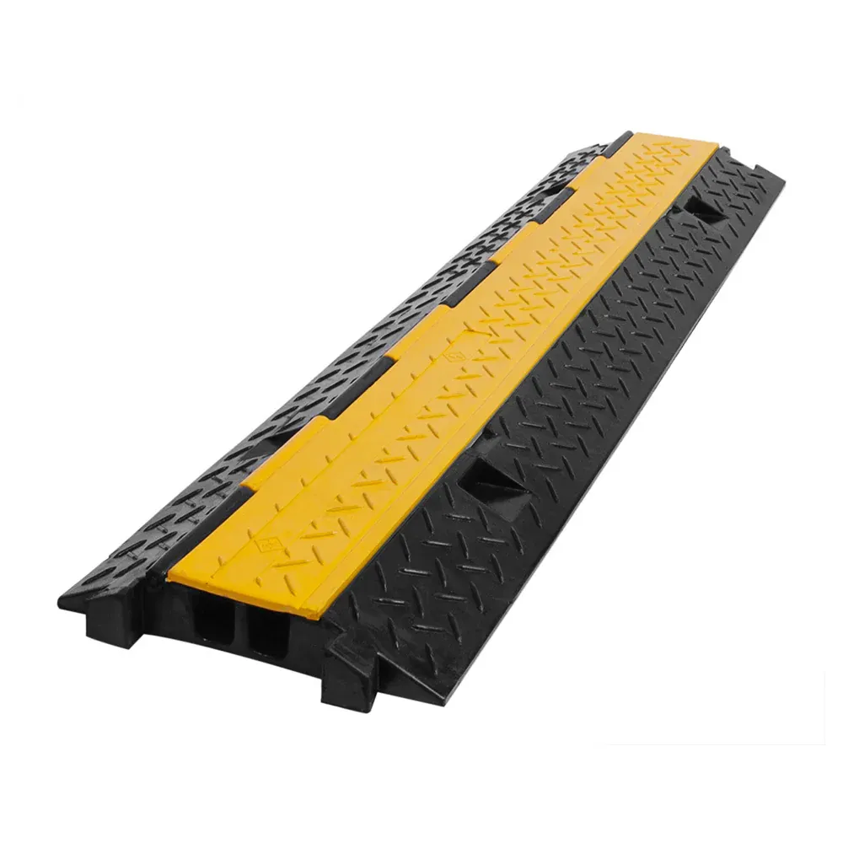 | 4D

28 | Trip Hazards | ✕ Cables across walkways  ✕ Uneven flooring  ✕ Temporary Equipment on floors / stages  ✕ Wet or slippery surfaces | Temporary power and signal cables run to equipment between power & signal source may be needed.  Outdoor public space with any inherent slip or trip hazards.  Crew or talent may need to egress across temporary cable runs around performance / presentation areas.  Audio-visual equipment may pose a trip hazard when run across access or doorways.  Possibility of precipitation may cause ground / grassed areas to be slippery underfoot is not anticipated at this site  Electrical hazards associated with proximity to water | 4A | - Trip hazards from cable runs will be controlled by either running cables overhead between existing points or via low-profile rubber-backed mats, tape, or cable trays.  - Floor hazards will be made stable with suitable weights and trip hazards made visible via hazard / hi-vis tape.  - Barricades involving temporary bollards, stanchions or witches-hats and combinations of ropes, cables, reflective or hazard tapes.  - Notification signage indicating hazardous areas to be avoided in favour of physical barriers. | 4D

29 | Edge Hazards | ✔ Edge of stage or raised platforms  ✔ Stairs or raked audience seating  ✔ Catwalks or stage rostra | Poorly maintained stage pieces could provoke unstable reactions for a person to fall off or fall into a collapsing stage.  Stage may be set at a height that could present a serious fall hazard.  Stage may have unprotected edges that could present a serious fall hazard.  People could fall off the edge of the raised stage if the edge is not clearly visible.  People may be accessing the stage, who have not been familiarised, and may pose a safety risk. | 4C | - All stage elements are thoroughly tested before allowing any non-crew person to access them. This should involve checking for trip hazards, loose parts, incorrectly setup stage support systems, ensuring no separation is possible  - All raised elements (stages / platforms) must have white contrast tape around the perimeter to indicate the edges to persons on the stage.  - Any raised stage (or raised platform) has been assessed as not requiring safety / handrails for this event, yet they can be provided on request.  - Any stairs / treads to access a raised stage are commercial grade and tested as safe for use. They may have handrails or a stage manager will be available to escort people on & off the stage.  - Highly visible access to and from venue stage via dedicated lighting system (i.e. no dark areas).  - All stairs / treads egress points “to” and “from” stage as per best practice – edge of stage made visible with white contrast tape.  - All egress “to” and “from” stage to be rehearsed and under supervision of stage management  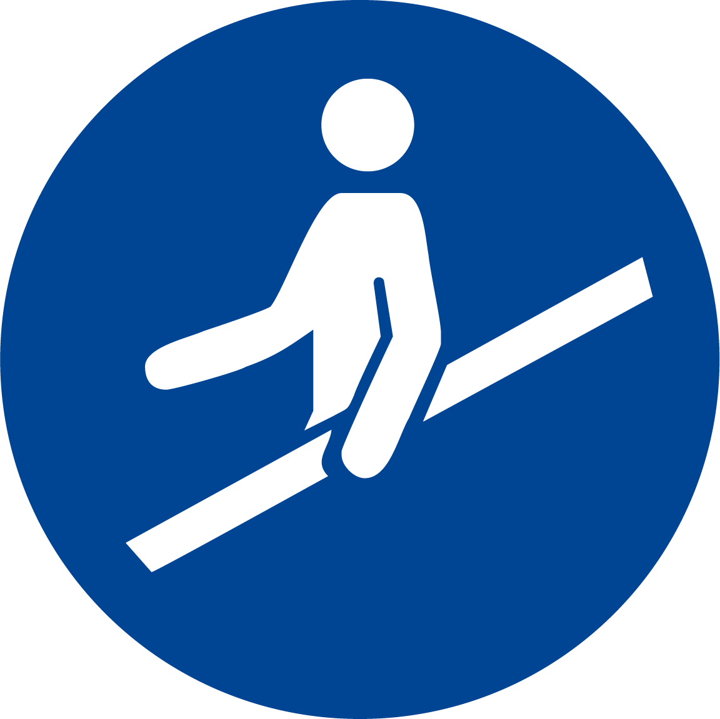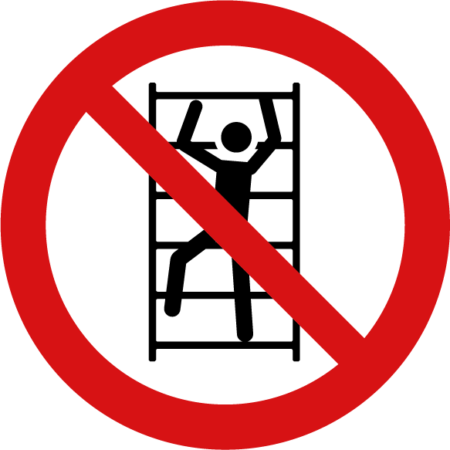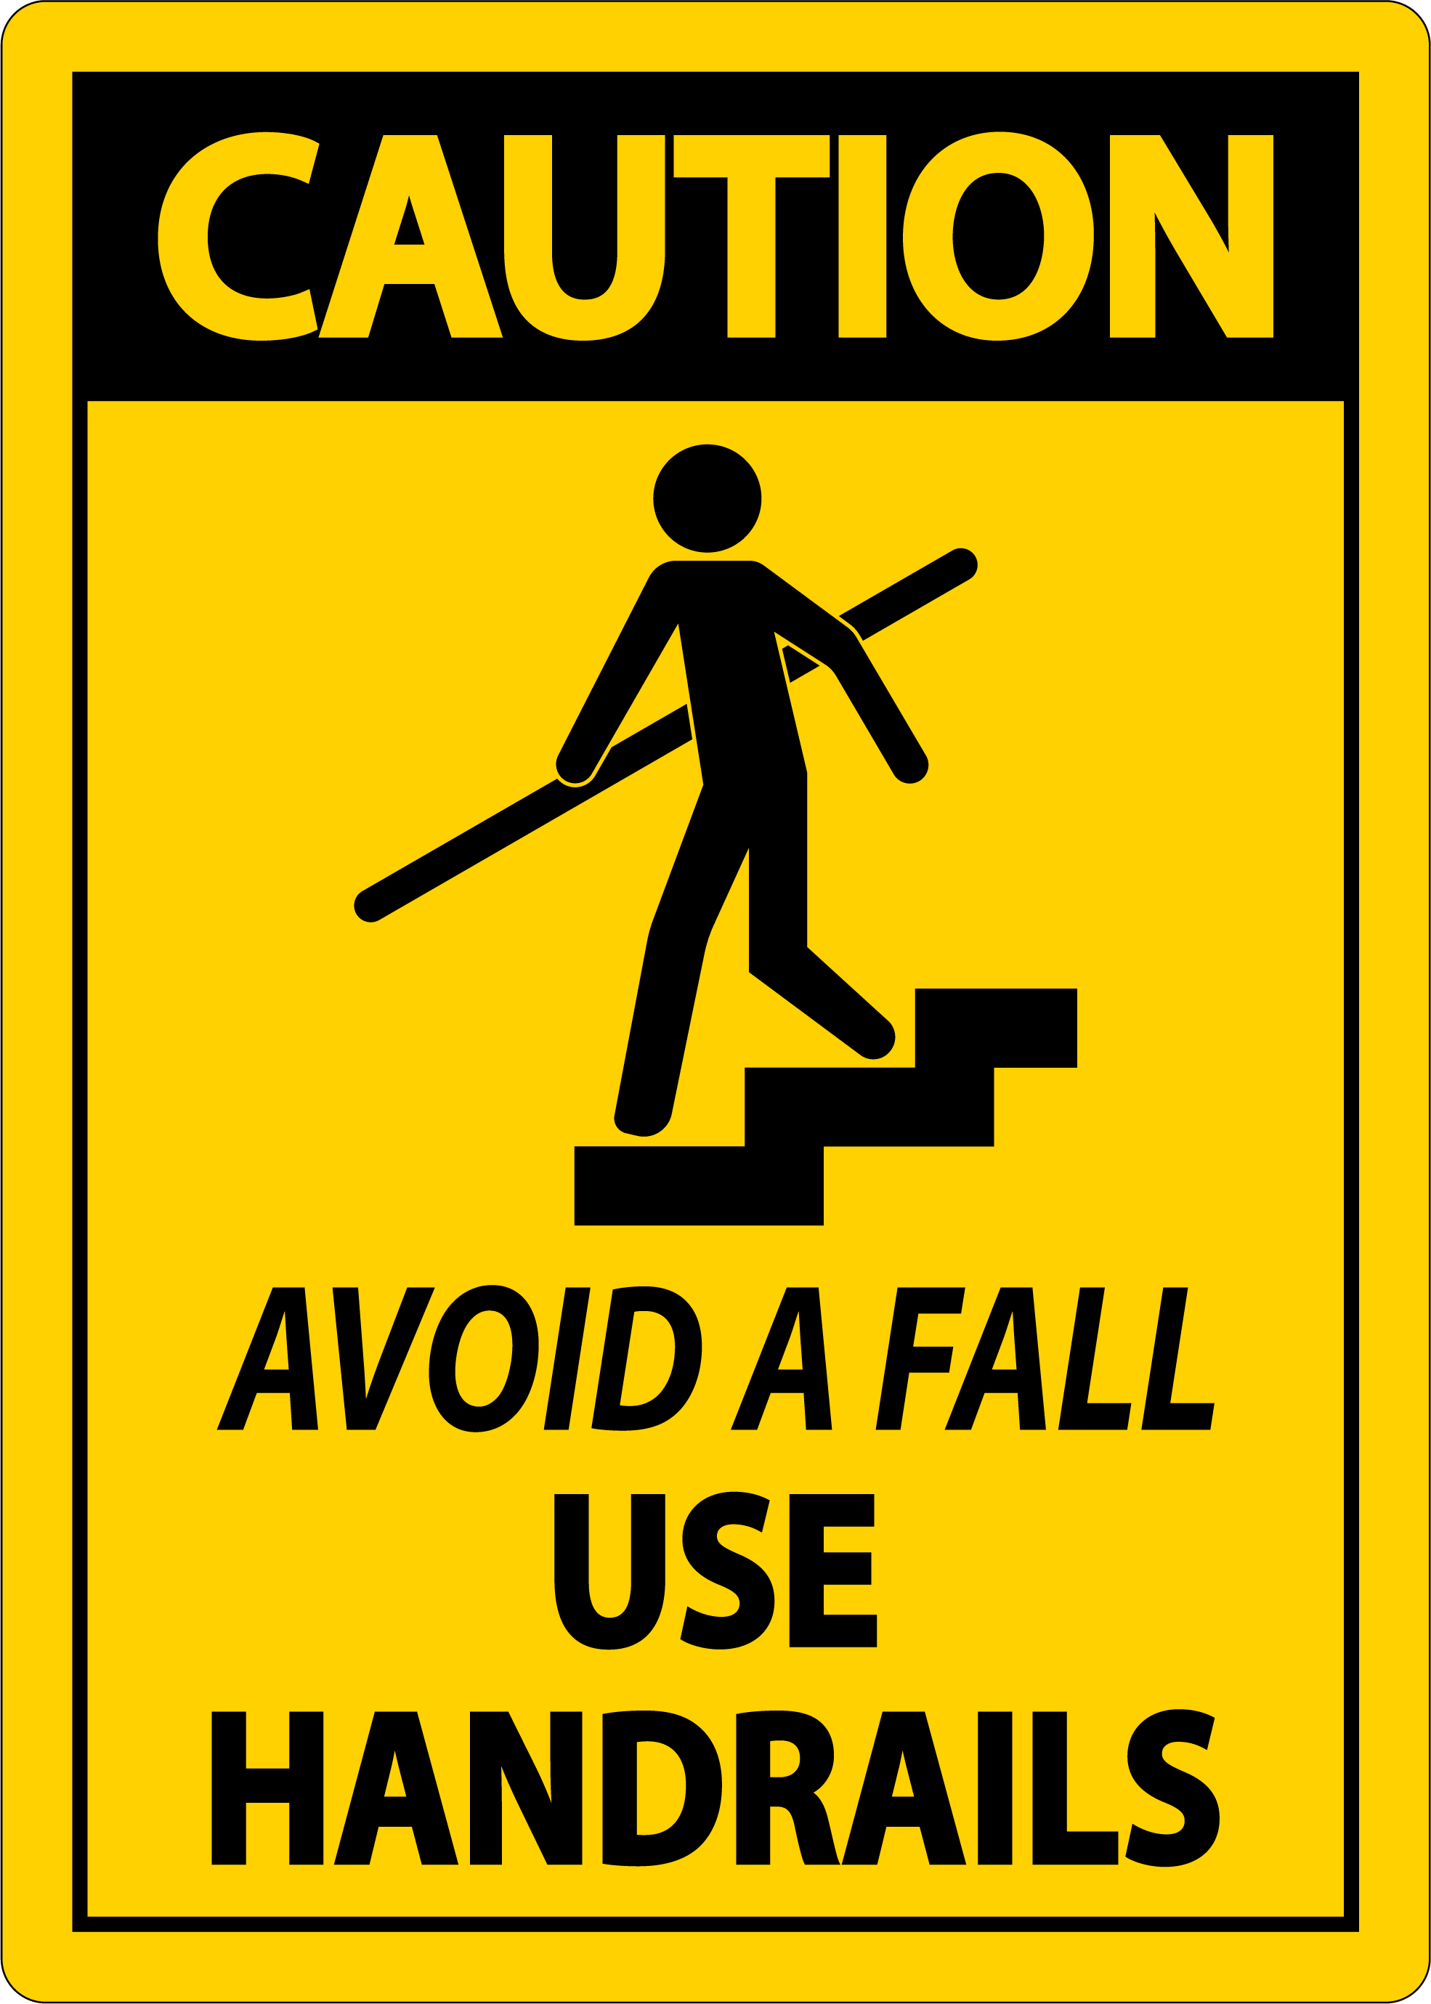  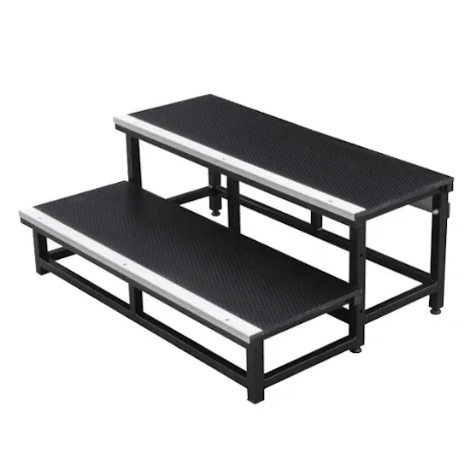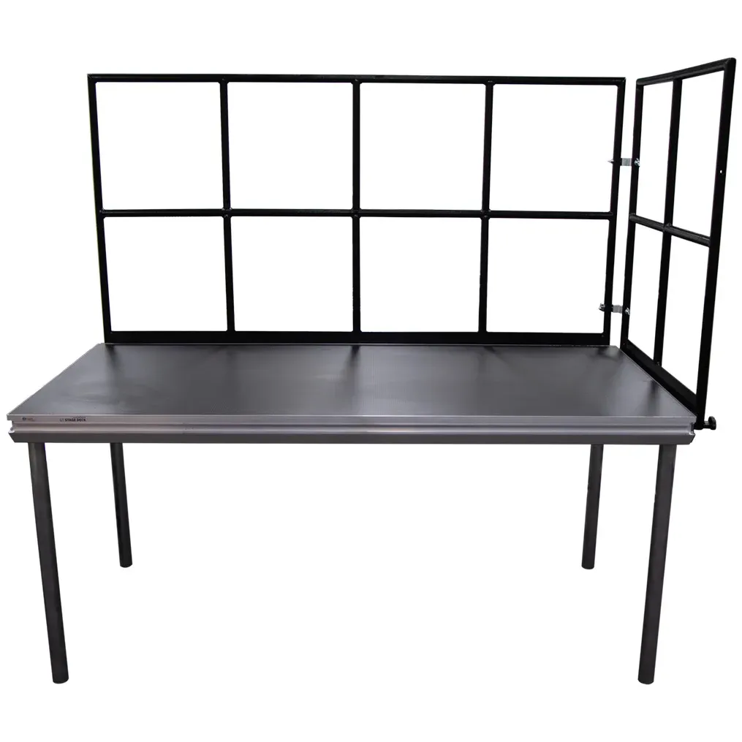 | 4D

29 | Edge Hazards | ✕ Edge of stage or raised platforms  ✕ Stairs or raked audience seating  ✕ Catwalks or stage rostra​ | Poorly maintained stage pieces could provoke unstable reactions for a person to fall off or fall into a collapsing stage.  Stage may be set at a height that could present a serious fall hazard.  Stage may have unprotected edges that could present a serious fall hazard.  People could fall off the edge of the raised stage if the edge is not clearly visible.  People may be accessing the stage, who have not been familiarised, and may pose a safety risk. | 4C | - All stage elements are thoroughly tested before allowing any non-crew person to access them. This should involve checking for trip hazards, loose parts, incorrectly setup stage support systems, ensuring no separation is possible  - All raised elements (stages / platforms) must have white contrast tape around the perimeter to indicate the edges to persons on the stage.  - Any raised stage (or raised platform) has been assessed as not requiring safety / handrails for this event, yet they can be provided on request.  - Any stairs / treads to access a raised stage are commercial grade and tested as safe for use. They may have handrails or a stage manager will be available to escort people on & off the stage.  - Highly visible access to and from venue stage via dedicated lighting system (i.e. no dark areas).  - All stairs / treads egress points “to” and “from” stage as per best practice – edge of stage made visible with white contrast tape.  - All egress “to” and “from” stage to be rehearsed and under supervision of stage management | 4E

30 | Flame / fire  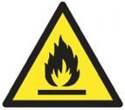 | ✔ Combustible materials  ✕ Pyrotechnics / Special effects  ✕ Naked flames  ✕ Isolation of alarms / sensors | Any materials to fuel any possible fire or spark.  Improper use of pyrotechnics or special effects (including Sparkulars).  Naked flames possibly igniting a fire.  Isolation of alarms in effect, due to the use of haze. | 4B | - Any material drapes provided are Industry standard, are commercially manufactured, and have been treated to be fire retardant.  - Projection & display screens are [Event Organiser.Company] standard and have inherent fire-retardant properties.  - Any Pyrotechnics / Spcial effects are managed by a trained professional and according to the dedicated Risk Assessment & SWMS.  - 'Sparkulars' are not permitted to be used on [Event Organiser.Company] events without dedicated SWMS provided to [Event Organiser.Company] (as of July 2025).  - Any naked flames under the control of [Event Organiser.Company] are subject to the approval of the venue. They will be managed according to a dedicated SWMS.  - Venue standard fire control facilities in operation for this event, and adhered to by all suppliers.  - If fire impairment is required, then suitable application forms are completed and submitted to the venue for approval. | 4D

30 | Flame / fire | ✔ Combustible materials  ✔ Pyrotechnics / Special effects  ✔ Naked flames  ✔ Isolation of alarms / sensors | Any materials to fuel any possible fire or spark.  Improper use of pyrotechnics or special effects (including Sparkulars).  Naked flames possibly igniting a fire.  Isolation of alarms in effect, due to the use of haze. | 4B | - Any material drapes provided are Industry standard, are commercially manufactured, and have been treated to be fire retardant.  - Projection & display screens are [Event Organiser.Company] standard and have inherent fire-retardant properties.  - Any Pyrotechnics / Spcial effects are managed by a trained professional and according to the dedicated Risk Assessment & SWMS.  - 'Sparkulars' are not permitted to be used on [Event Organiser.Company] events without dedicated SWMS provided to [Event Organiser.Company] (as of July 2025).  - Any naked flames under the control of [Event Organiser.Company] are subject to the approval of the venue. They will be managed according to a dedicated SWMS.  - Venue standard fire control facilities in operation for this event, and adhered to by all suppliers.  - If fire impairment is required, then suitable application forms are completed and submitted to the venue for approval.  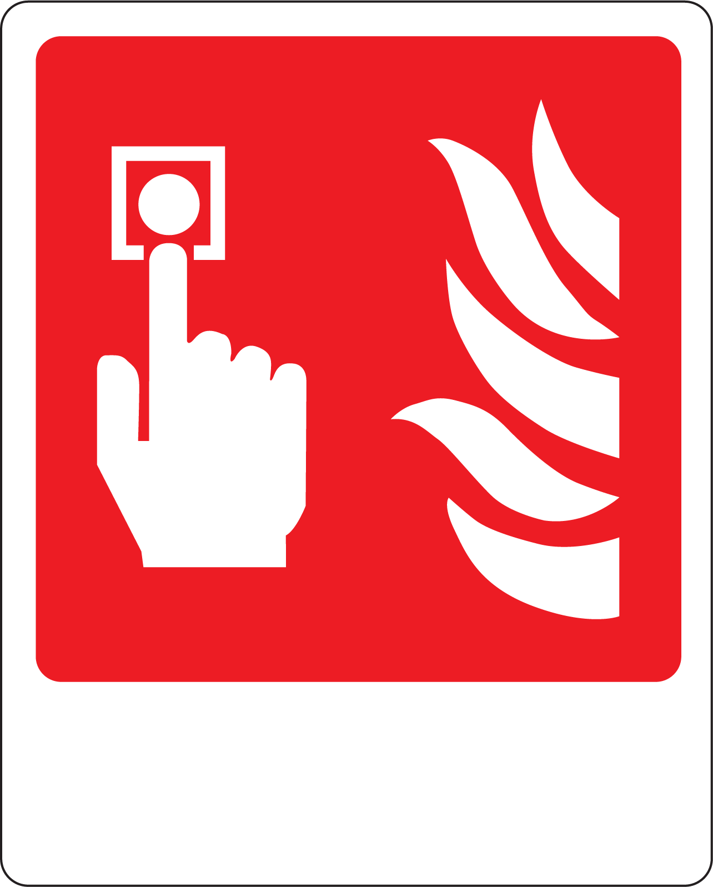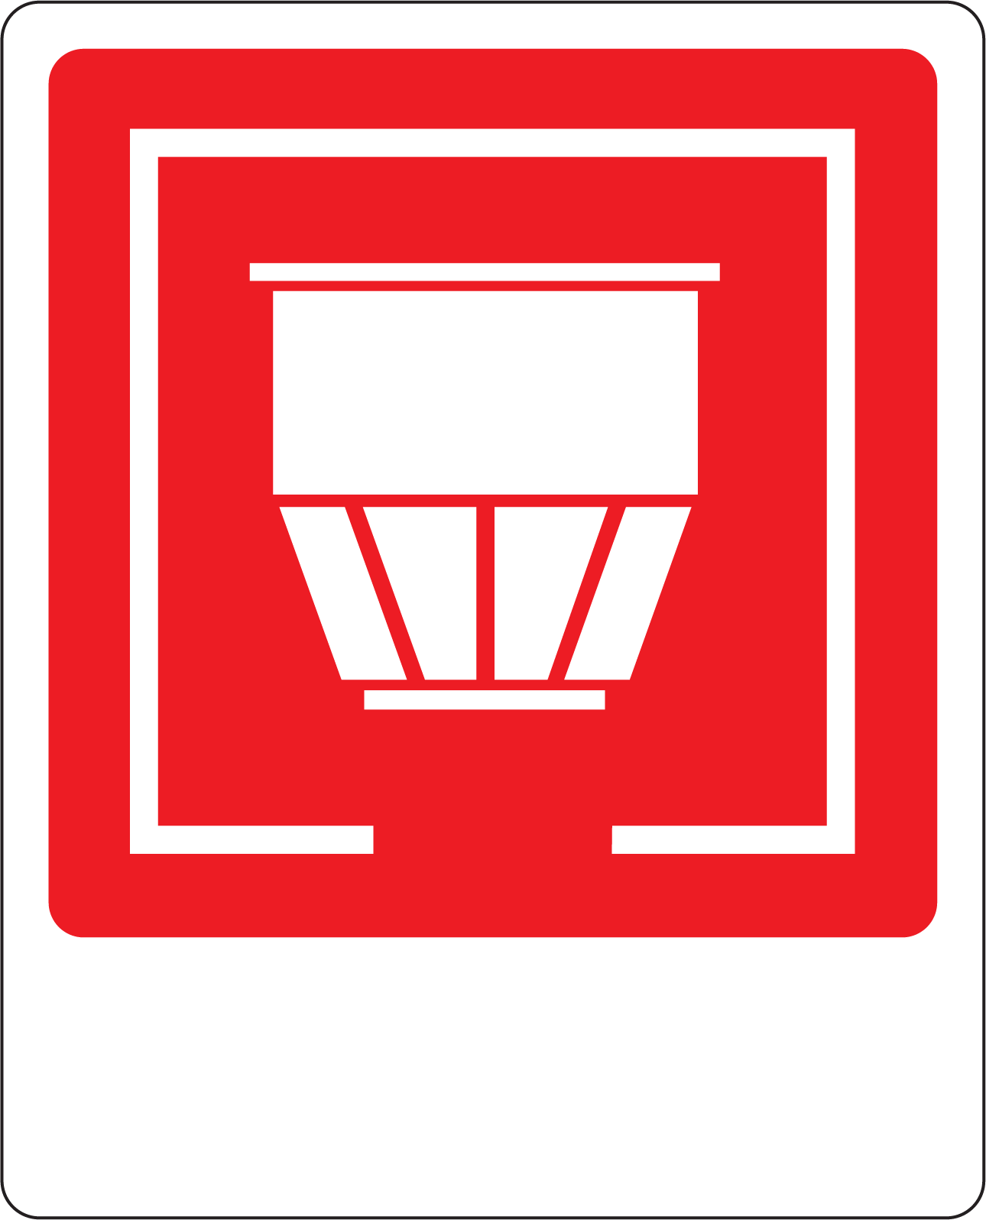 | 4D

30 | Flame / fire | ✕ Combustible materials  ✕ Pyrotechnics / Special effects  ✕ Naked flames  ✕ Isolation of alarms / sensors | Any materials to fuel any possible fire or spark.  Improper use of pyrotechnics or special effects (including Sparkulars).  Naked flames possibly igniting a fire.  Isolation of alarms in effect, due to the use of haze. | 4B | - Any material drapes provided are Industry standard, are commercially manufactured, and have been treated to be fire retardant.  - Projection & display screens are [Event Organiser.Company] standard and have inherent fire-retardant properties.  - Any Pyrotechnics / Spcial effects are managed by a trained professional and according to the dedicated Risk Assessment & SWMS.  - 'Sparkulars' are not permitted to be used on [Event Organiser.Company] events without dedicated SWMS provided to [Event Organiser.Company] (as of July 2025).  - Any naked flames under the control of [Event Organiser.Company] are subject to the approval of the venue. They will be managed according to a dedicated SWMS.  - Venue standard fire control facilities in operation for this event, and adhered to by all suppliers.  - If fire impairment is required, then suitable application forms are completed and submitted to the venue for approval. | 4E

31 | Dark Areas   | ✔ Dark areas  ✔ Impaired vision due to high contrast lighting | People may not have enough functional light to adequately move around the space safely without knocking into possible hazards.  Darkened areas due to stage blackout or poorly lit areas, yet accessible to unauthorised people  People on the stage may be temporarily 'blinded' by stage lighting, and may fall off stage or miss the steps to descend.  Events staff may not have adequate functional light to move around backstage, due to intentionally darkened areas. | 3C | - Adequate ambient public lighting available at all times in all spaces being used by people.  - Trained AV Technicians are in control of lighting for the stage / presentation / dance floor, and for general room visibility.  - Visibility of the edge of stage to be increased with high-contrast tape as required.  - All known people ascending to the stage are requested to rehearse their entry and exit, and also to provide any feedback about any lighting that may create blind spots for them onstage.  - Venue room lighting to be pre-focussed on stairs to decrease contrast effect between stage and audience illumination.  - Any backstage areas (behind drapes) to be illuminated by temporary work light as required, and/or ensuring that any events staff have access to torches for personal use.  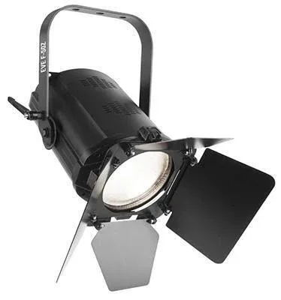 | 3E

31 | Dark Areas | ✕ Dark areas  ✕ Impaired vision due to high contrast lighting | People may not have enough functional light to adequately move around the space safely without knocking into possible hazards.  Darkened areas due to stage blackout or poorly lit areas, yet accessible to unauthorised people  People on the stage may be temporarily 'blinded' by stage lighting, and may fall off stage or miss the steps to descend.  Events staff may not have adequate functional light to move around backstage, due to intentionally darkened areas. | 3C | - Adequate ambient public lighting available at all times in all spaces being used by people.  - Trained AV Technicians are in control of lighting for the stage / presentation / dance floor, and for general room visibility.  - Visibility of the edge of stage to be increased with high-contrast tape as required.  - All known people ascending to the stage are requested to rehearse their entry and exit, and also to provide any feedback about any lighting that may create blind spots for them onstage.  - Venue room lighting to be pre-focussed on stairs to decrease contrast effect between stage and audience illumination.  - Any backstage areas (behind drapes) to be illuminated by temporary work light as required, and/or ensuring that any events staff have access to torches for personal use. | 3E

32 | Venomous snakes & animals / Wild animals   | ✔ Venomous Snakes / Venomous animals  ✔ Wild animals | People bitten by a venomous snake, spider or other animal.  People harmed or injured by a wild animal. | 4C | - There is no anticipated contact likely with venomous snakes, spiders or other animals.  - [Event Organiser.Company] Crew to carry out a visual inspection of the general area for these hazards before commencing bump-in.  - [Event Organiser.Company] Crew made aware of the likelihood of these hazards during [Event Organiser.Company] Toolbox briefing.  - [Event Organiser.Company] Crew to wear appropriate PPE if likely to encounter these hazards (i.e. closed toe shoes, trousers, gloves, etc.).  - Venue to provide certified first aiders on-site at all times, who are specifically knowledgable in the first aid treatment of snake bites / spider bites, etc.  - In the event of any person being bitten, immediate transfer to a hospital is recommended, to provide the best care possible.  - Venue to arrange for the prompt removal of any animals in the event of unexpected encounters with these hazards.   | 4E

32 | Venomous snakes & animals / Wild animals | ✕ Venomous Snakes / Venomous animals  ✕ Wild animals | People bitten by a venomous snake, spider or other animal.  People harmed or injured by a wild animal. | 4C | - There is no anticipated contact likely with venomous snakes, spiders or other animals.  - [Event Organiser.Company] Crew to carry out a visual inspection of the general area for these hazards before commencing bump-in.  - [Event Organiser.Company] Crew made aware of the likelihood of these hazards during [Event Organiser.Company] Toolbox briefing.  - [Event Organiser.Company] Crew to wear appropriate PPE if likely to encounter these hazards (i.e. closed toe shoes, trousers, gloves, etc.).  - Venue to provide certified first aiders on-site at all times, who are specifically knowledgable in the first aid treatment of snake bites / spider bites, etc.  - In the event of any person being bitten, immediate transfer to a hospital is recommended, to provide the best care possible.  - Venue to arrange for the prompt removal of any animals in the event of unexpected encounters with these hazards. | 4E

33 | Inclement Weather / Storms  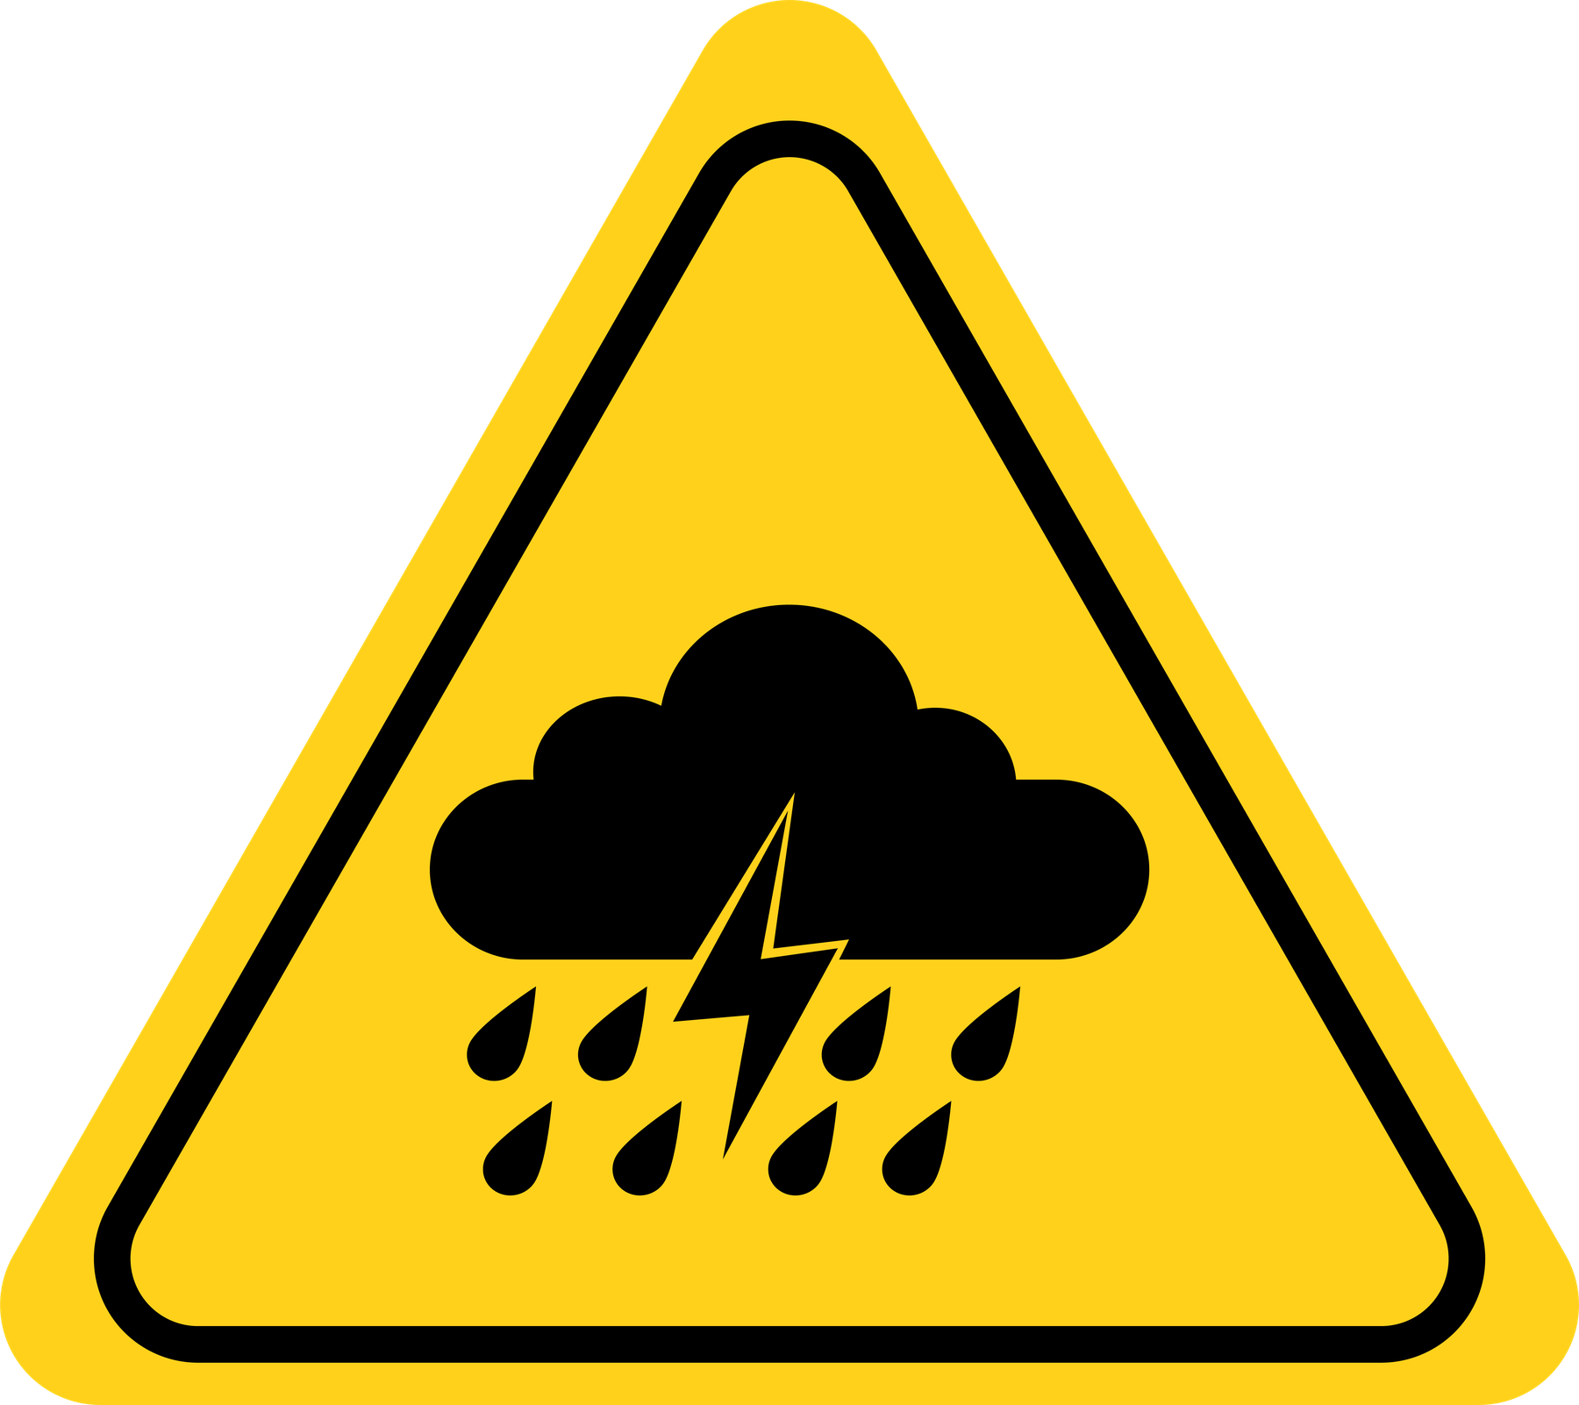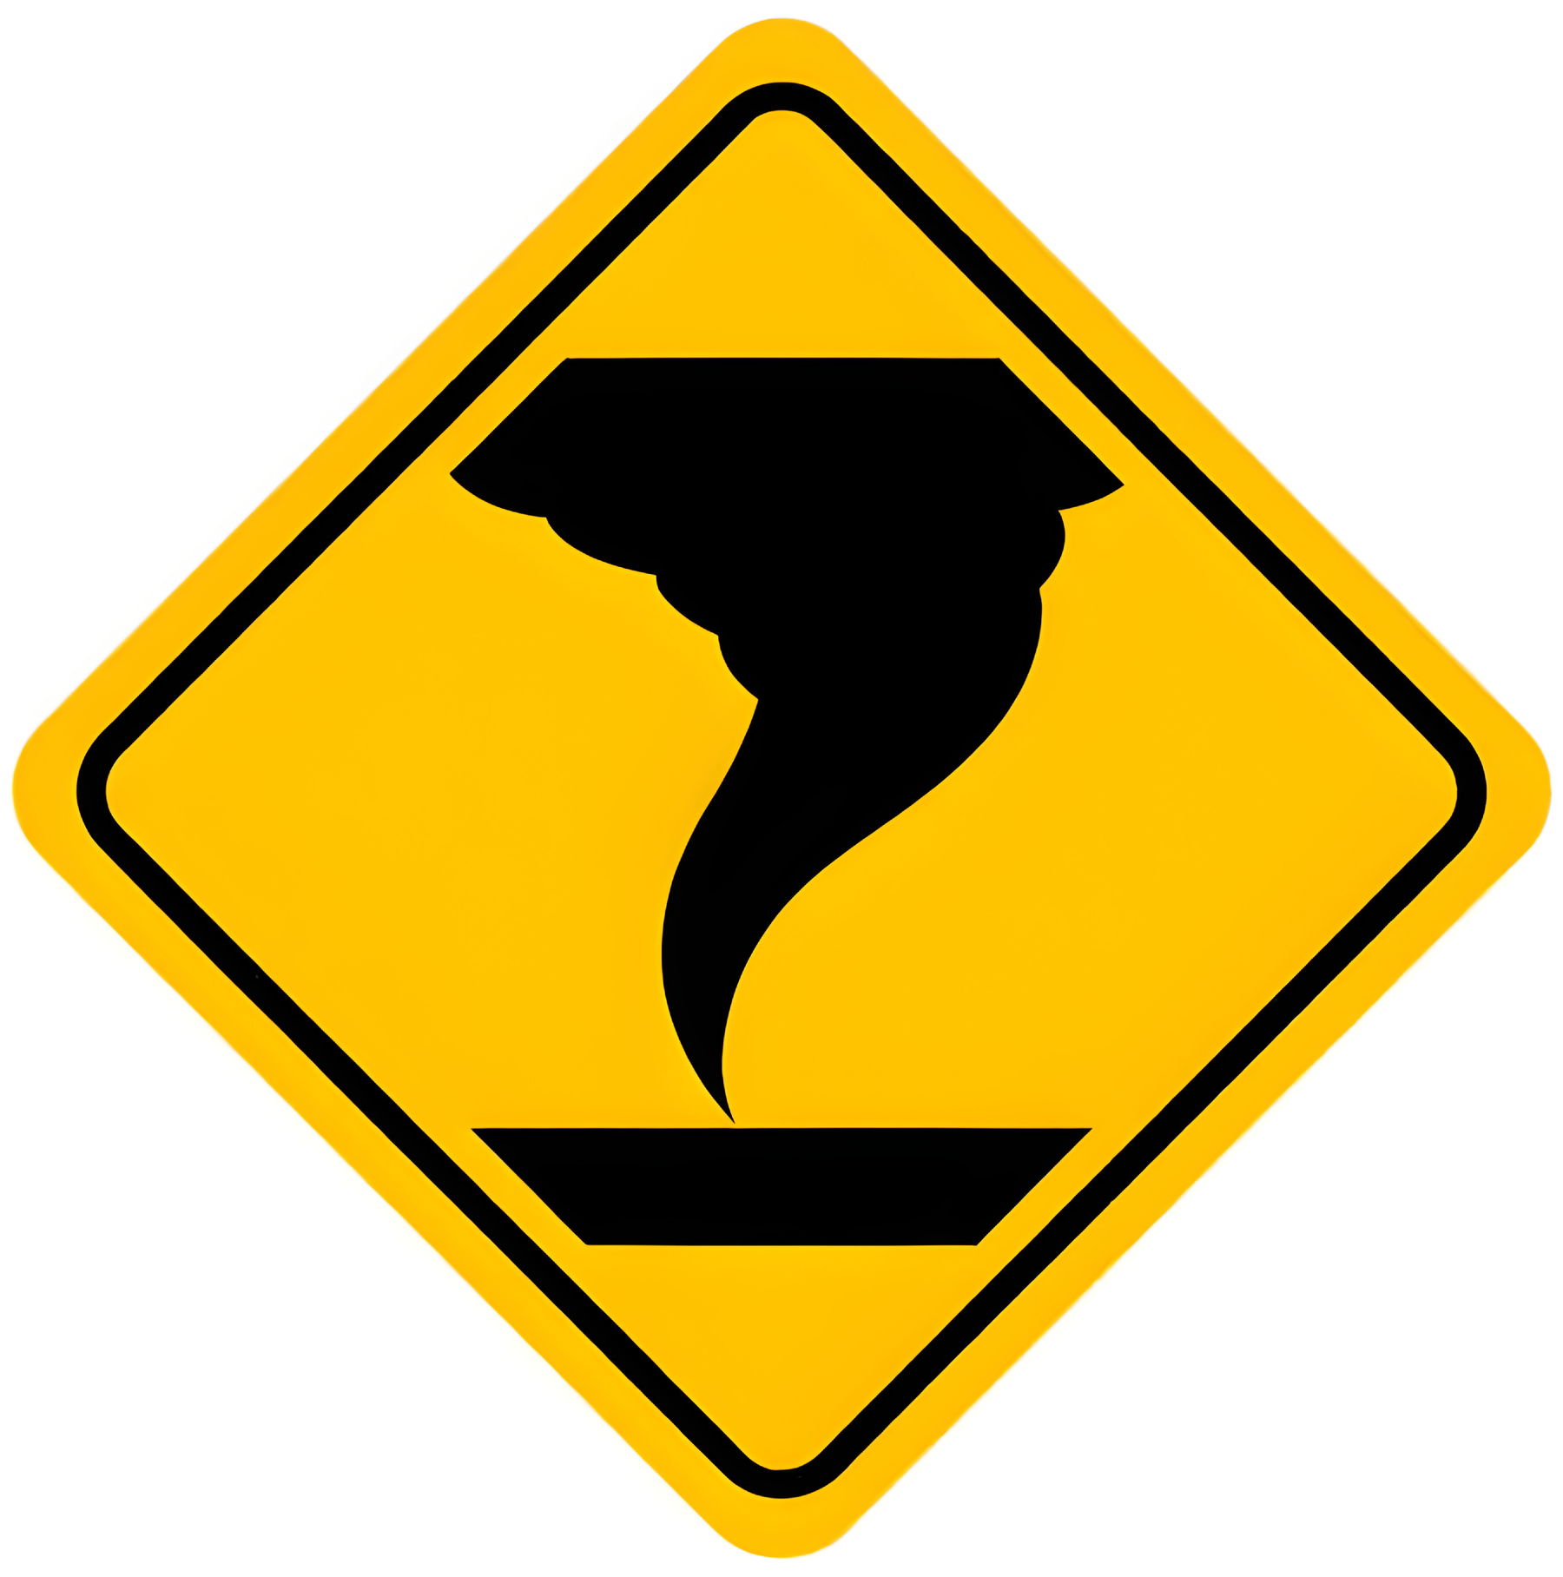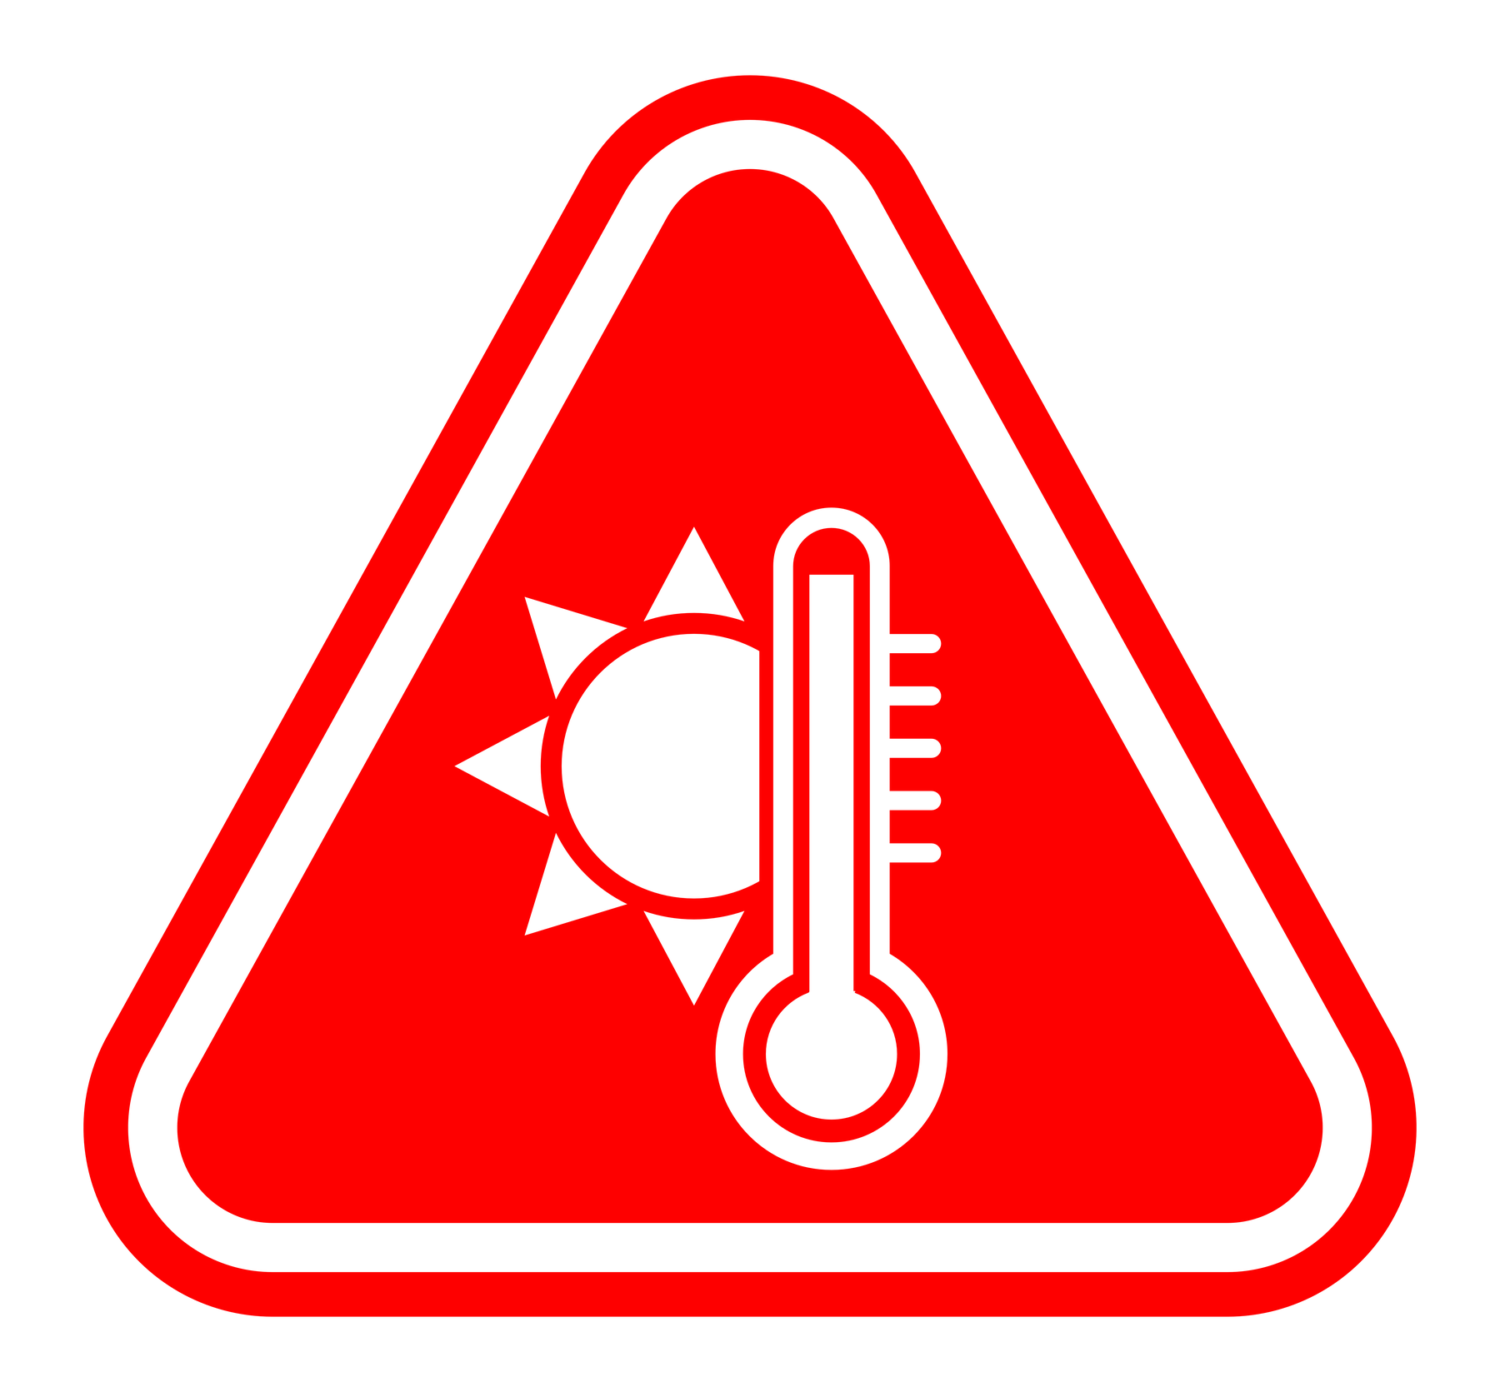 | ✔ Hazardous Storms / Precipitation  ✔ Hazardous Winds / Cyclones | Rain starts before the setup of the event.  Rain starts during the event.  Some outdoor egress which is exposed to the elements and may be subject to rain or precipitation affecting the Event operation and its’ temporary exterior setting.  Outdoor area may be compromised depending on any extreme prevailing weather conditions on the day.  Items could fall over either directly from heavy winds or indirectly from doors swinging open onto them. | 3B | - Commercial Venue operating in a sub-tropical climate. These hazards will be assessed as part of their normal operation.  - Wet weather contingency considered by [Event Organiser.Company] before the setup.  - Predictions and real-time monitoring of weather conditions in the lead-up and during the event.  - Utilising IP65 rated (or above) equipment in any outdoor situation. If not rated at IP65 (or above) then to adequately cover and protect with tarp coverings over electrical equipment in advance of any precipitation. Using IP65 boxes to protect exposed electrical connections.  - Environmental / Weather conditions will be assessed and coordinated by the Venue operators and the Weather contingency will be invoked if necessary.  - Severe wind and weather conditions and contingency plans to be communicated by Venue operators  - Designated person from [Event Organiser.Company] is to check BOM website and advise on weather forecasts & severe weather warnings and if activities are to be deferred to another suitable time  - [Event Organiser.Company] Crew to be in contact with the designated venue controller always to ensure weather warnings and activity cancellation information is maintained  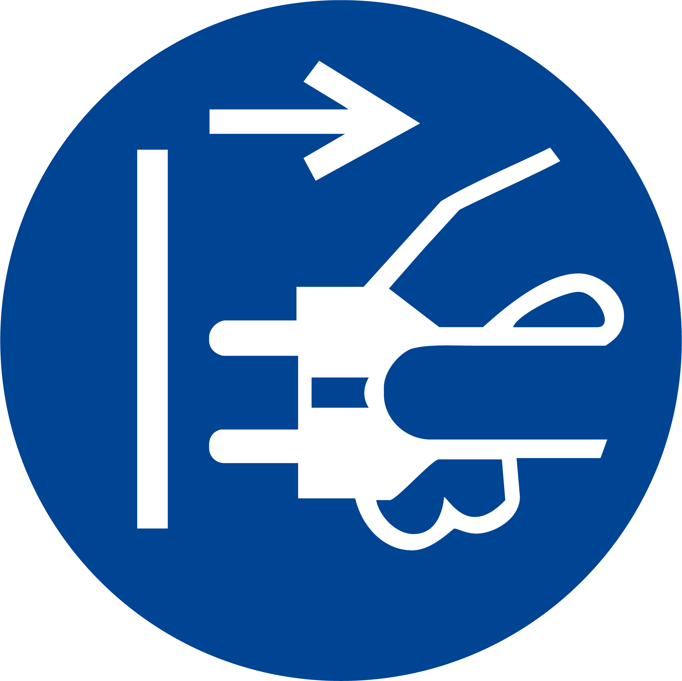 | 3C

33 | Inclement Weather / Storms | ✕ Hazardous Storms / Precipitation  ✕ Hazardous Winds / Cyclones | Rain starts before the setup of the event.  Rain starts during the event.  Some outdoor egress which is exposed to the elements and may be subject to rain or precipitation affecting the Event operation and its’ temporary exterior setting.  Outdoor area may be compromised depending on any extreme prevailing weather conditions on the day.  Items could fall over either directly from heavy winds or indirectly from doors swinging open onto them. | 3B | - Commercial Venue operating in a sub-tropical climate. These hazards will be assessed as part of their normal operation.  - Wet weather contingency considered by [Event Organiser.Company] before the setup.  - Predictions and real-time monitoring of weather conditions in the lead-up and during the event.  - Utilising IP65 rated (or above) equipment in any outdoor situation. If not rated at IP65 (or above) then to adequately cover and protect with tarp coverings over electrical equipment in advance of any precipitation. Using IP65 boxes to protect exposed electrical connections.  - Environmental / Weather conditions will be assessed and coordinated by the Venue operators and the Weather contingency will be invoked if necessary.  - Severe wind and weather conditions and contingency plans to be communicated by Venue operators  - Designated person from [Event Organiser.Company] is to check BOM website and advise on weather forecasts & severe weather warnings and if activities are to be deferred to another suitable time  - [Event Organiser.Company] Crew to be in contact with the designated venue controller always to ensure weather warnings and activity cancellation information is maintained | 3C

Acceptance
As a key PCBU involved; please review the above, and if agreeable and appropriate please accept this Event Risk Management Plan by signing below.

*Please note that if you choose not to agree to any of the controls, hazard identifications or risks outlined in this document, please get in touch with [Event Organiser.Company]'s WHS representative (details in the footer) to discuss and work through a more thorough WHS consultation process.

Please note that by signing, you are also agreeing that you have forwarded a copy of this Event Risk Management Plan to all relevant personnel with whom you have arranged to be onsite during the event (such as your colleagues, event staff, and third-party suppliers).

[Client.FirstName] [Client.LastName]  [Client.Company] | [Venue.FirstName] [Venue.LastName]  [Venue.Company] | [Event Organiser.FirstName] [Event Organiser.LastName]  [Event Organiser.Company]

Thank you, and we look forward to safely working with you!

PCBU acceptance
**Insert any other relevant documents into this ERMP, as the following pages, such as;
- SWMS / JSA, etc. that your company will conduct
- Insurances *Public Liability, Professional Indemnity, Cyber, Special Risks, Travel, etc.
- Licenses / Applicable certifications / Exemptions / Verification of Competency
- Floorplans / Site plans / Diagrams / Structural drawings, etc.

*Recommend to include any other Subcontractor's documents, so it creates a 'Master' from your company
- Other Subcontractor's Risk Assessments / SWMS / JSA that they will conduct
- Insurances *Public Liability, Professional Indemnity, Cyber, Special Risks, Travel, etc.
- Licenses / Applicable certifications / Exemptions / Verification of Competency
- Floorplans / Site plans / Diagrams / Structural drawings, etc.

**This text can be removed from your own template version
Disclaimer
The information provided in this document is for informational purposes only and does not constitute professional advice. No warranties, express or implied, are made regarding the accuracy, completeness, or suitability of the information contained herein. The user assumes all responsibility and risk for the use of this information. To the fullest extent permitted by law, The author disclaims all liability for any loss or damage that may arise from the use of this document or the information it contains.

​**This text can be removed from your own template version

